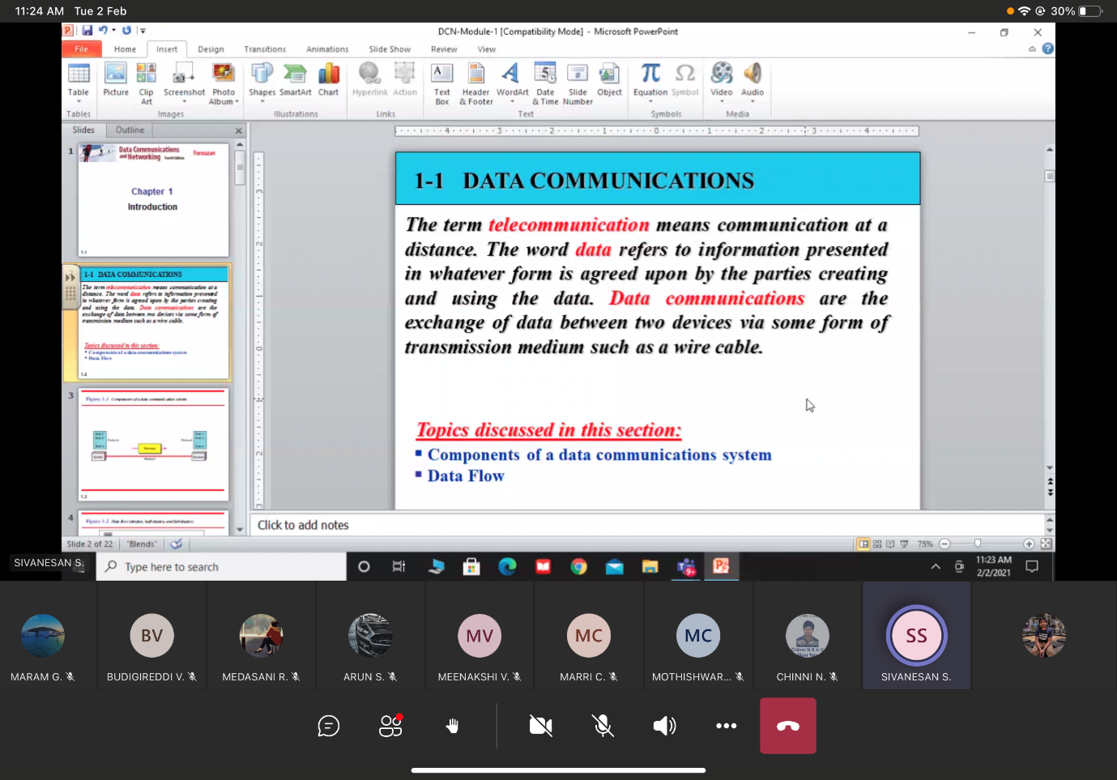

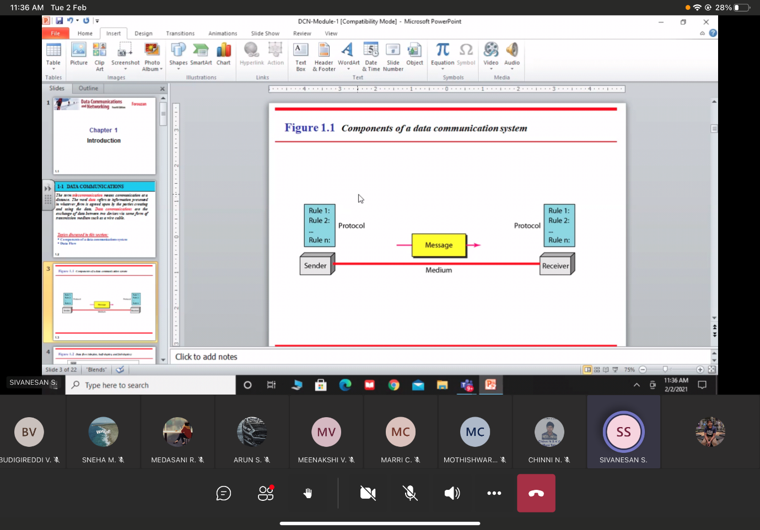

Simplex, half duplex and full duplex

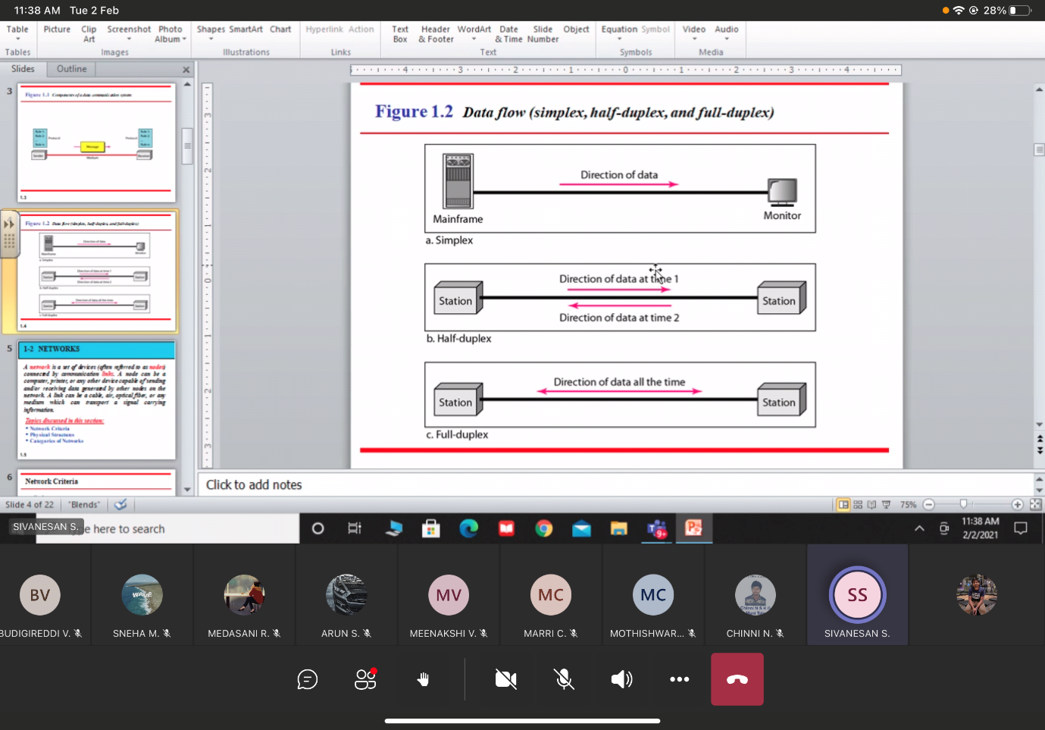

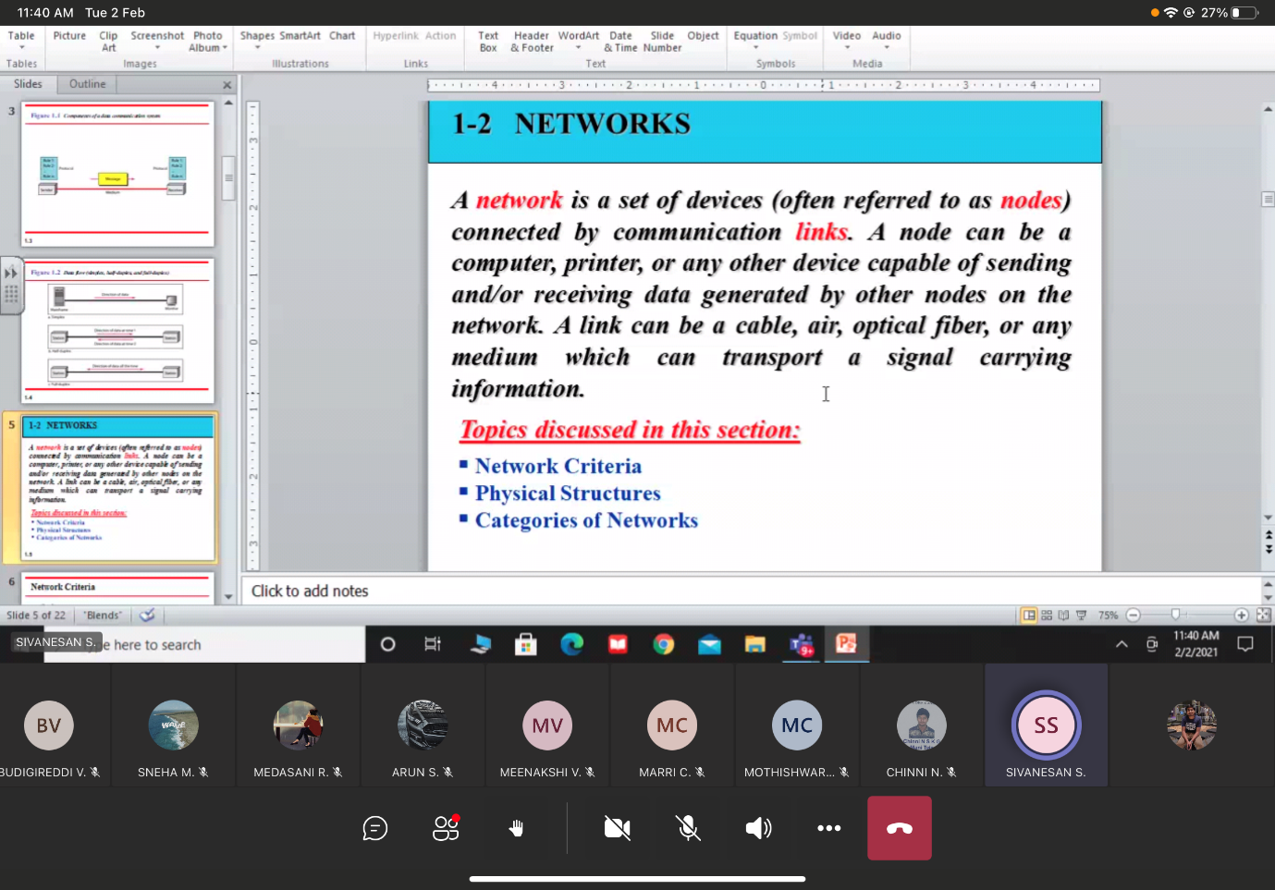

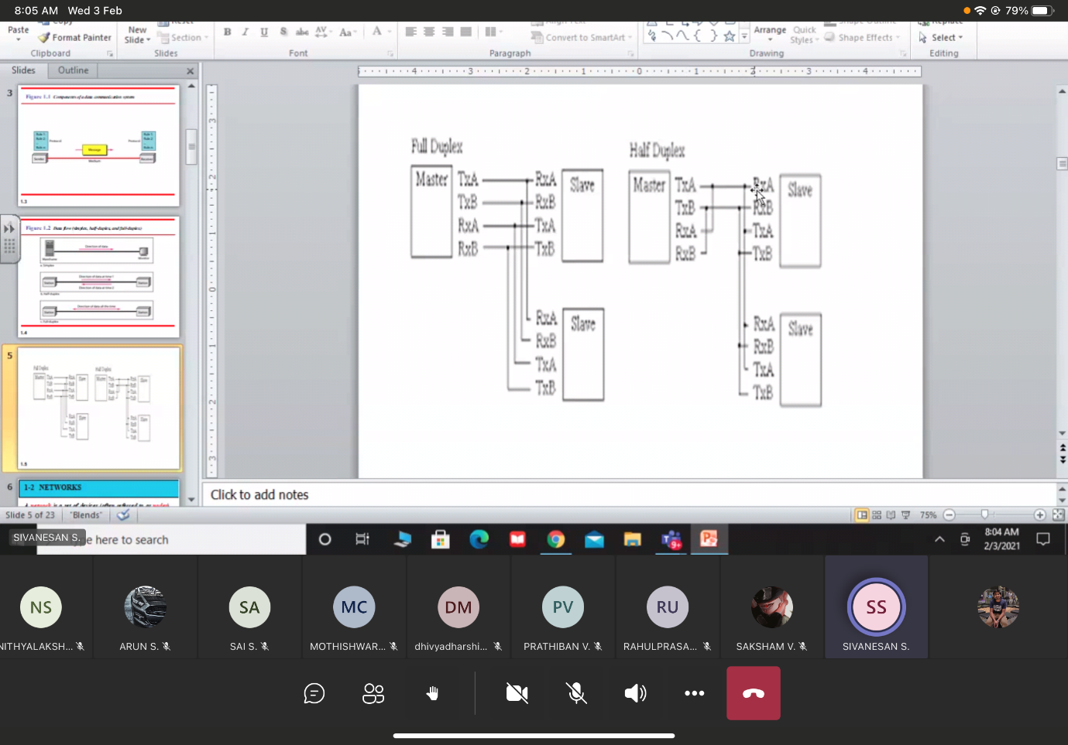

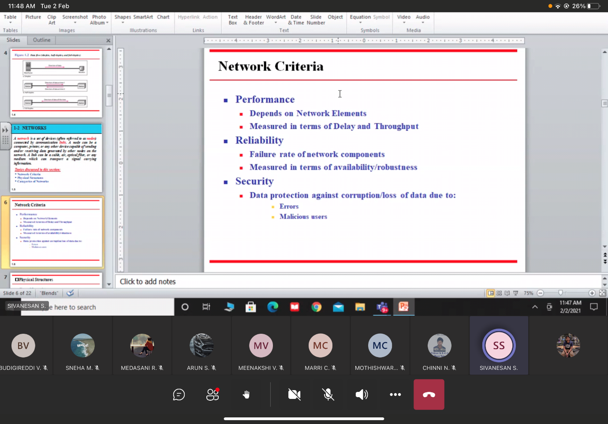

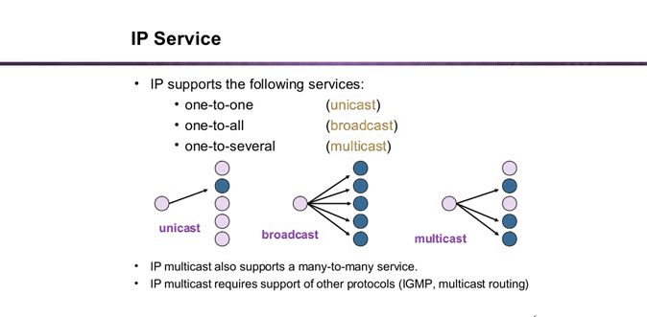

5/2/2021

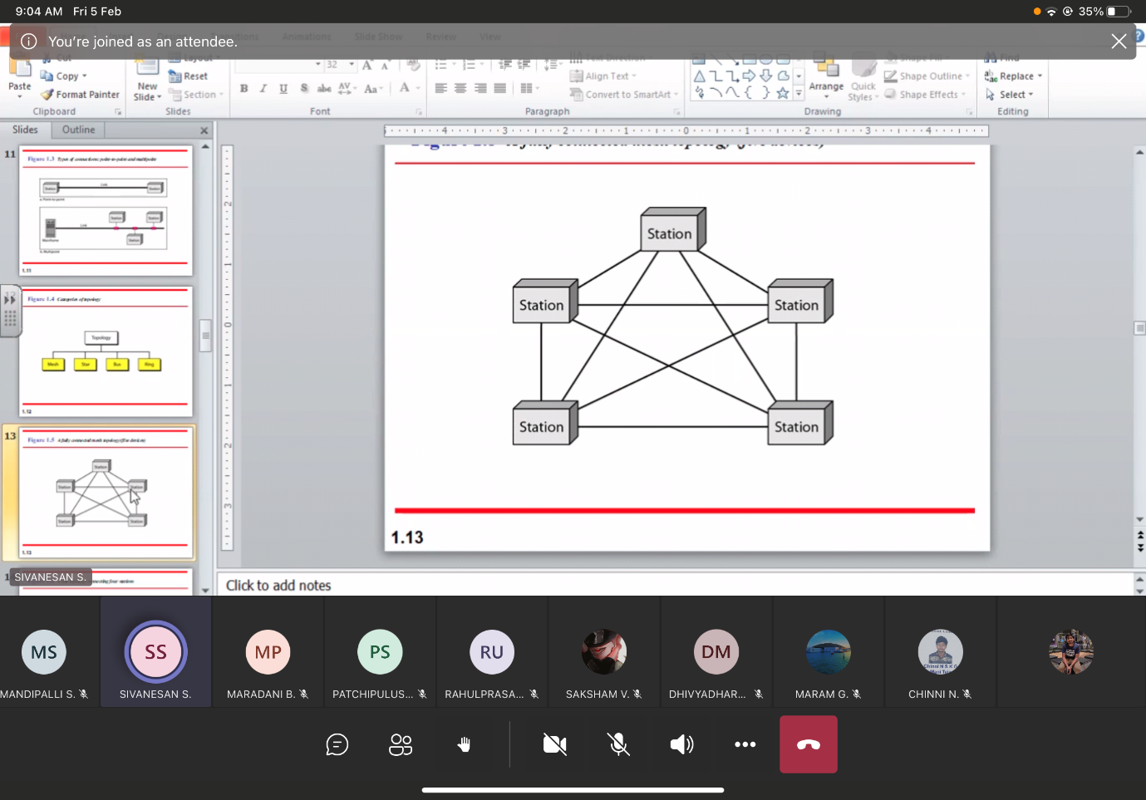

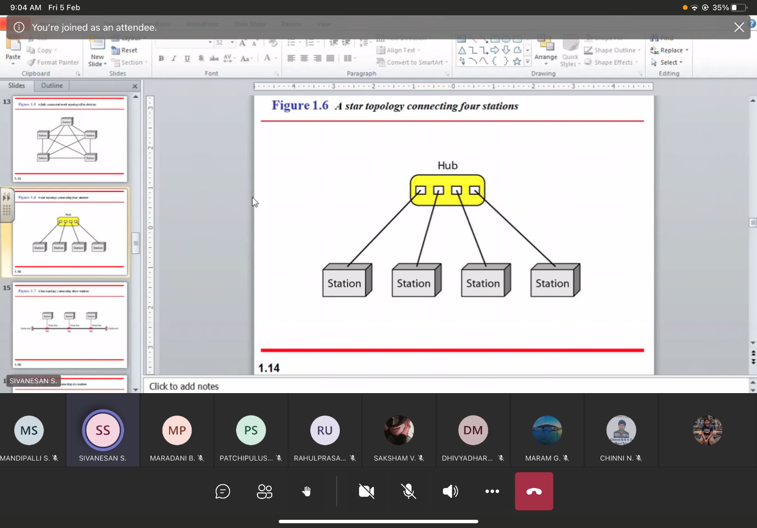

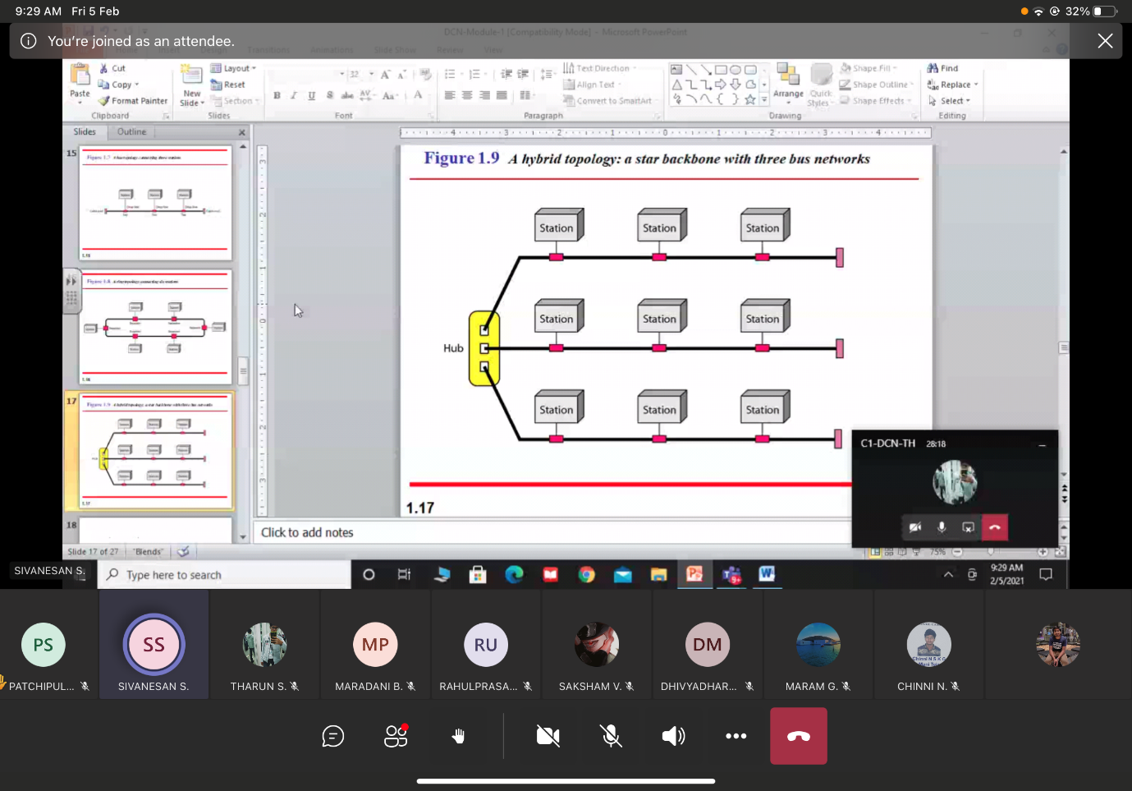

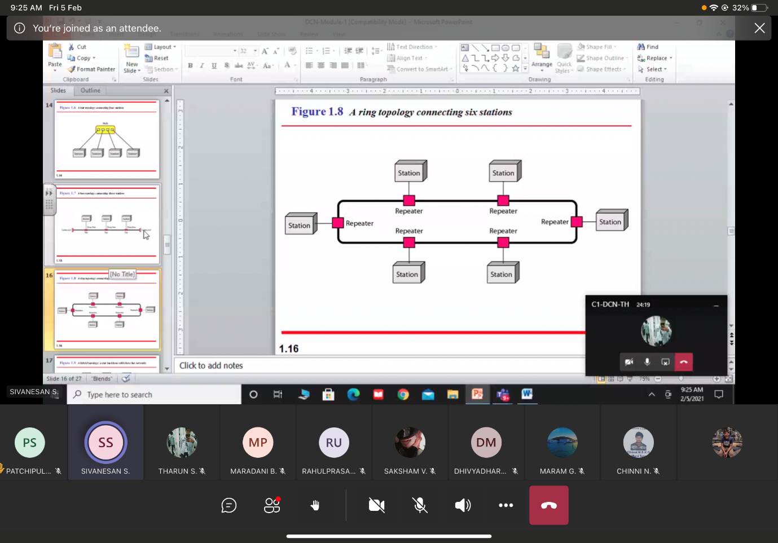

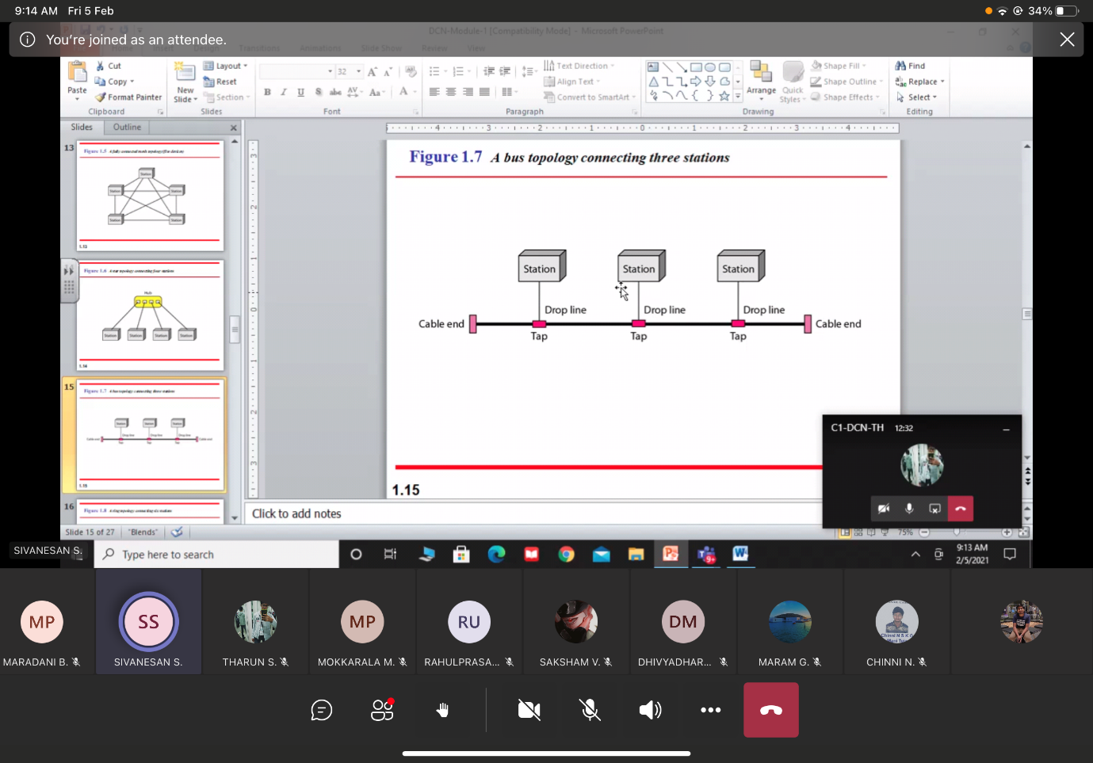

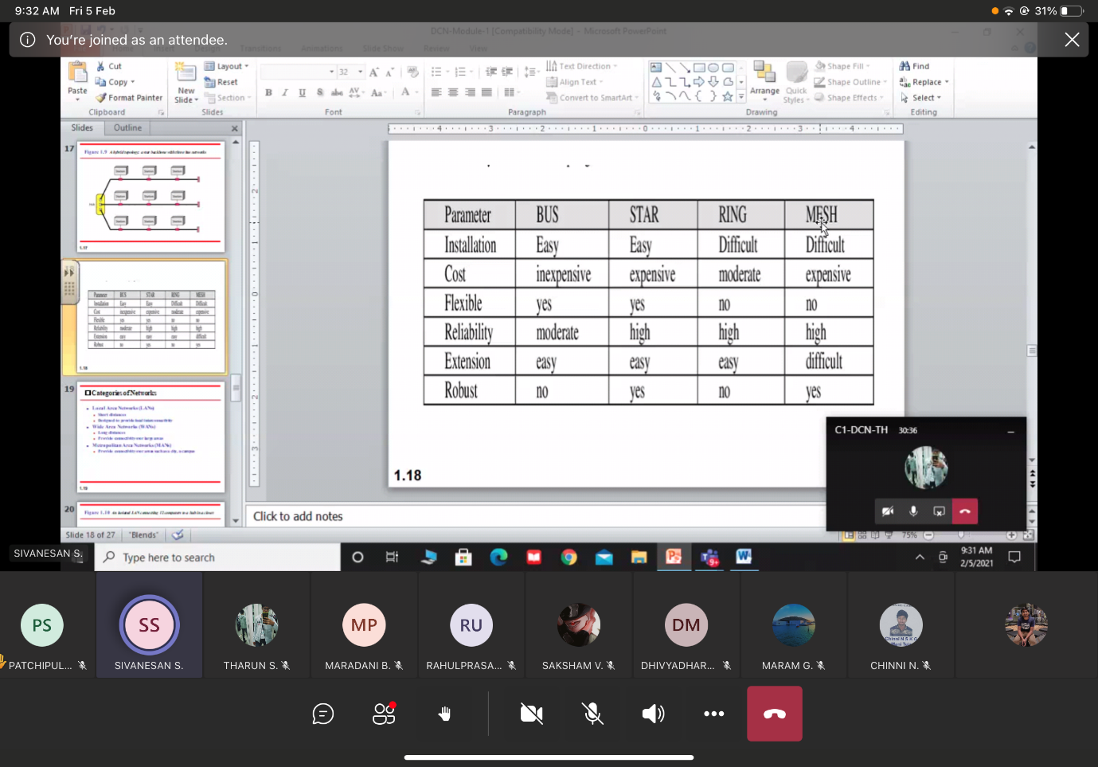

12/2/2021

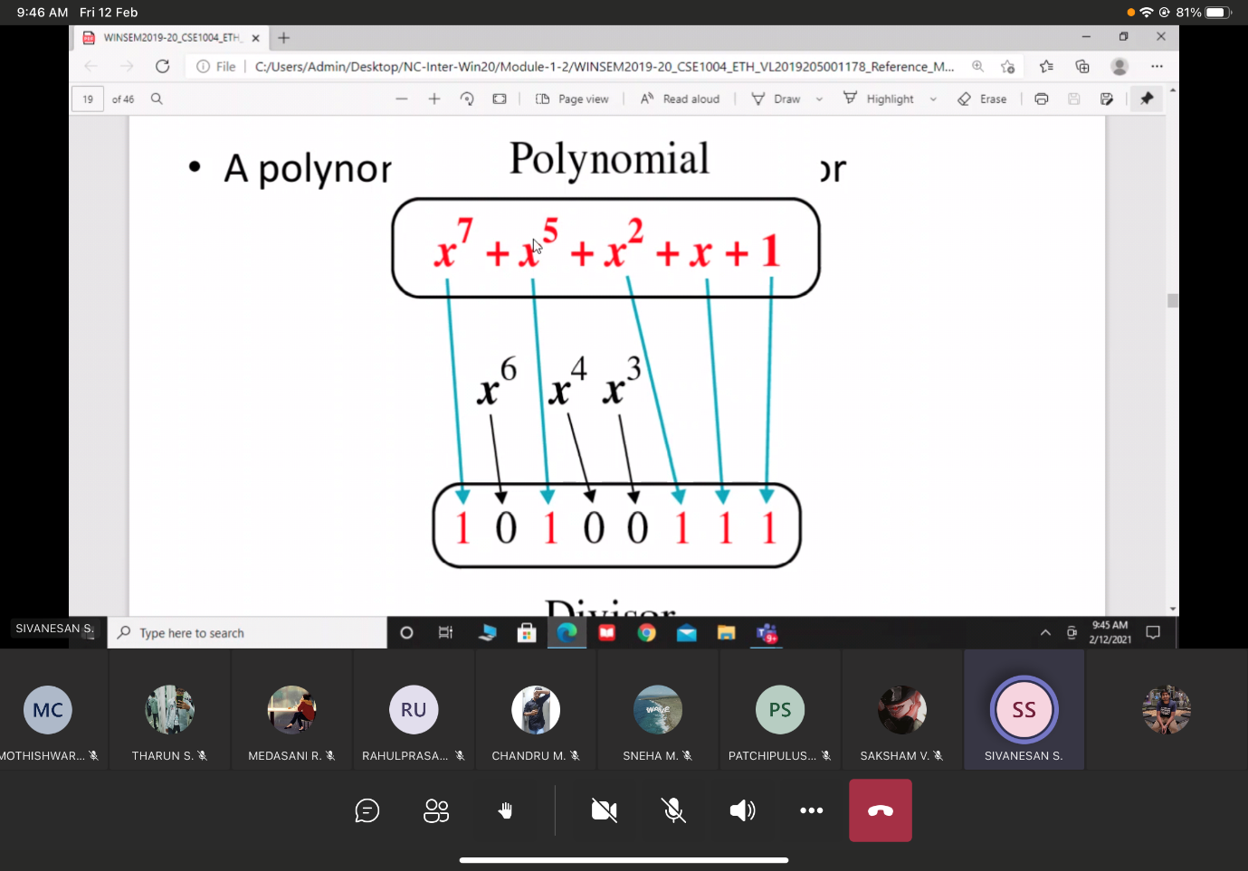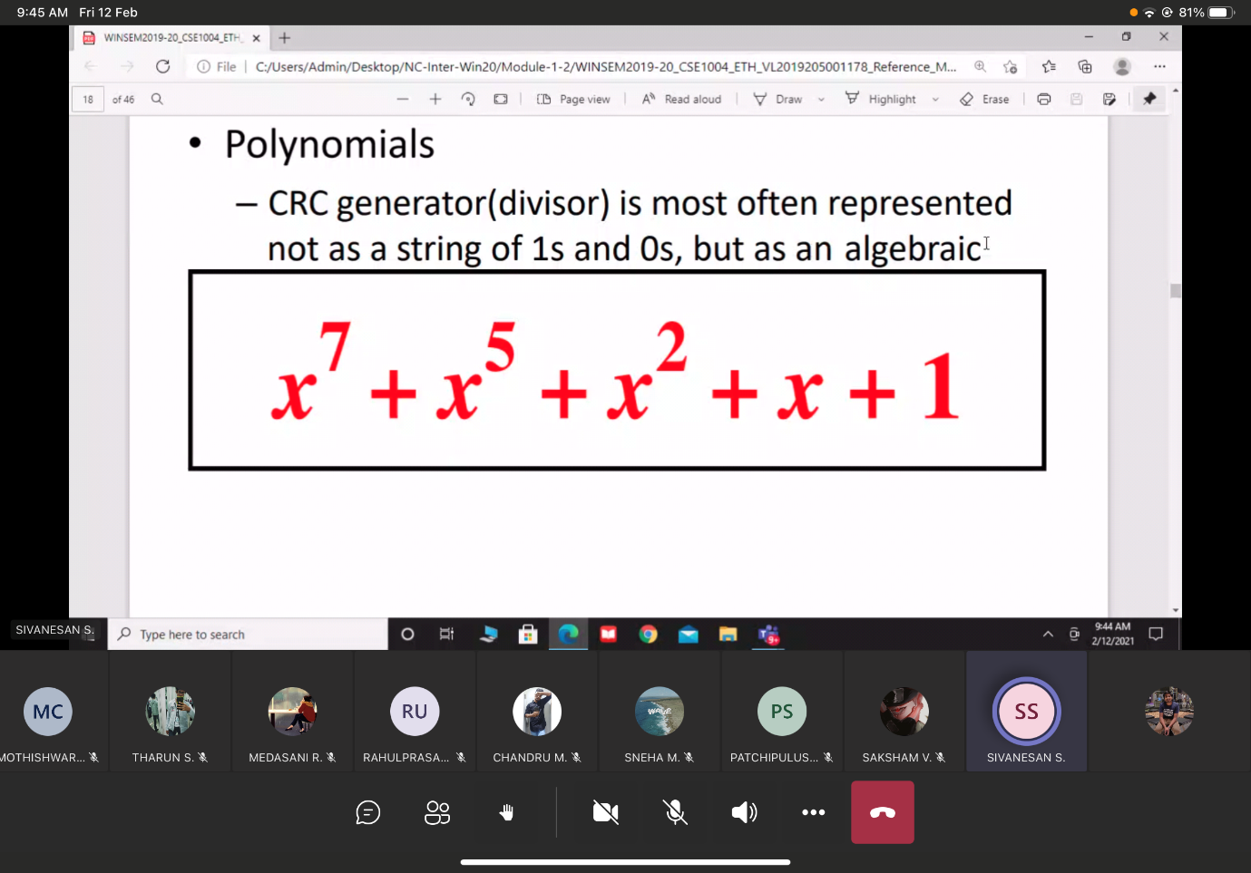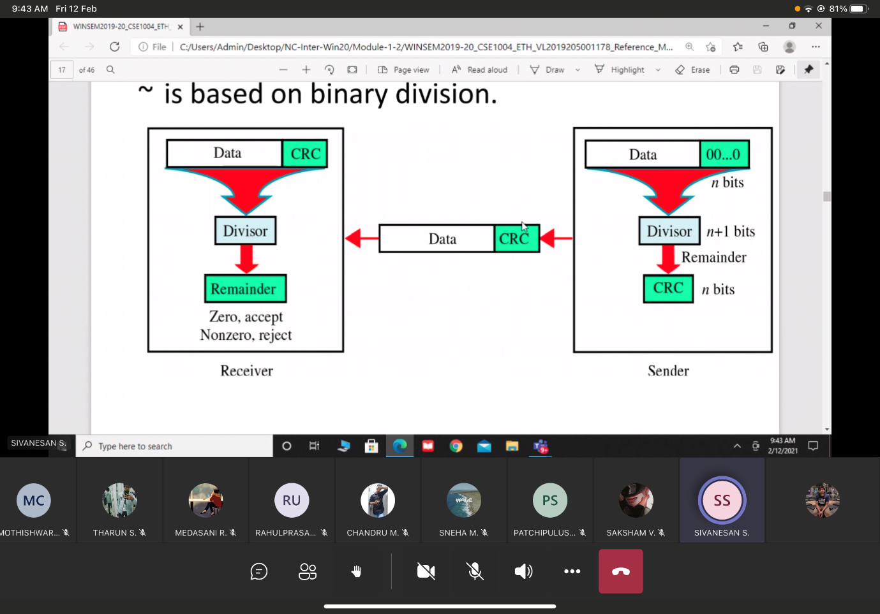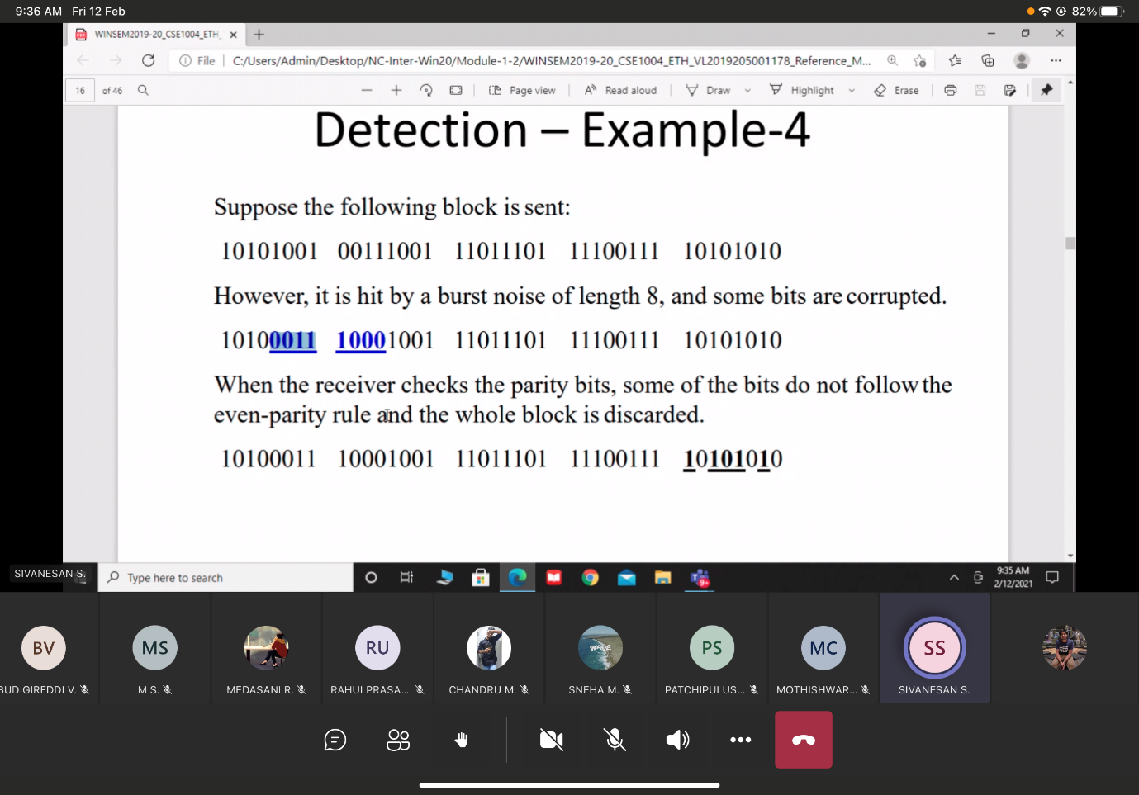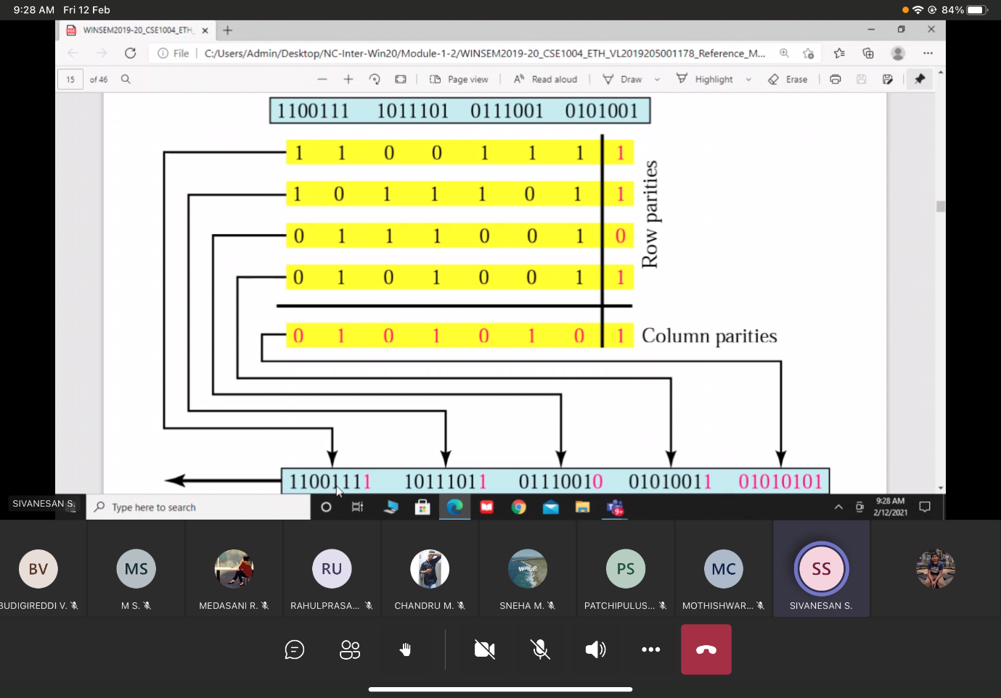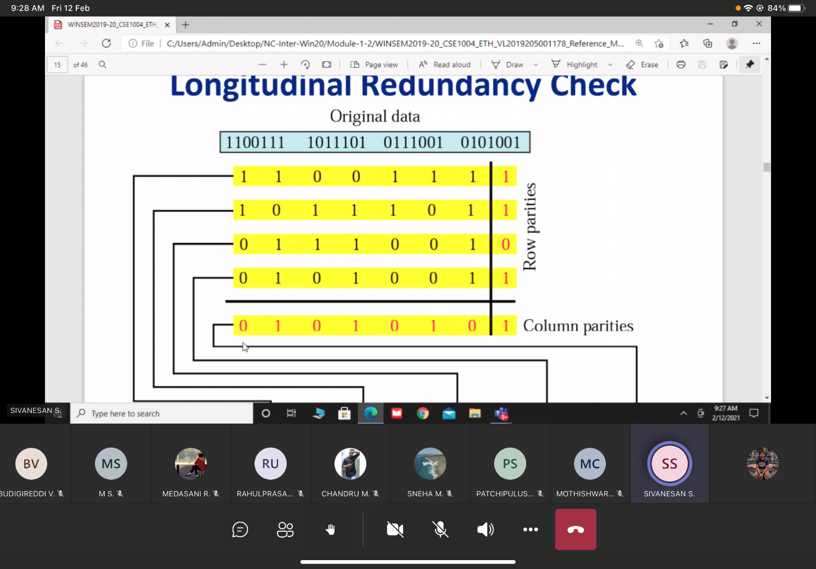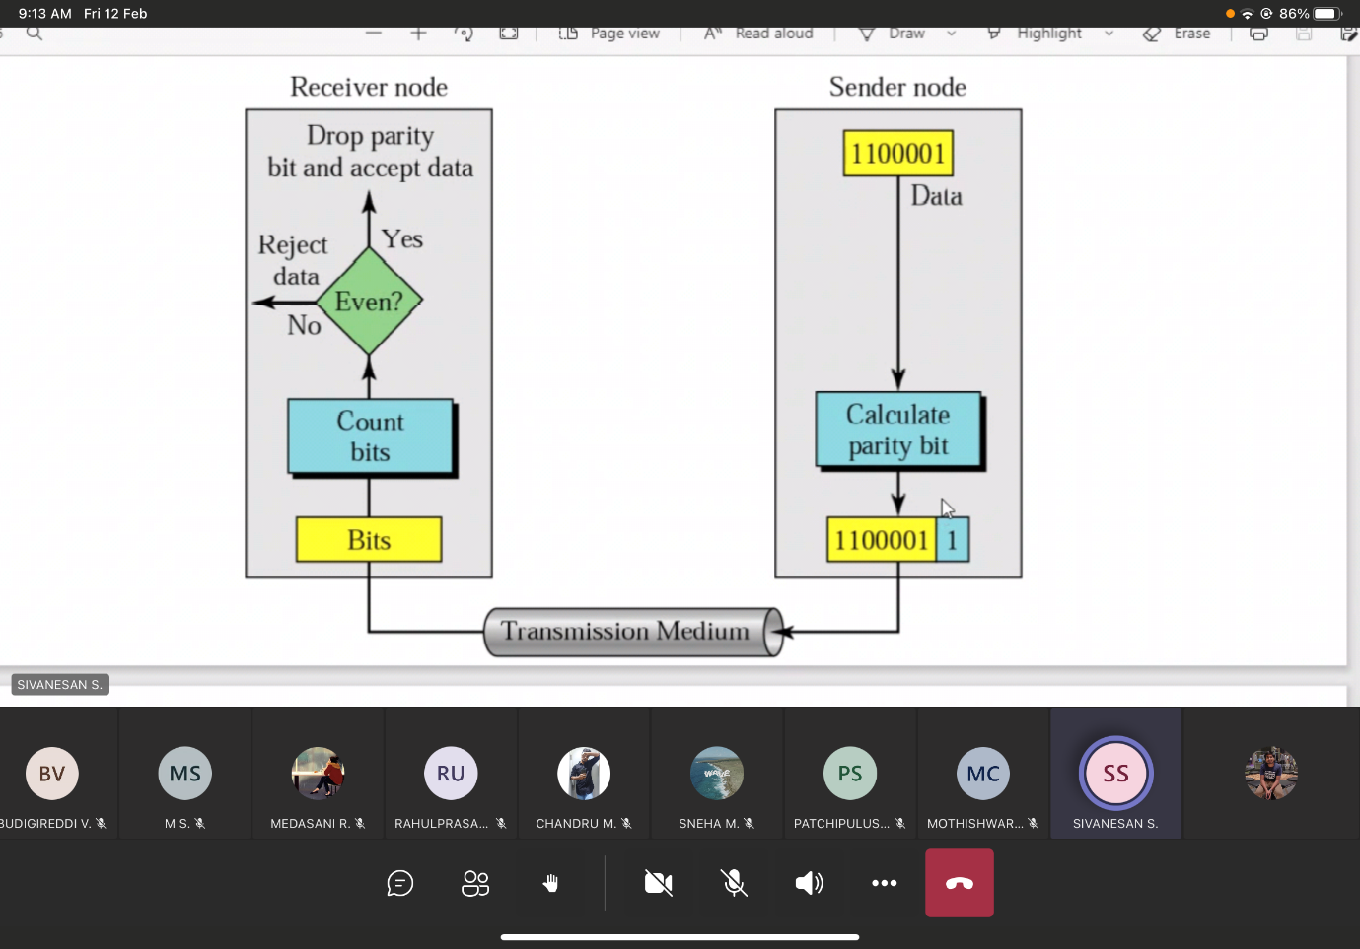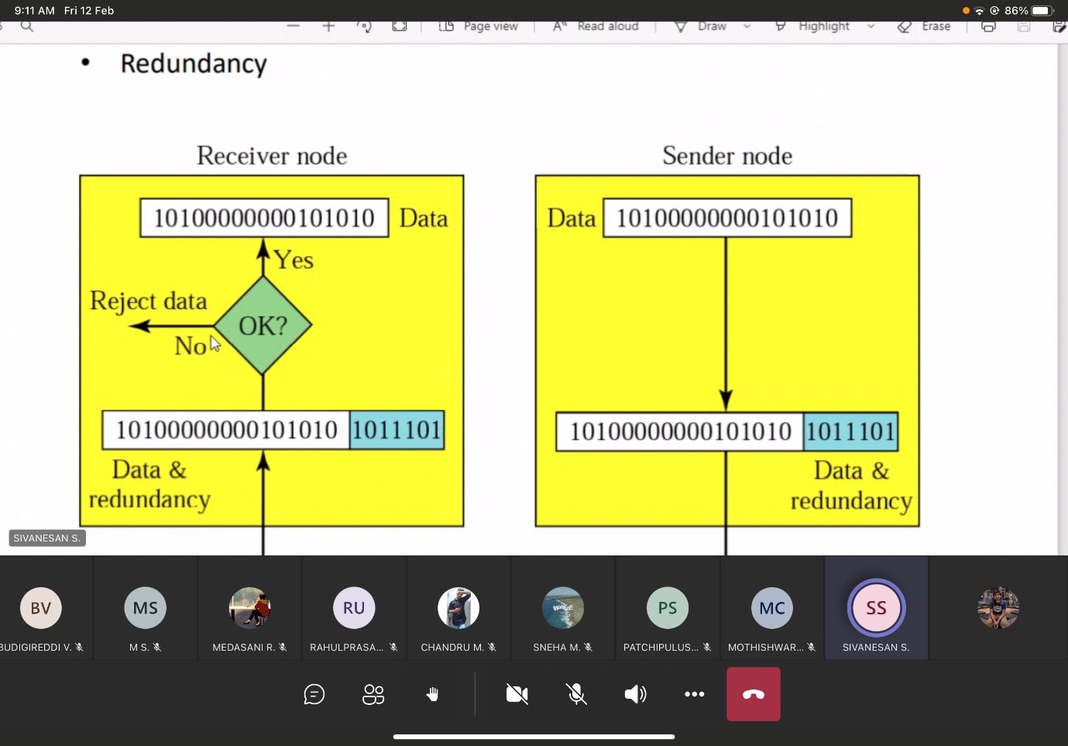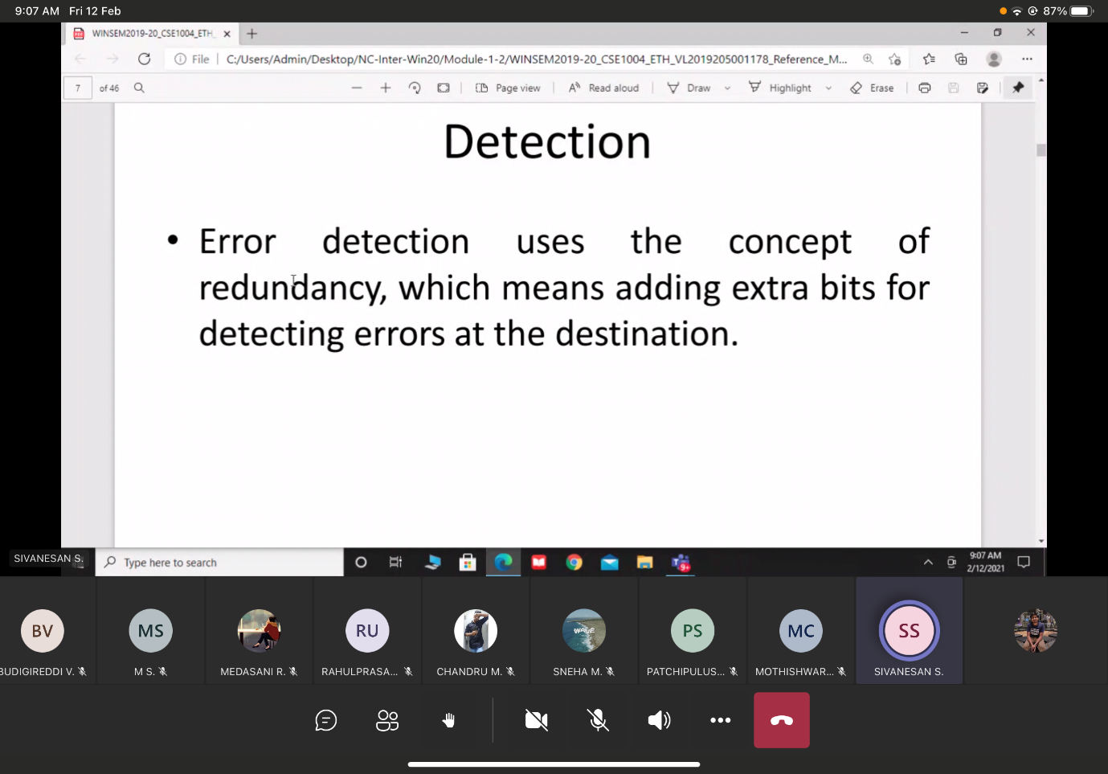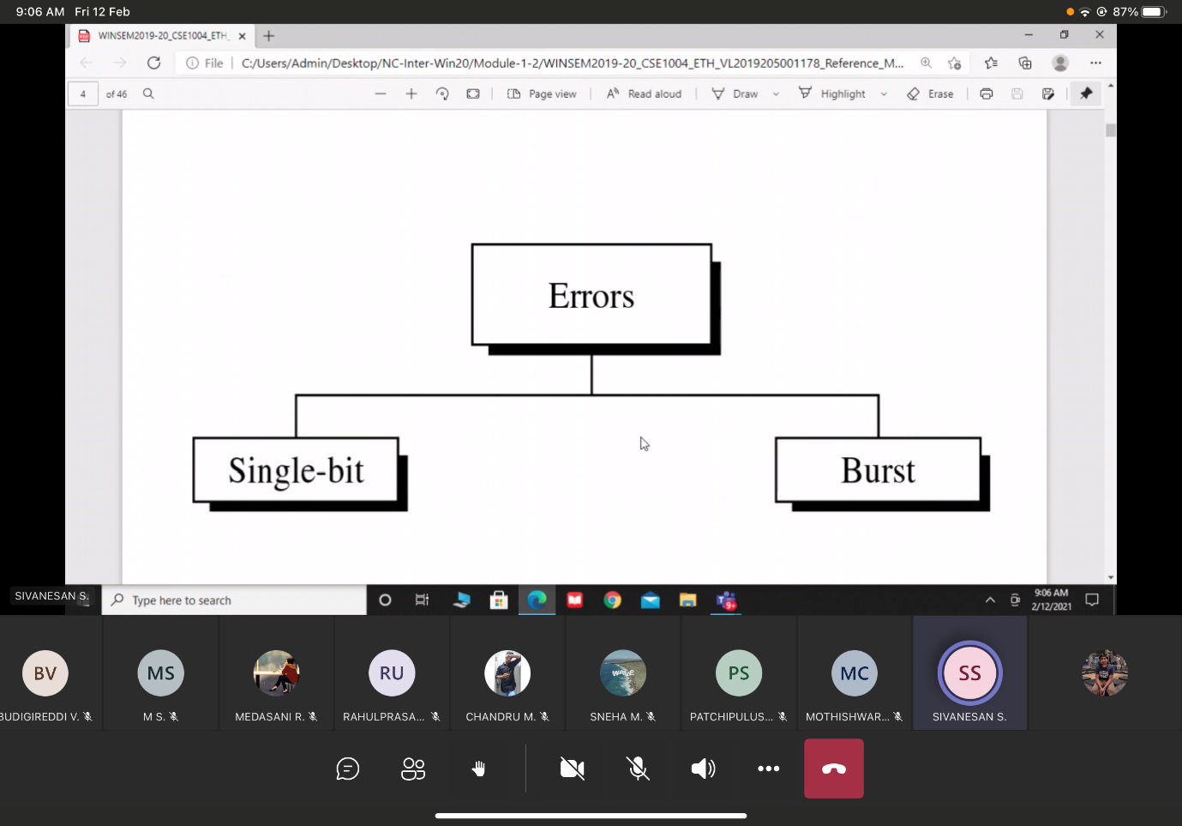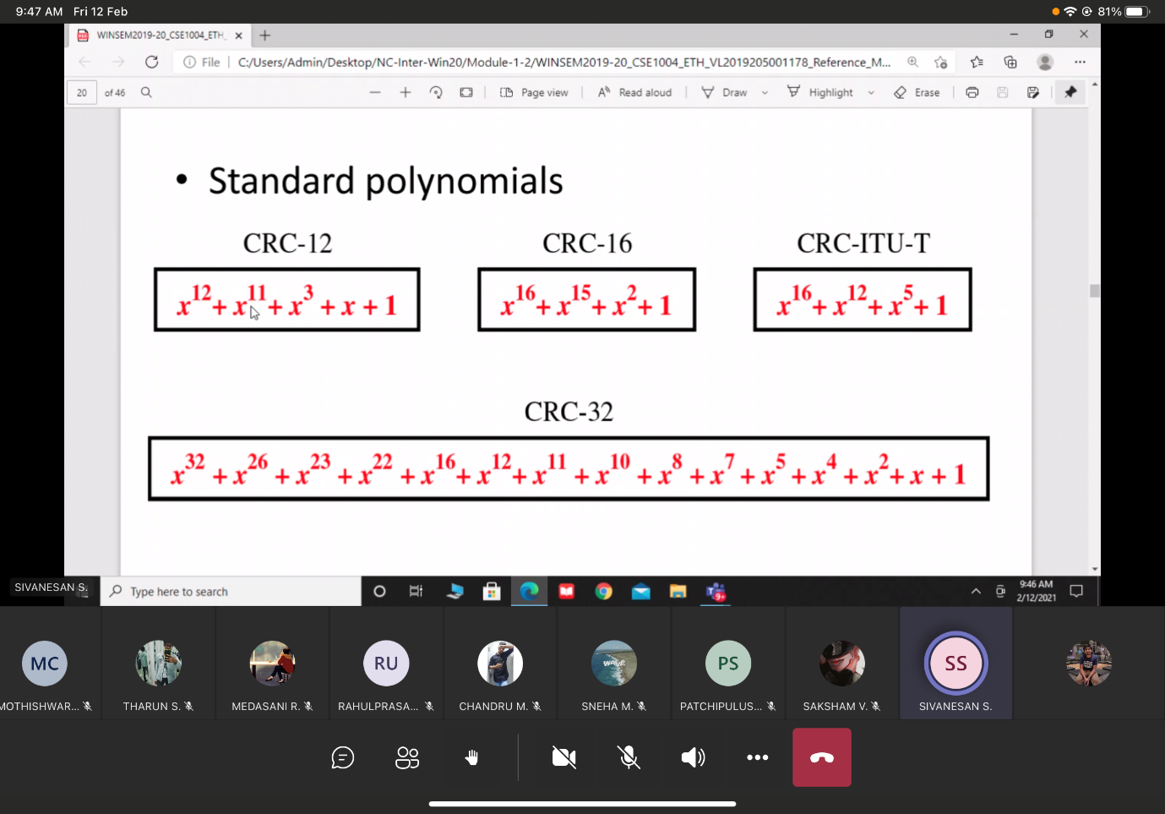

16/2/2021

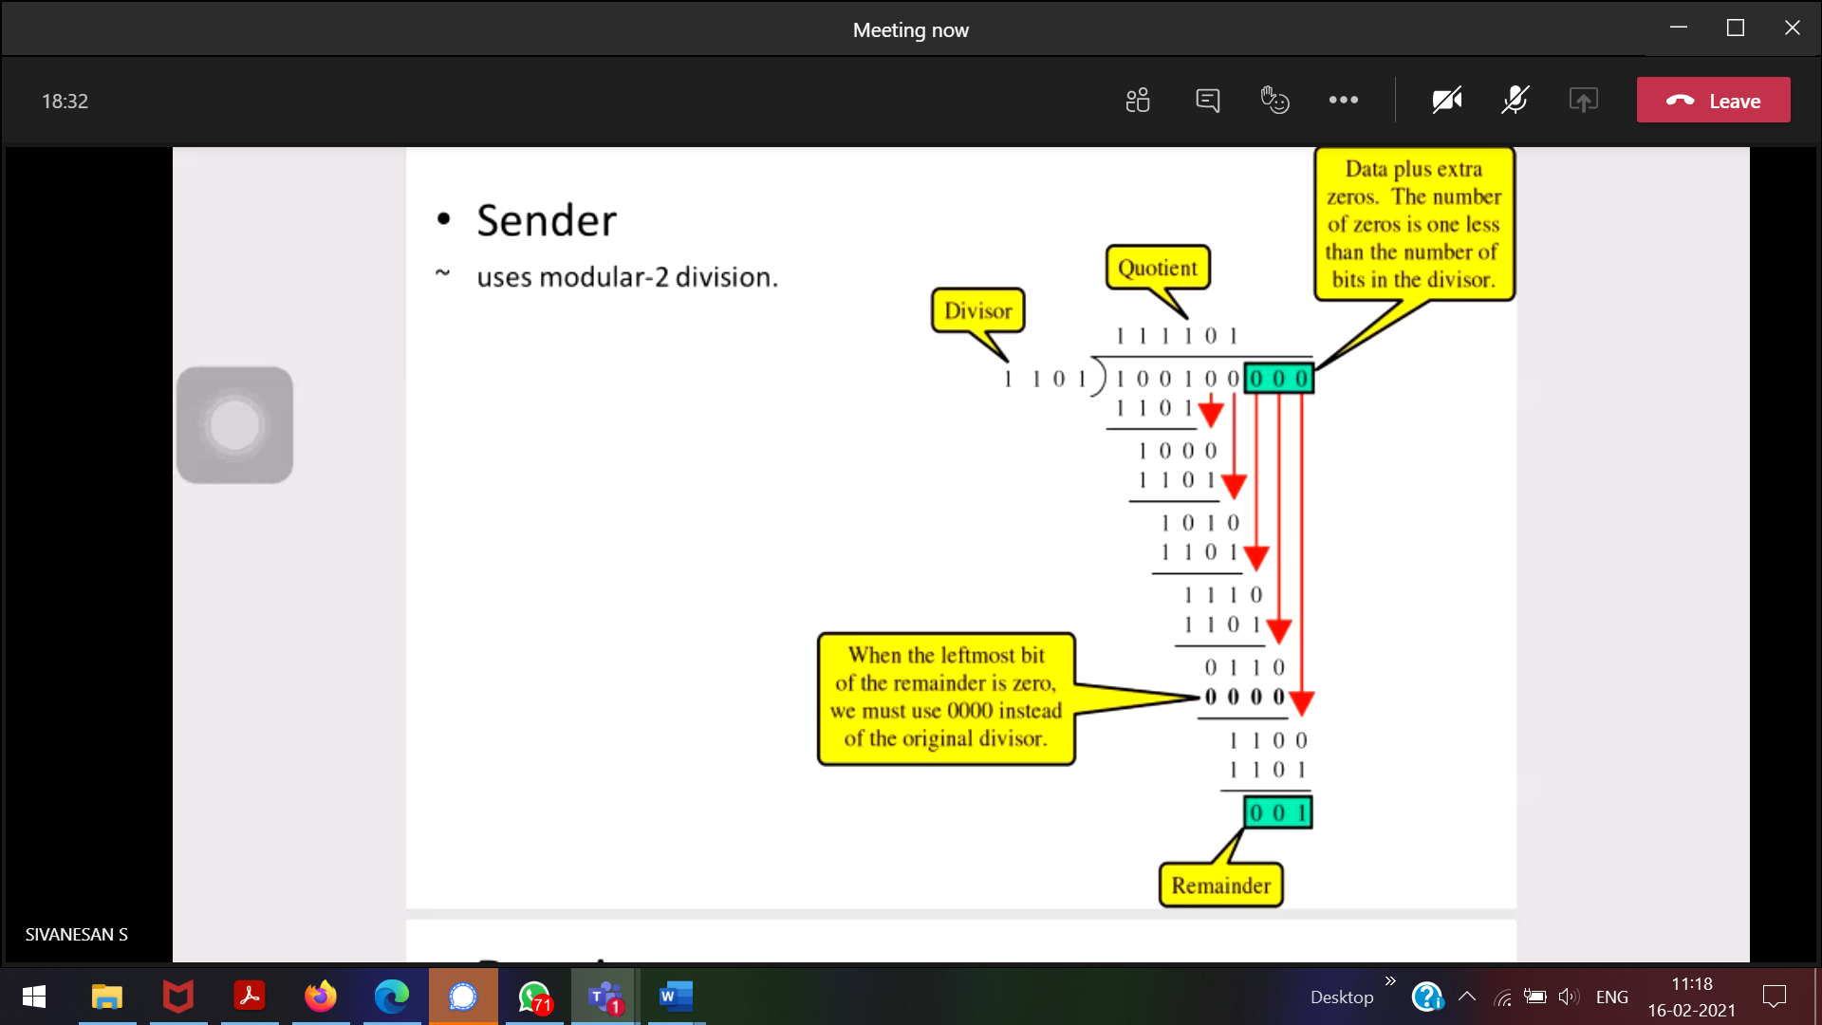

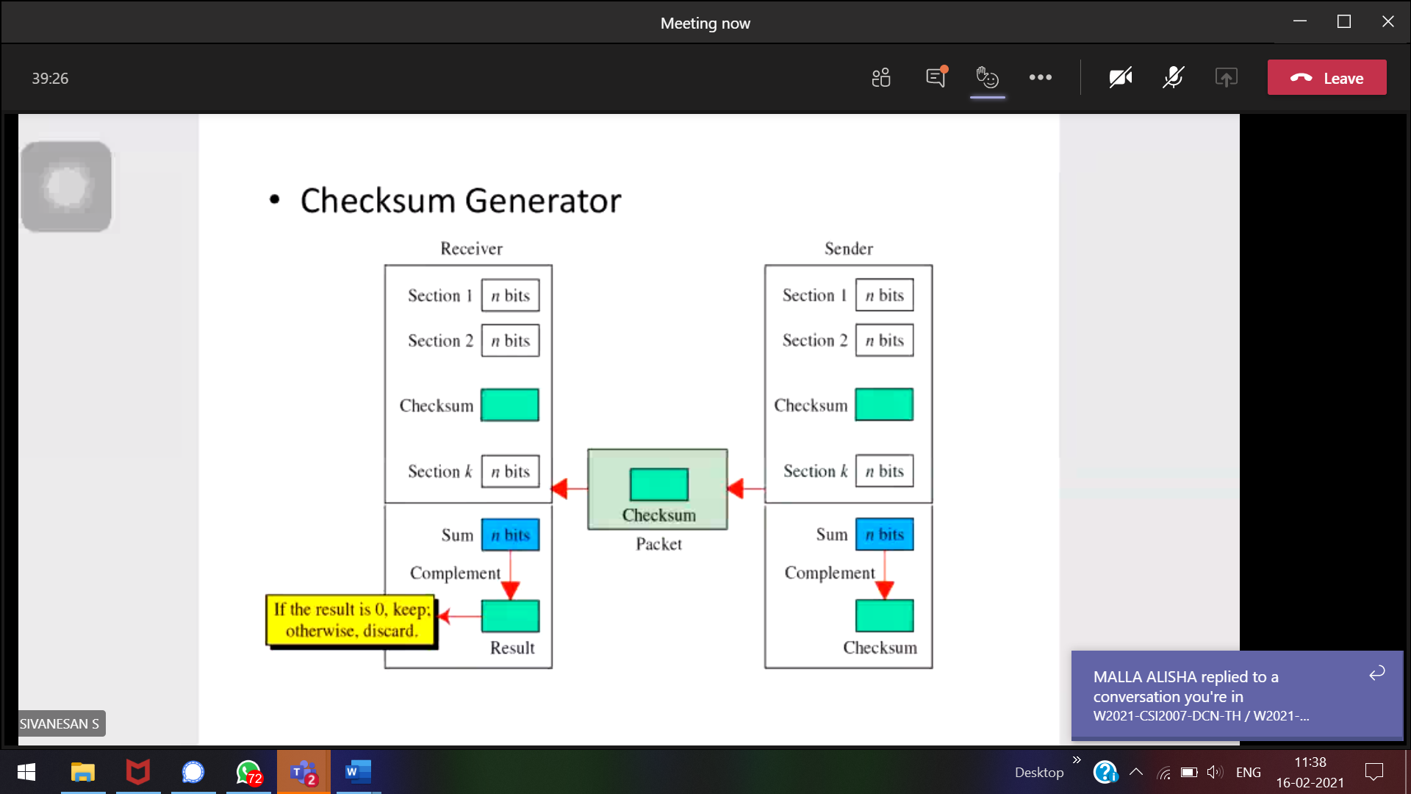

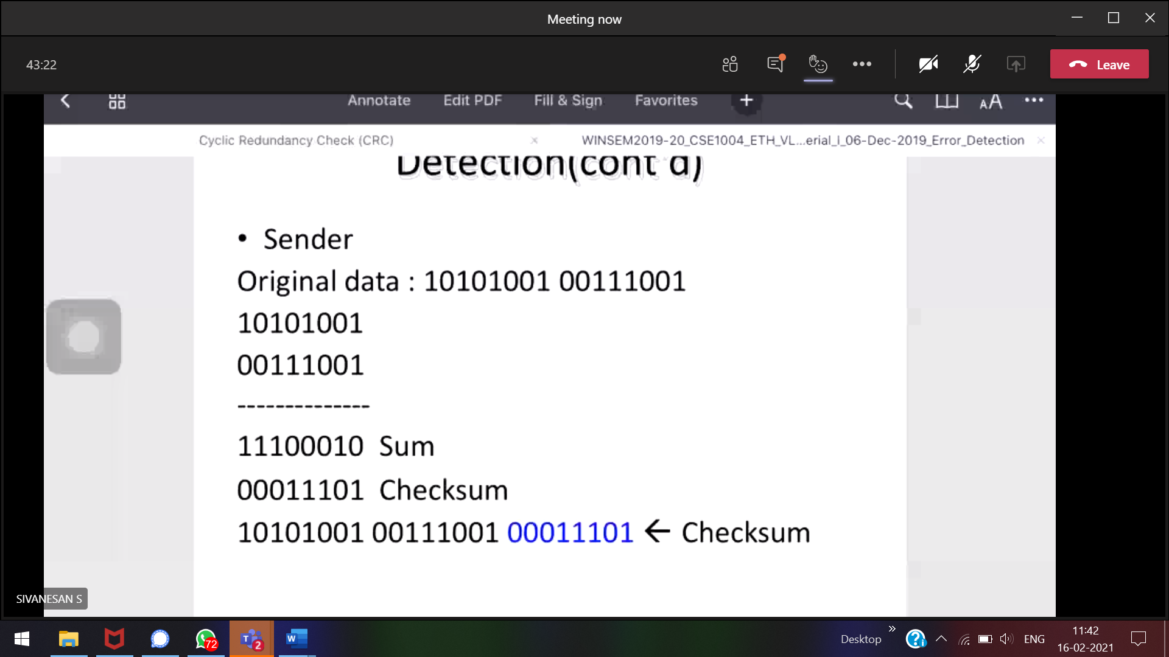

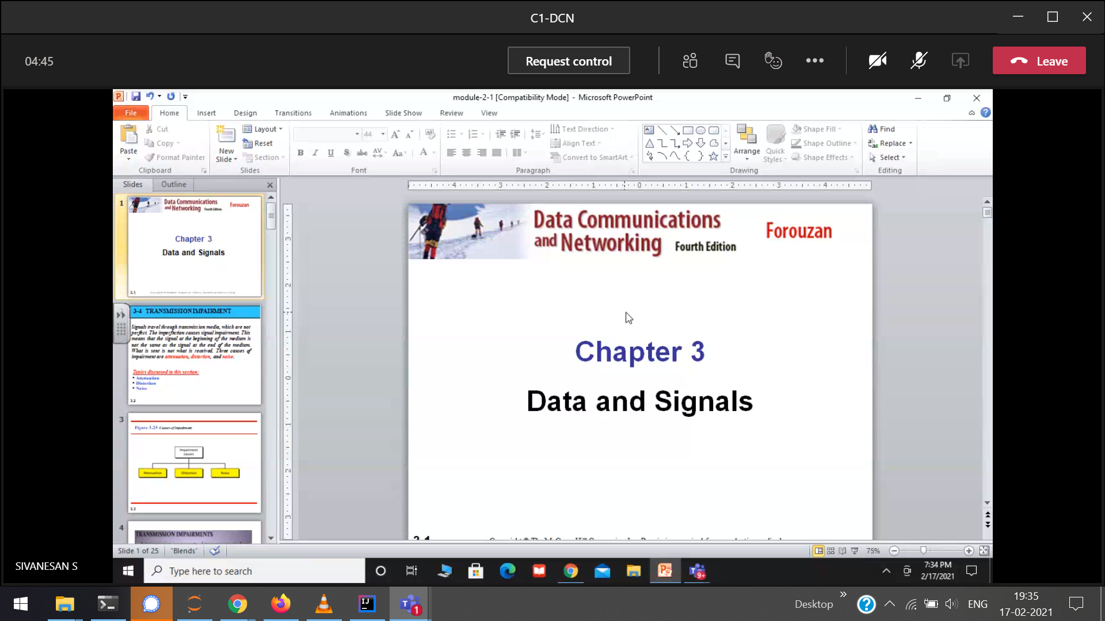  
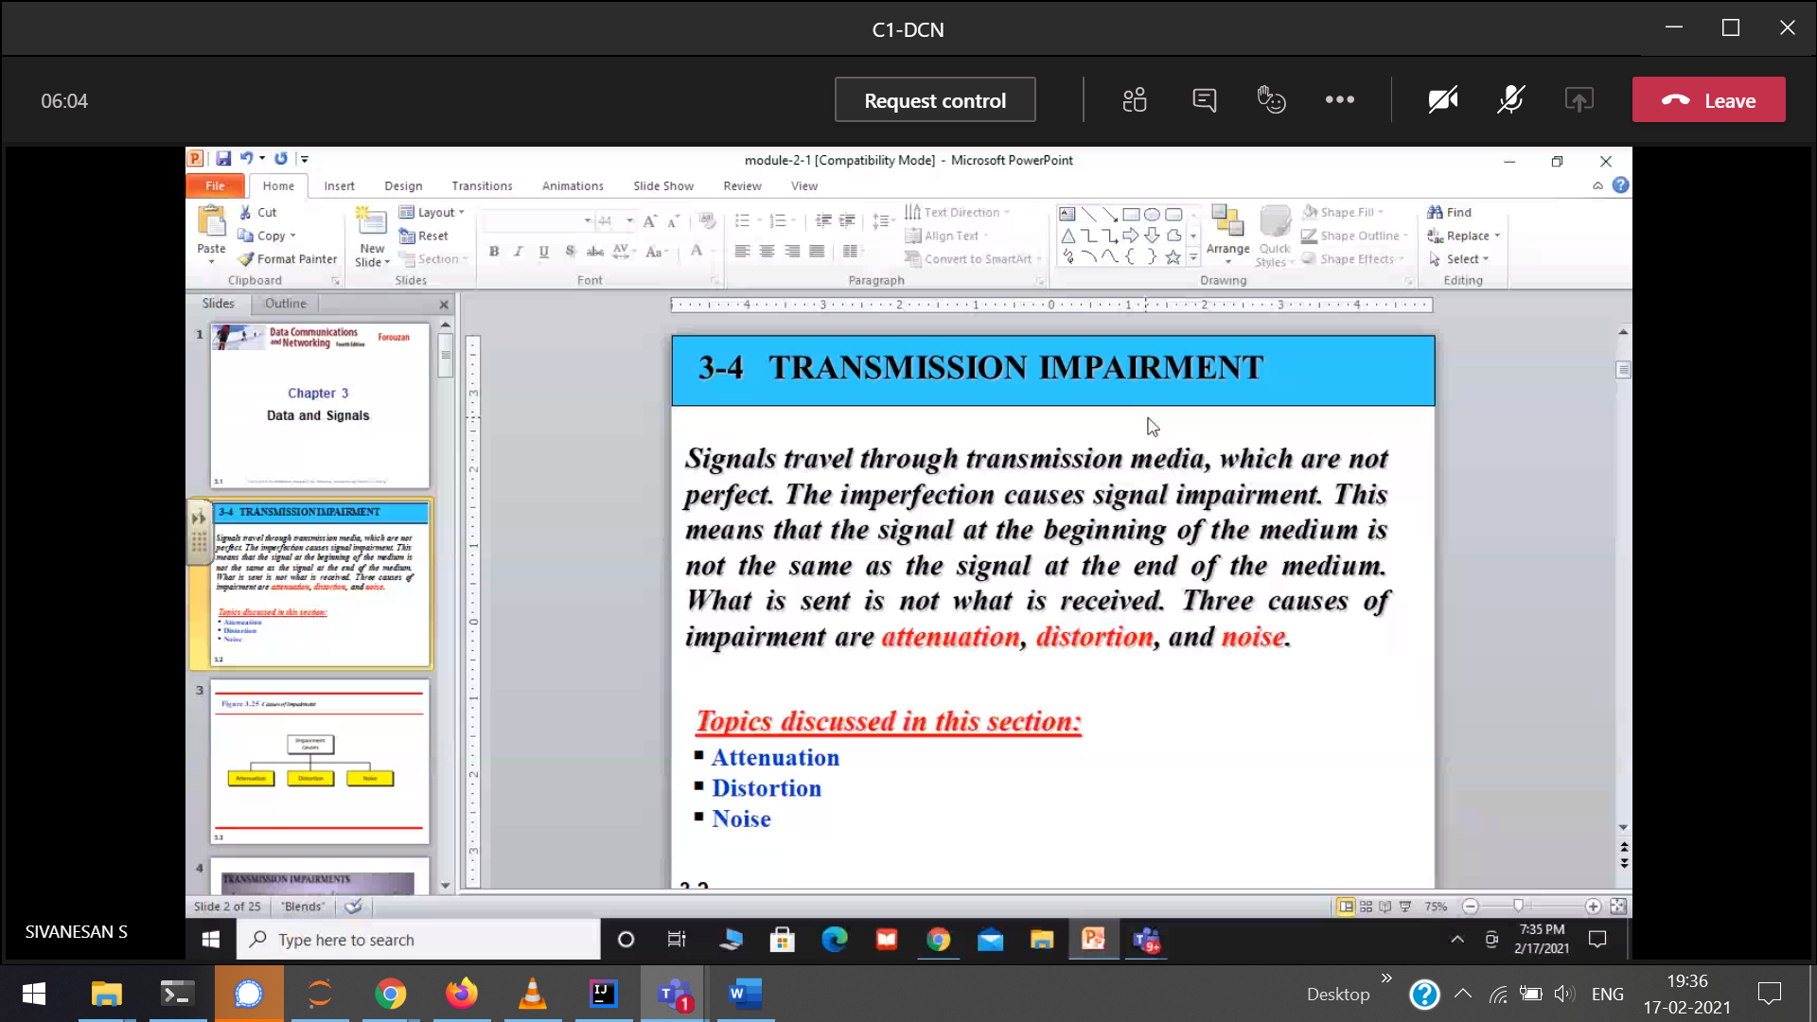

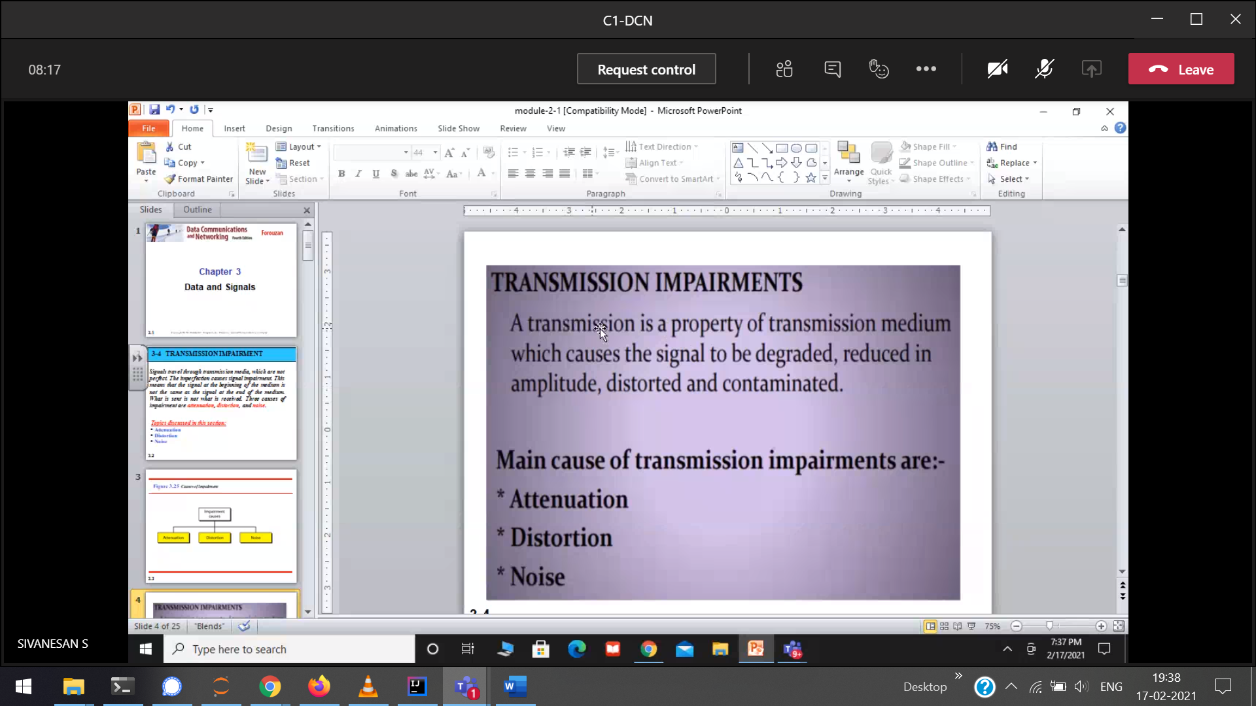  
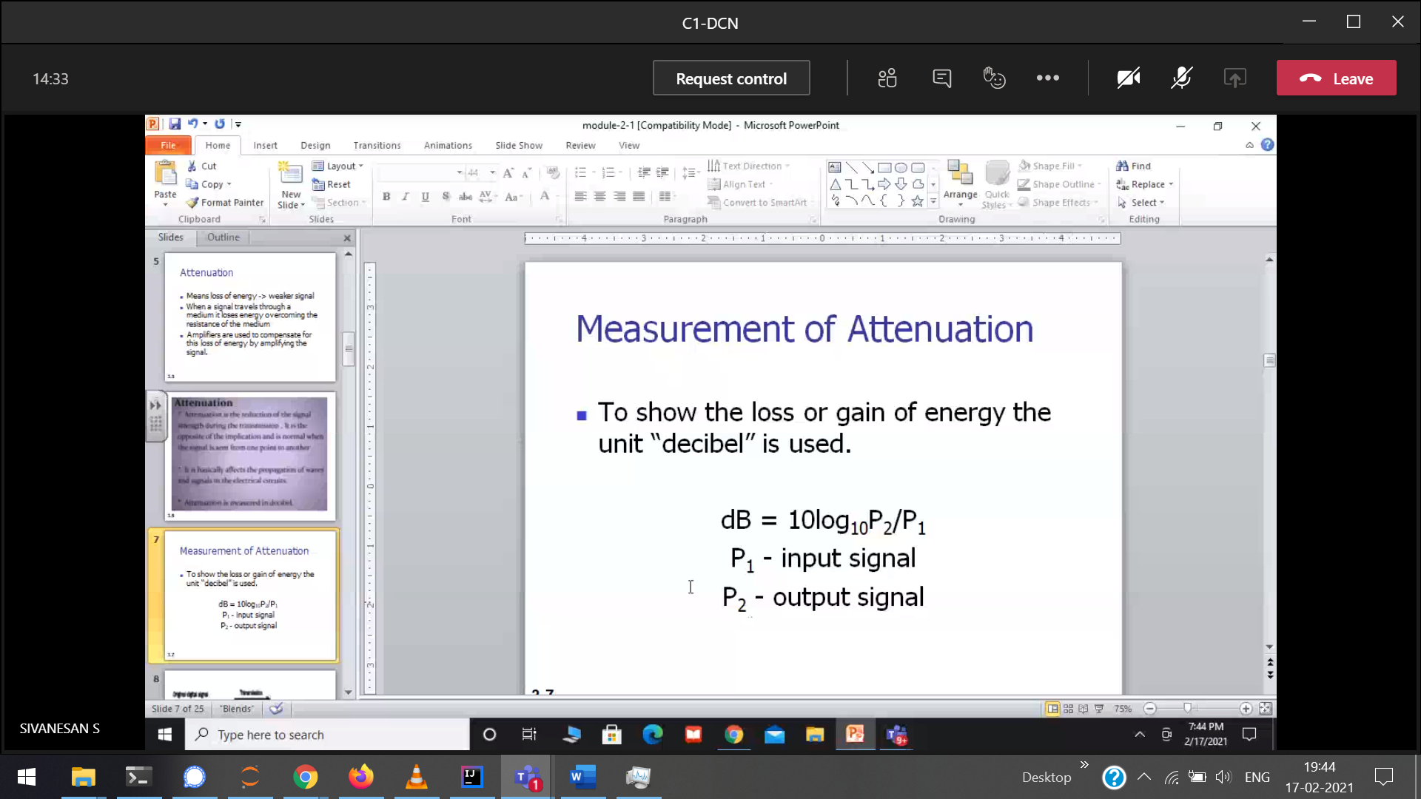  
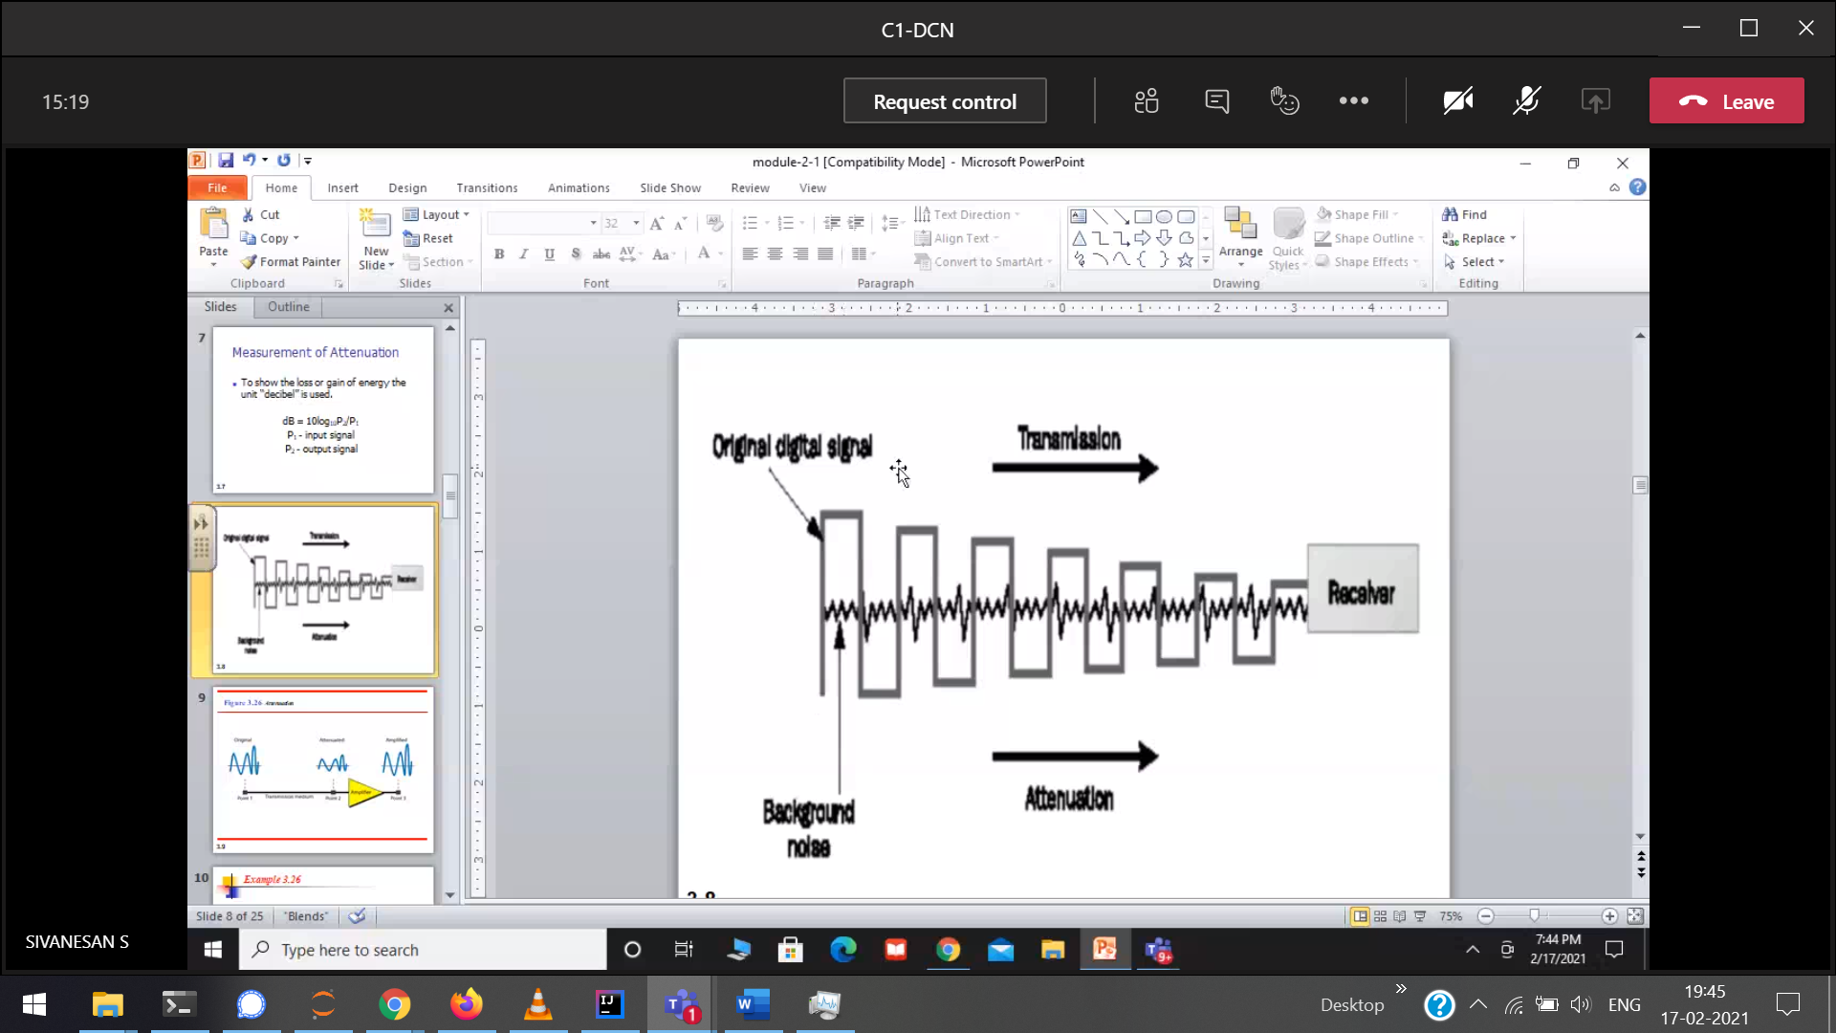  
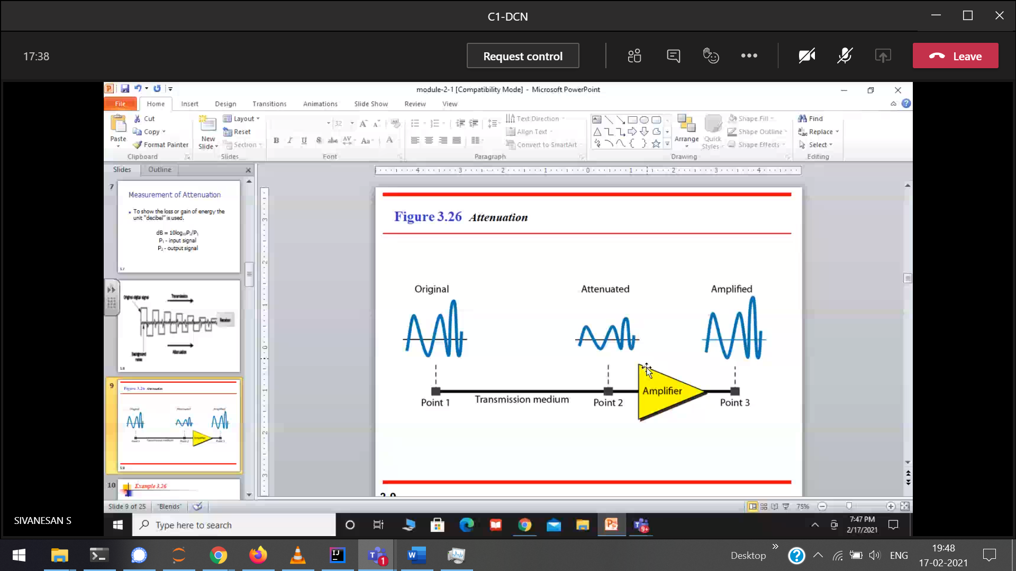  
point 1 🡪 repeater, Original and amplified 🡪 same.

Amplifier 🡪 1) eliminate the noise(or the noise will also be amplified)  
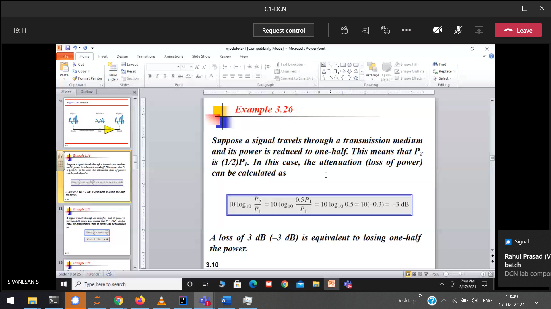  
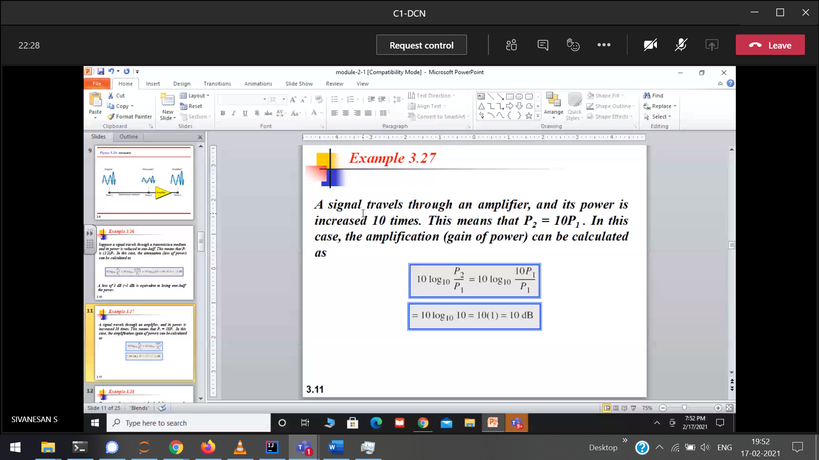

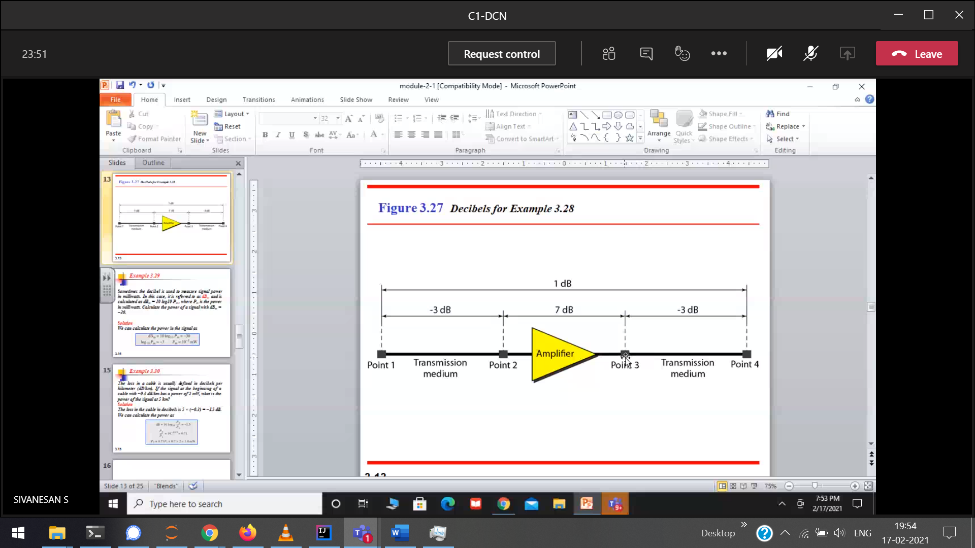  
end-to-end attenuation  
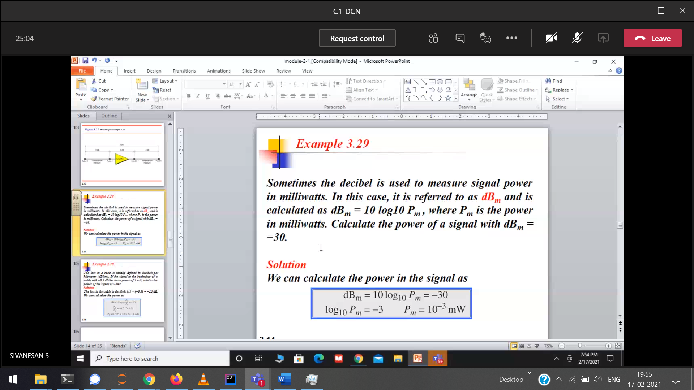

dBm 🡪 dB in milliwats

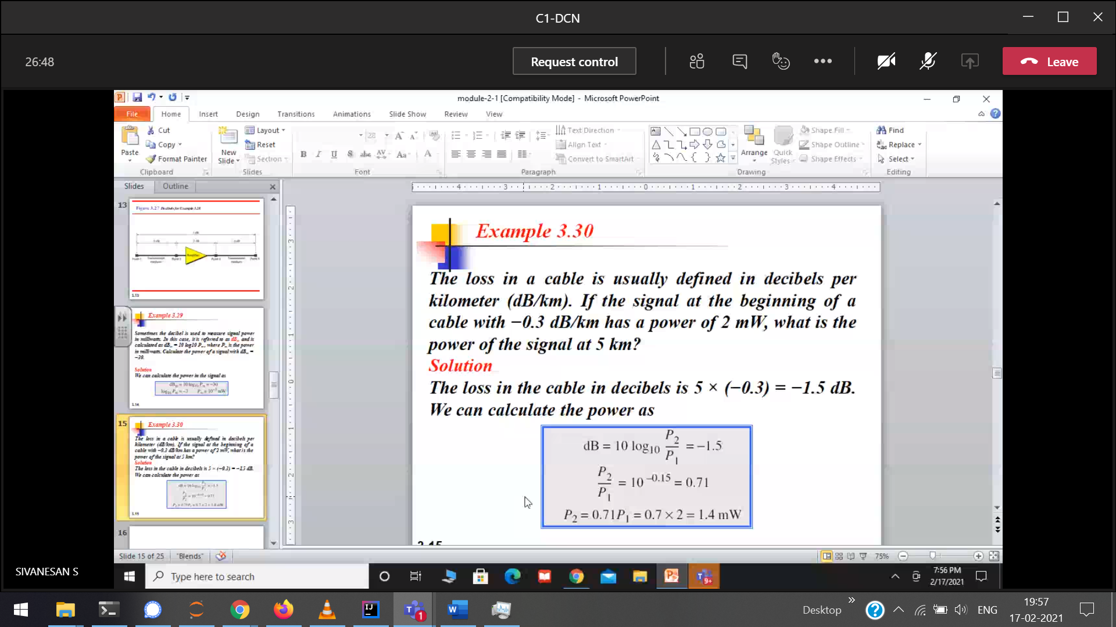  
loss in a cable 🡪 attenuation

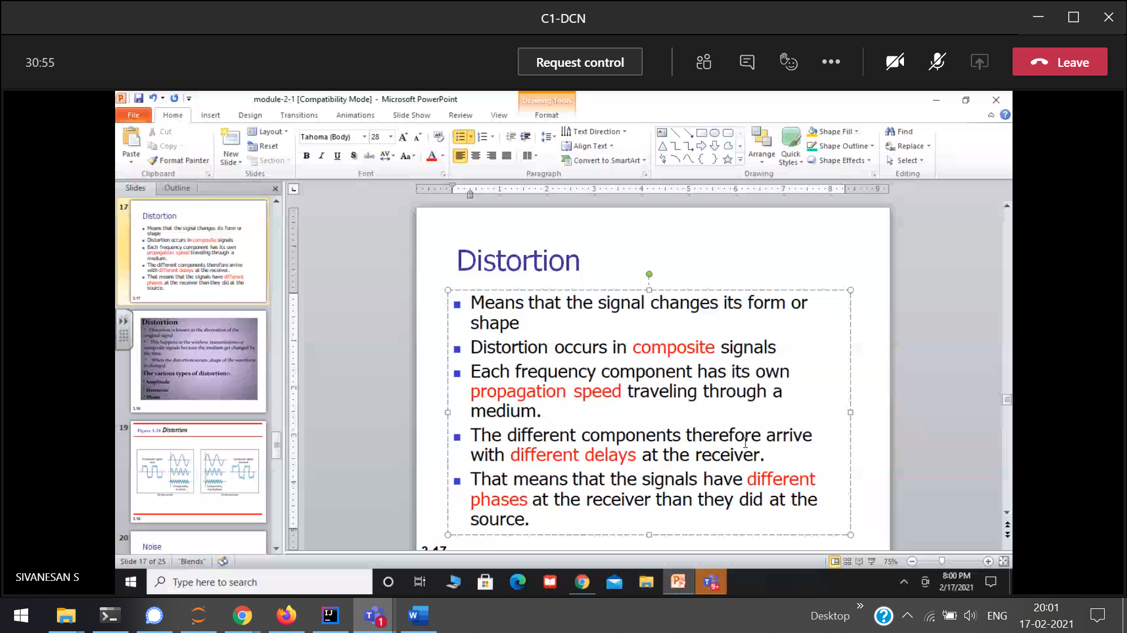

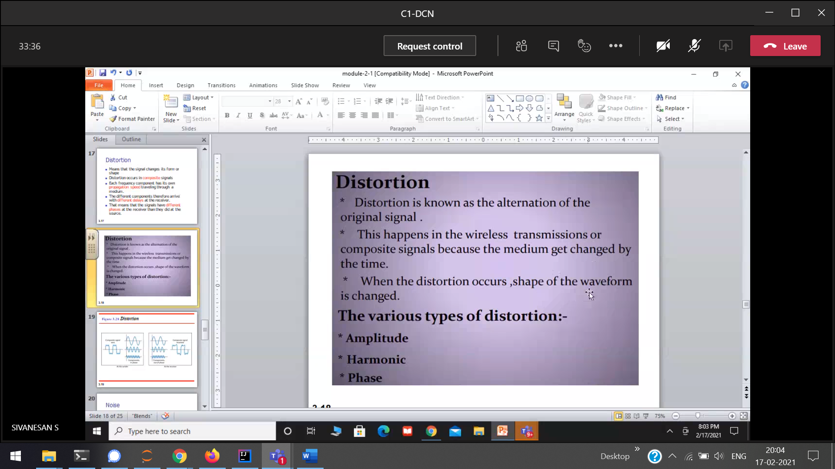  
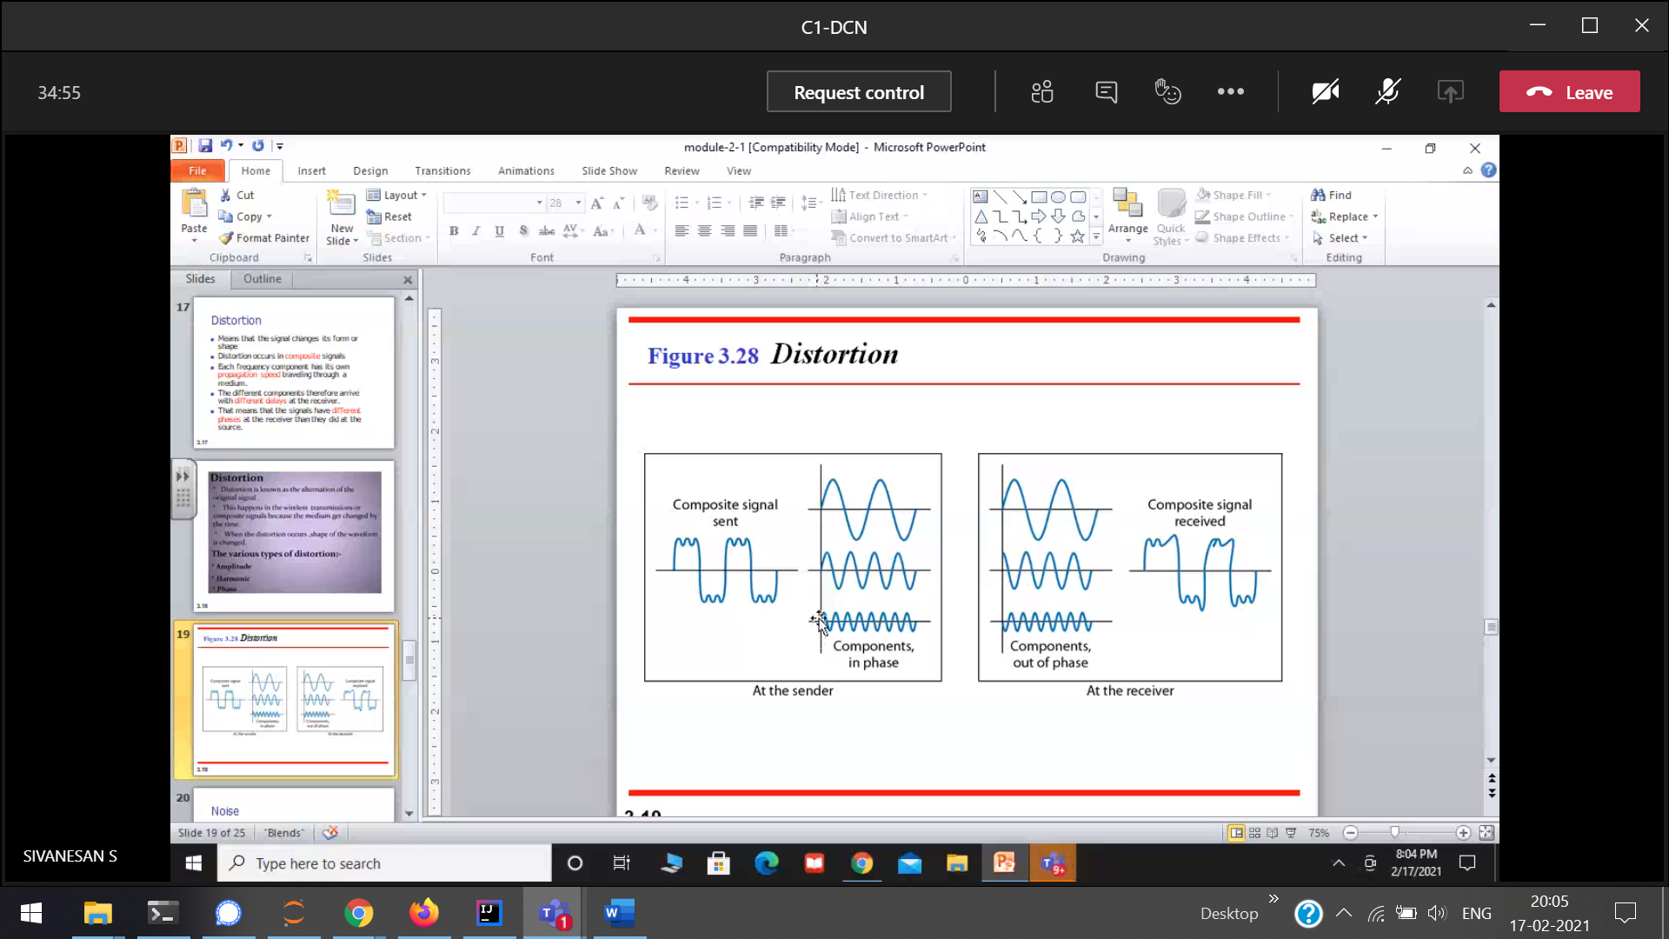  
All threre are starting from the origin



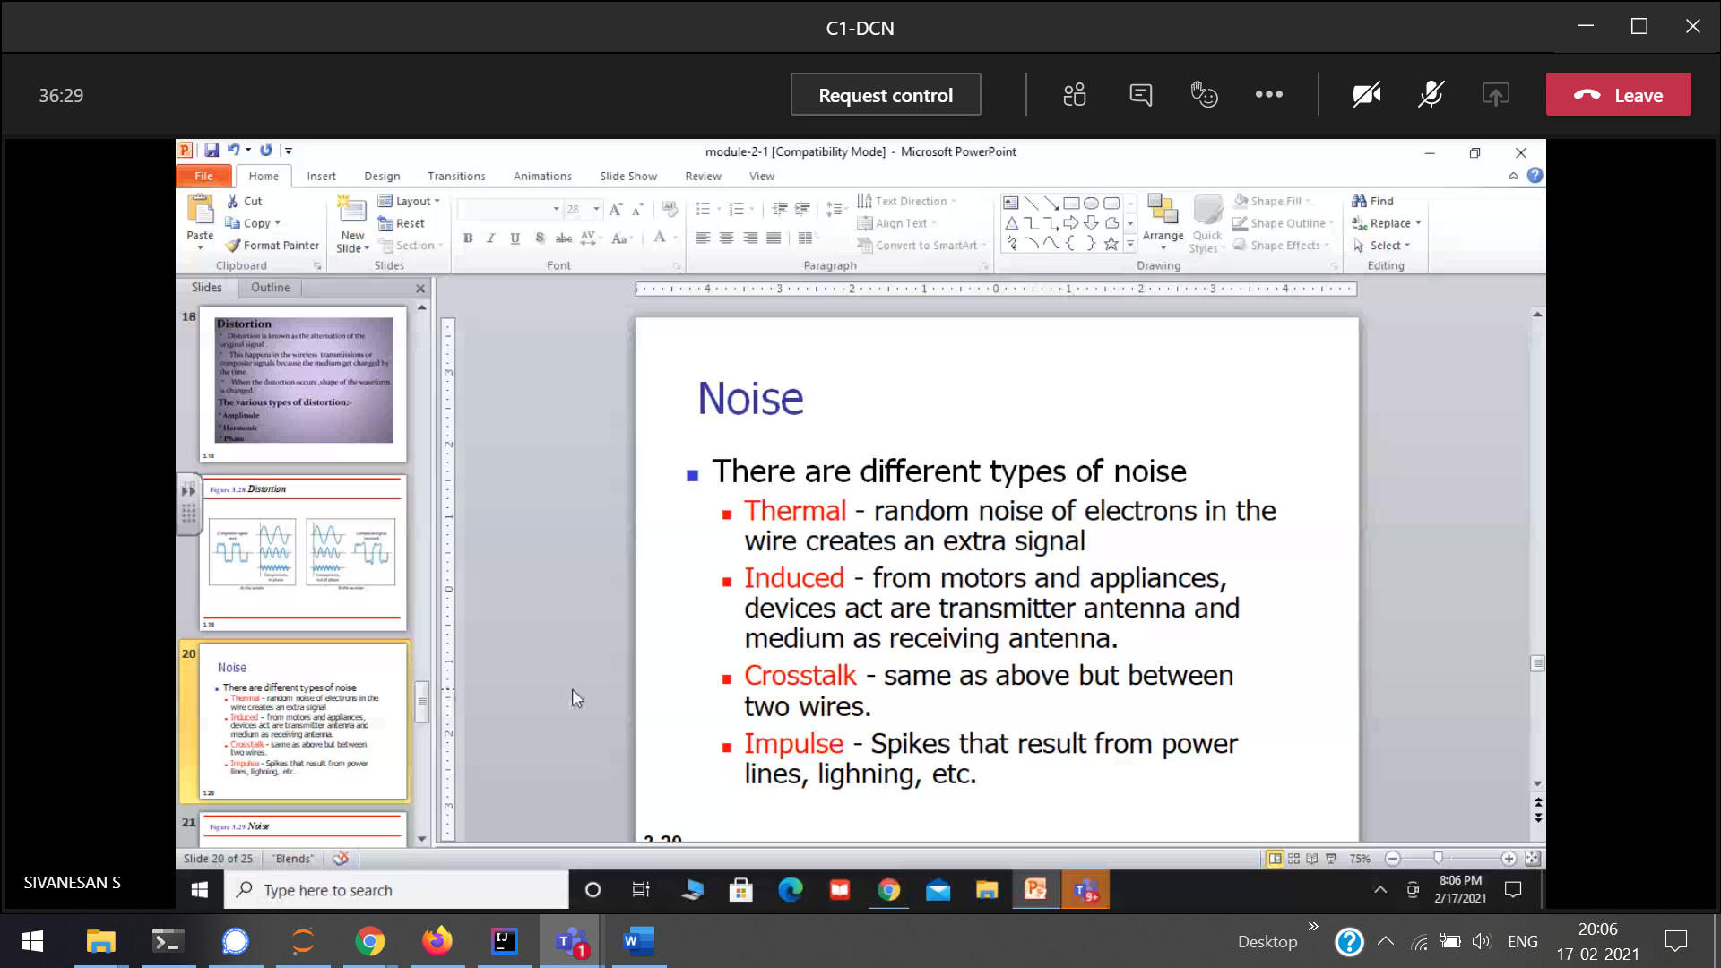  
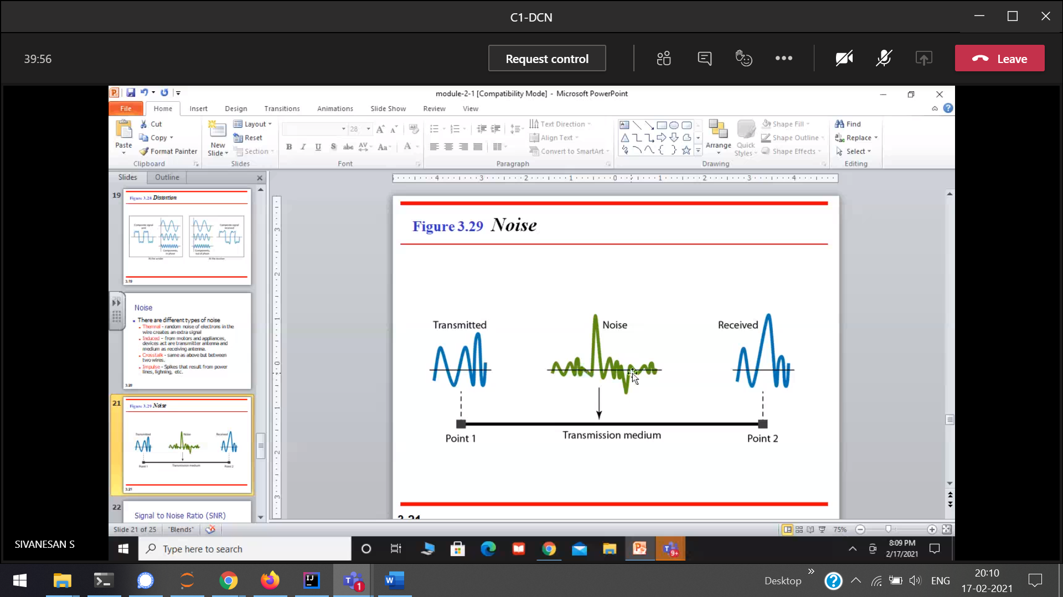  
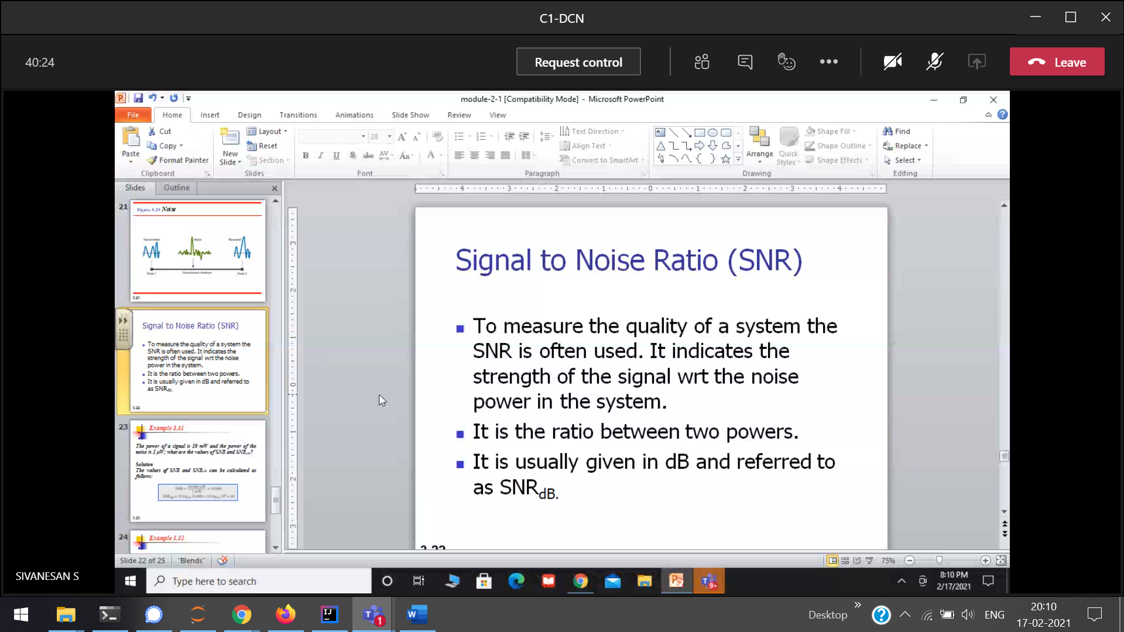  
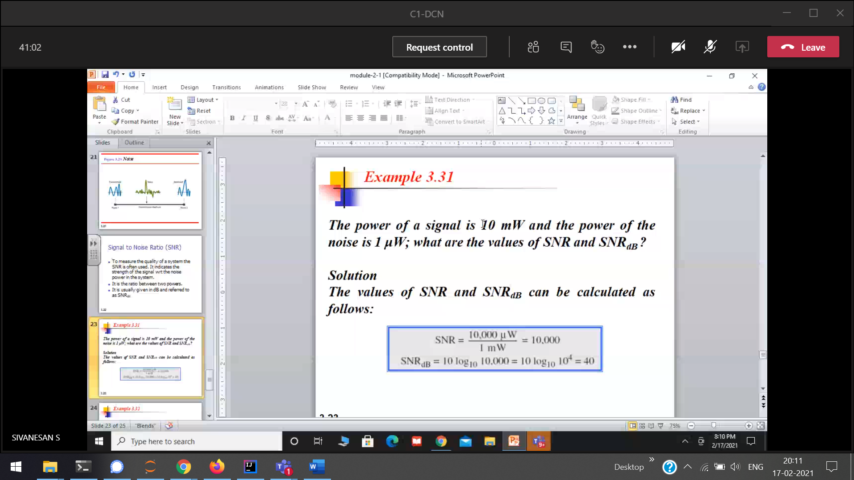  
SNR = noise power / signal power

19/2/2021

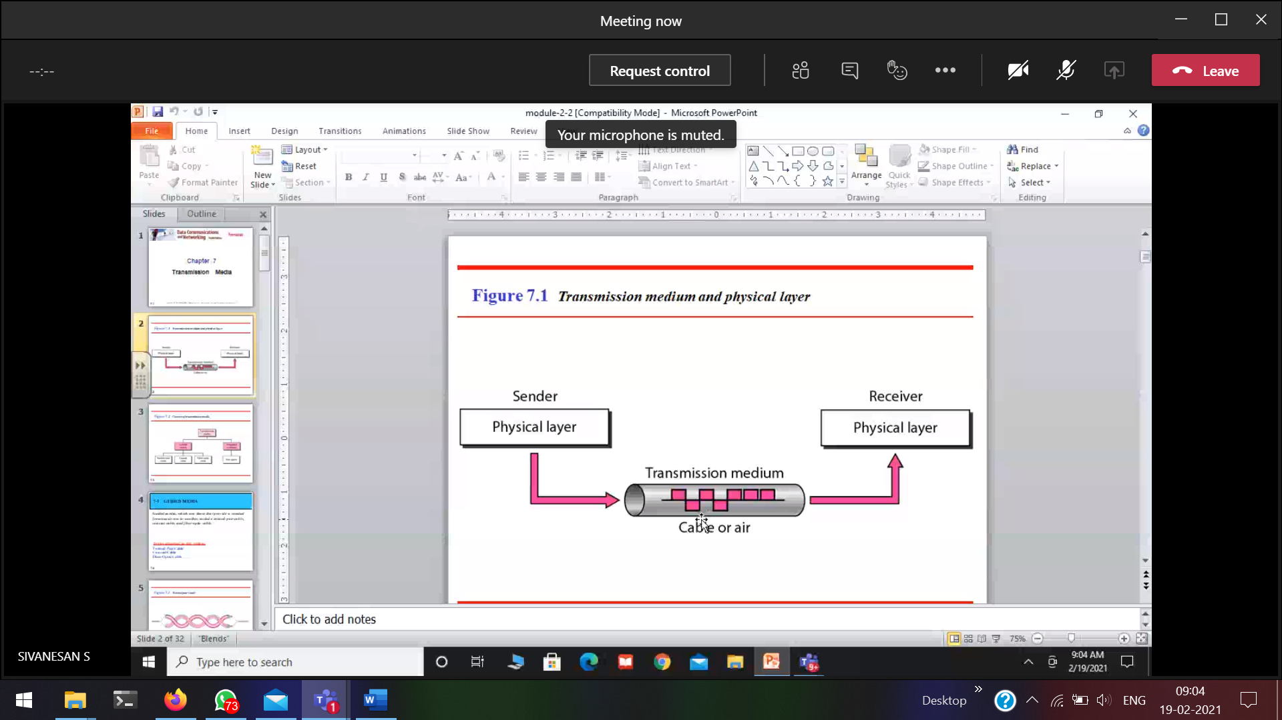  
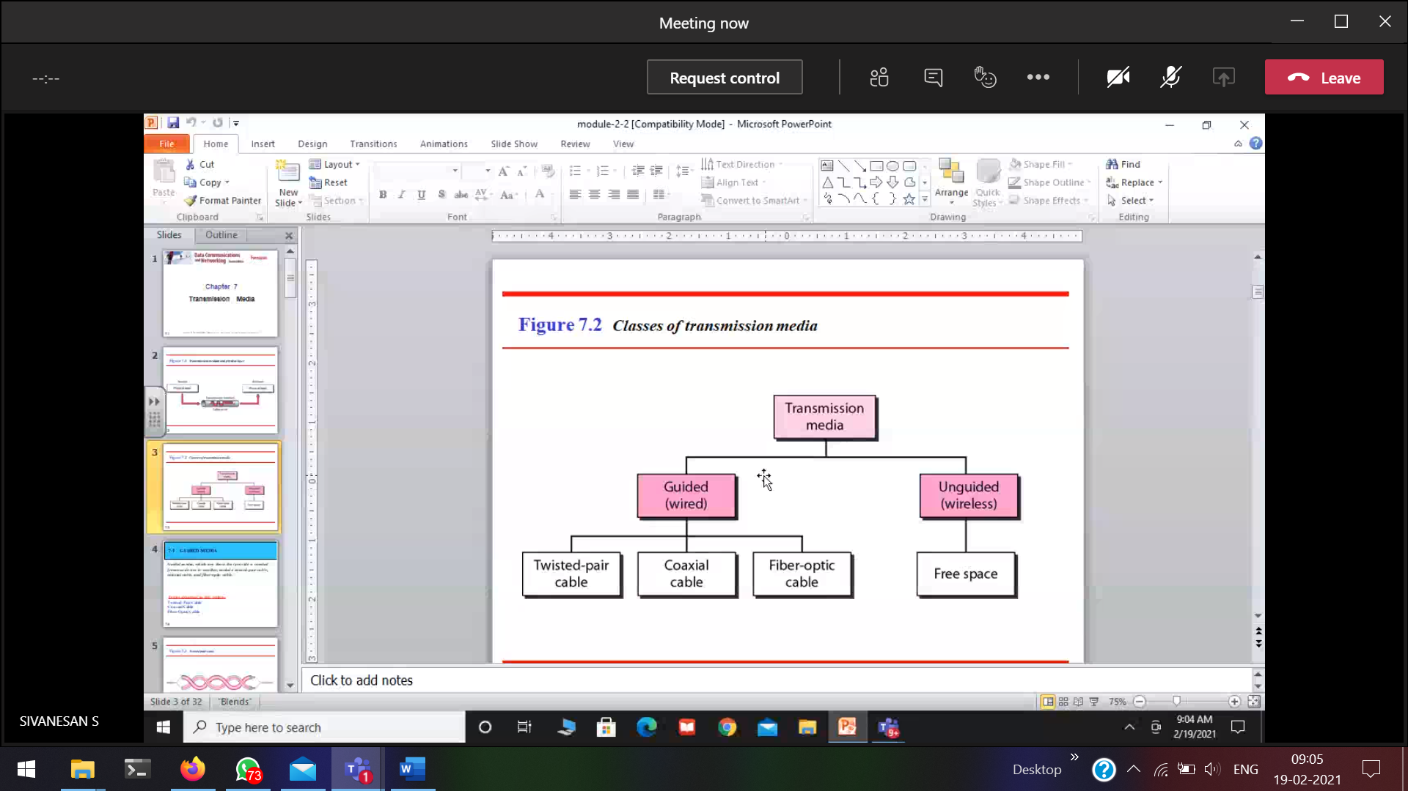  
Guided(wire) 🡪 wherever cable, the signal will be going.  
Unguided(wire-less)

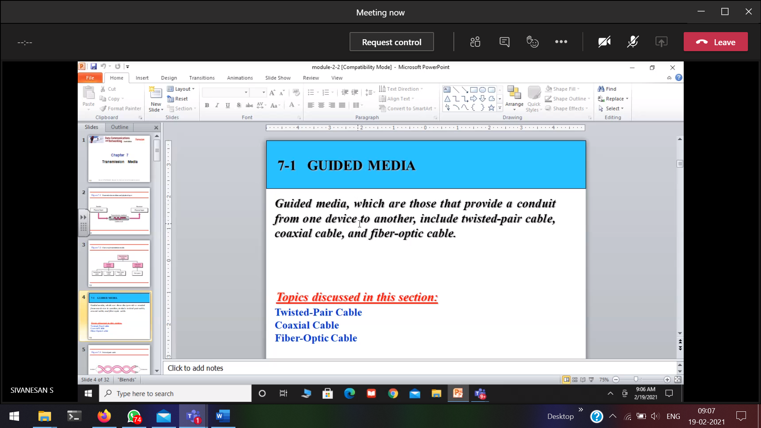

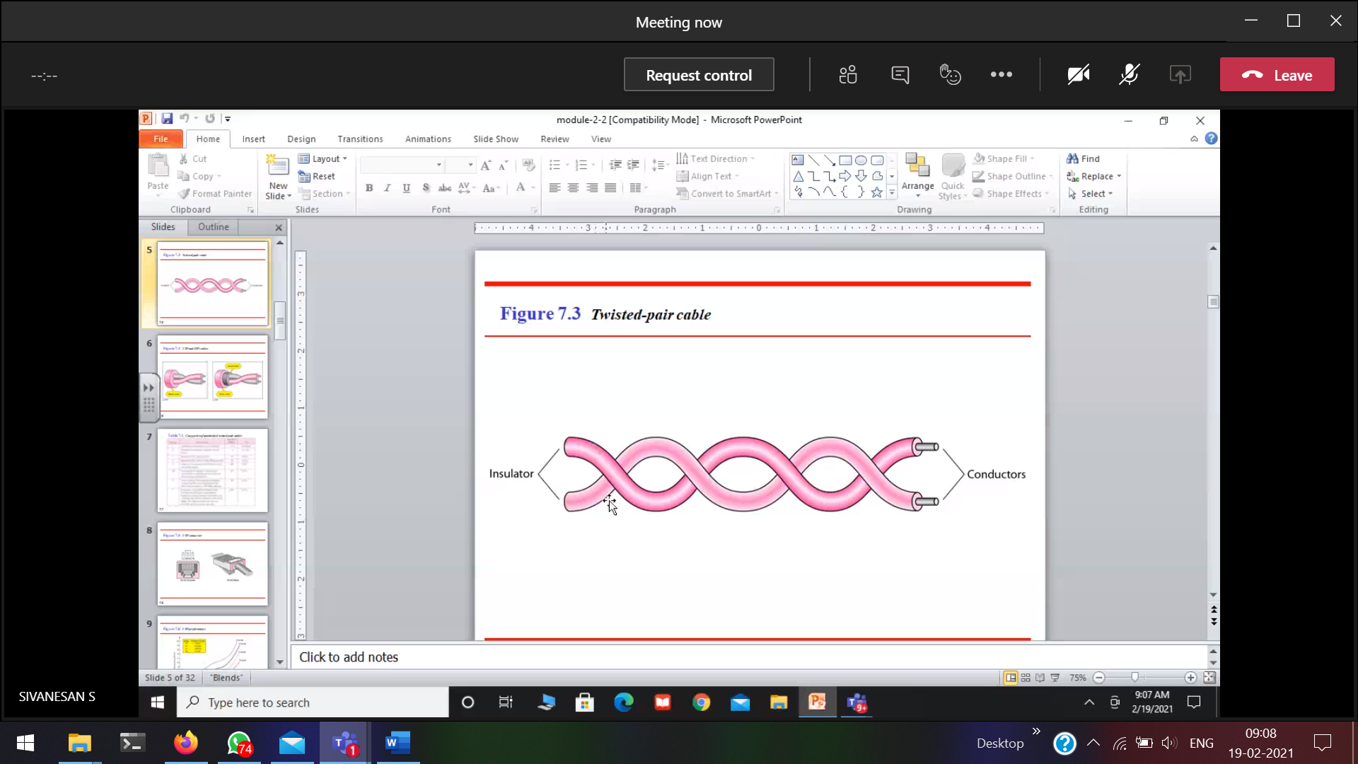

Pair 🡪 two cables

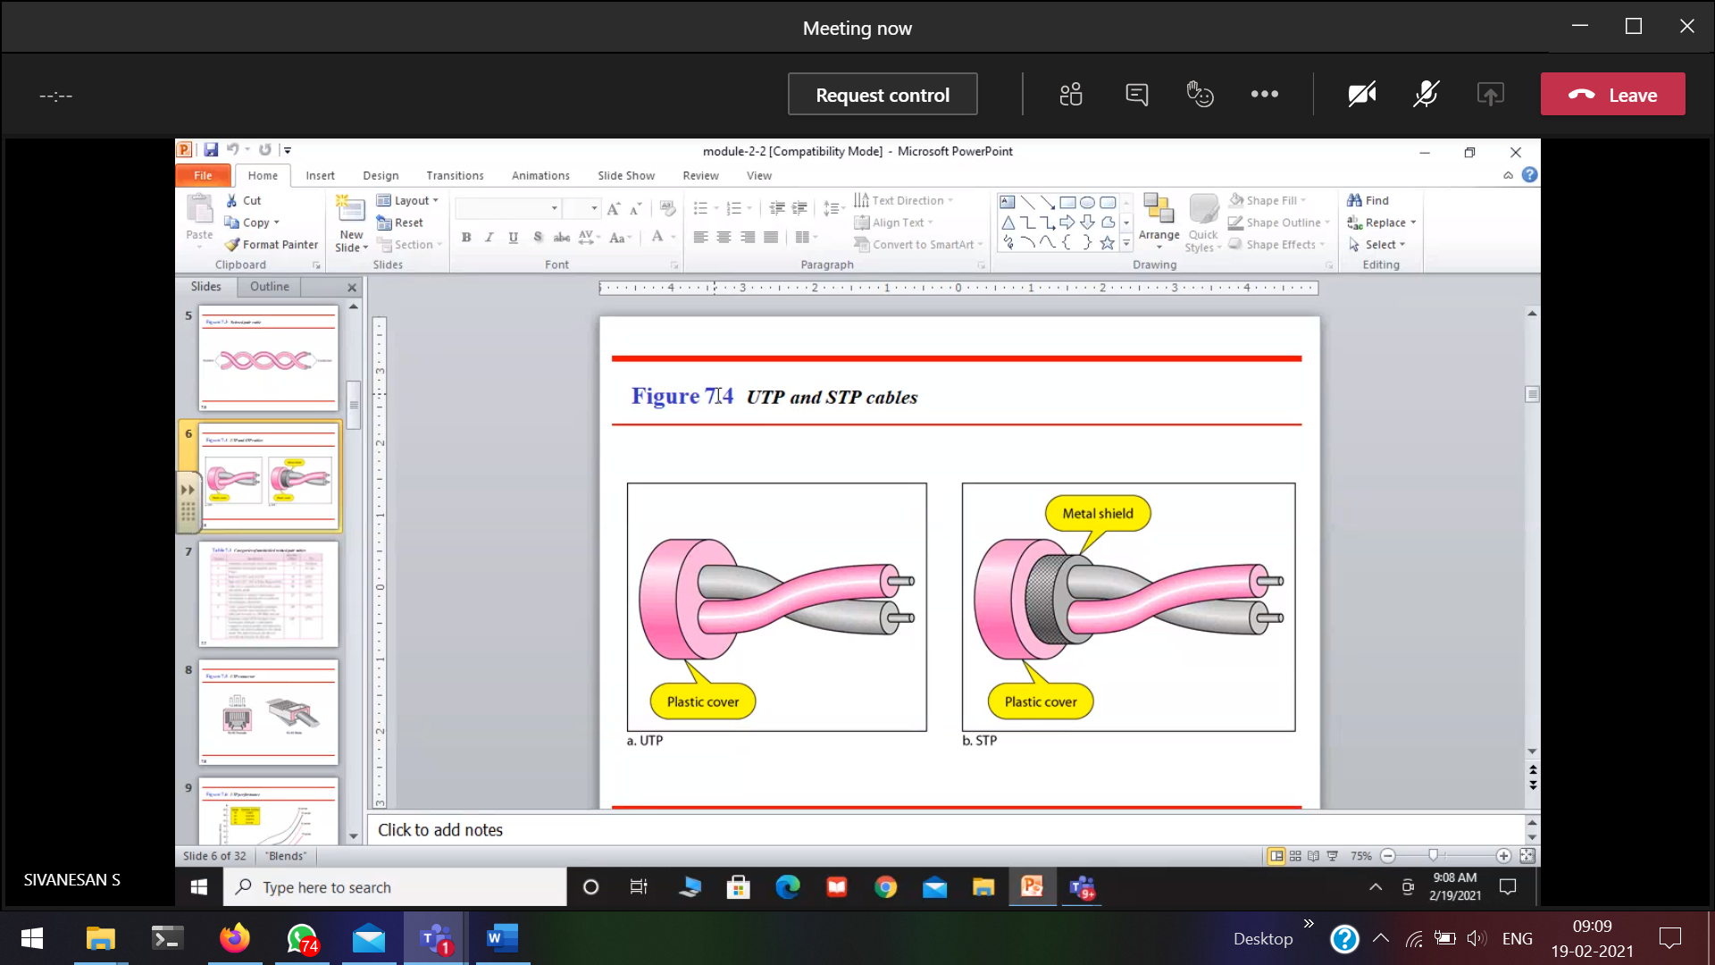

UTP 🡪 Un-shield Twisted Pair cable (not so complex)  
STP 🡪 Shield Twisted Pair cable (complex)

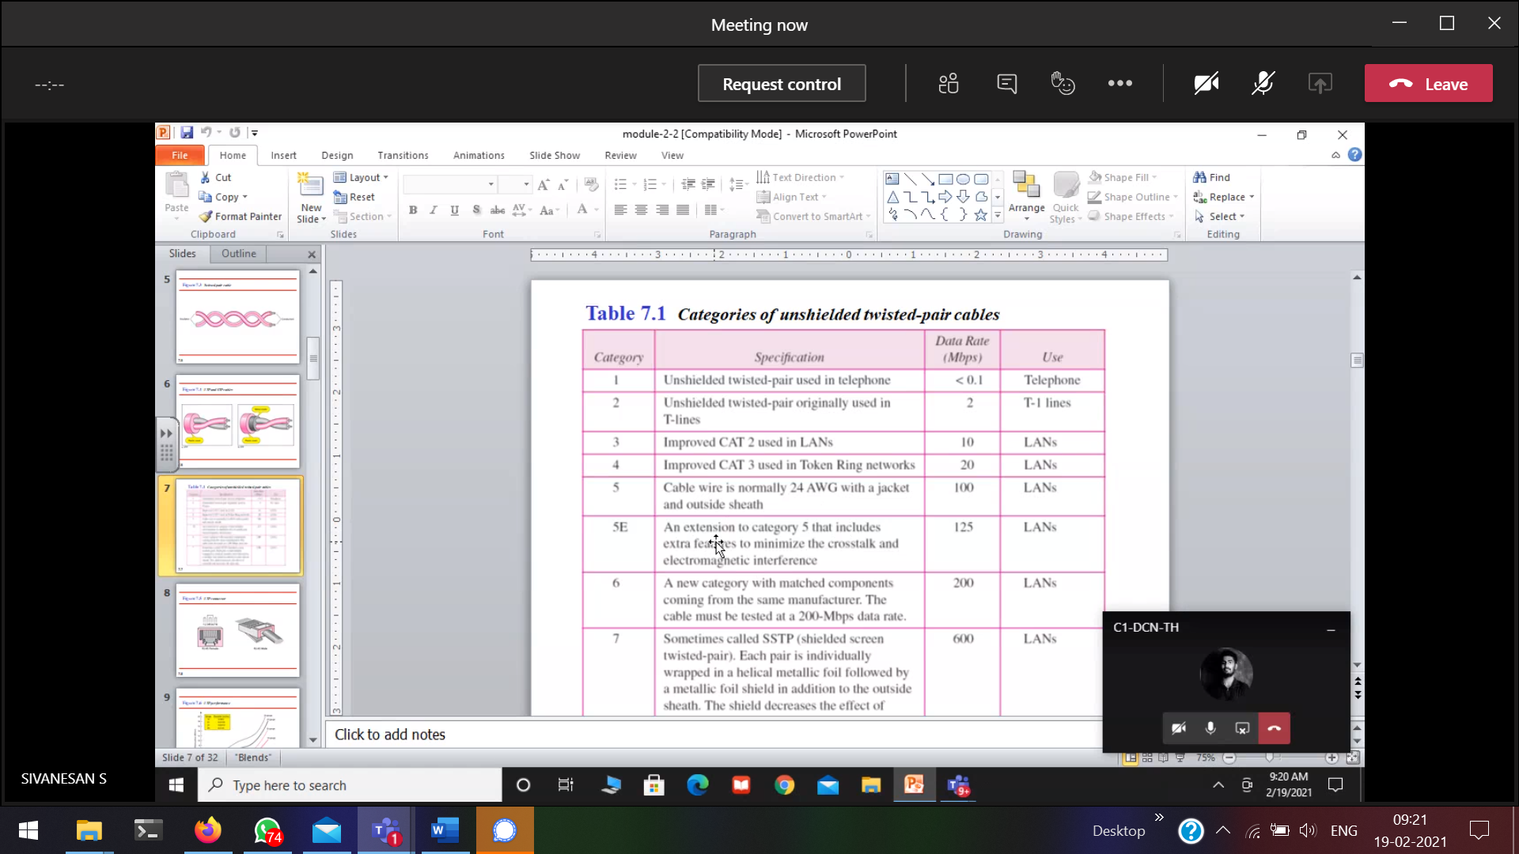

Voice grade 🡪 Only voice (telephone cables)  
Data grade 🡪 Only data (cable is more insulated)

If increase more number of twists 🡪 cancellation is more and noise is reduced. Minimises the cross-talk.

7🡪 Each pair is individually wrapped,

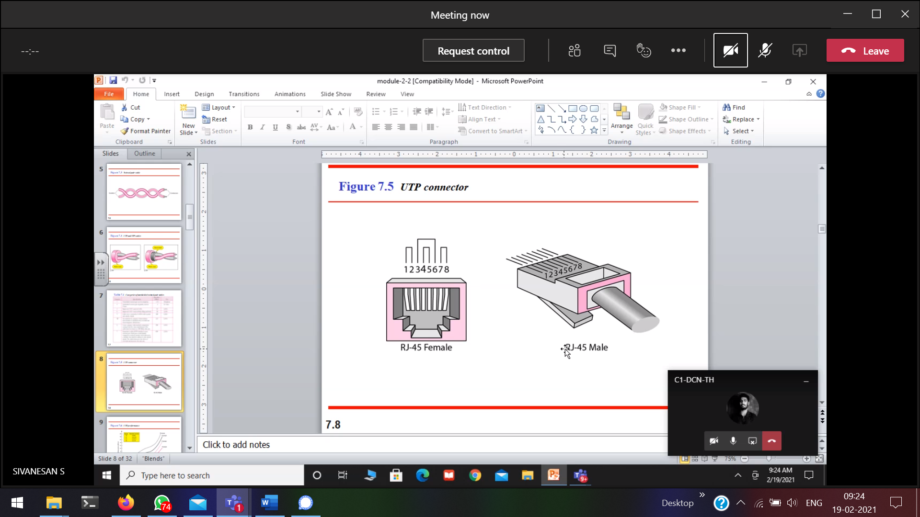  
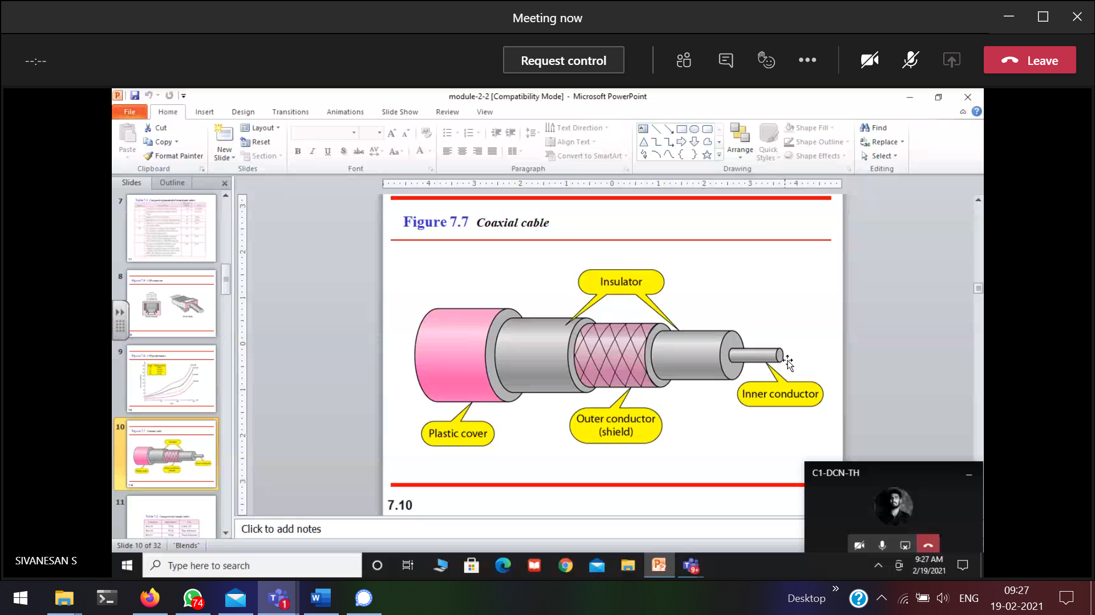  
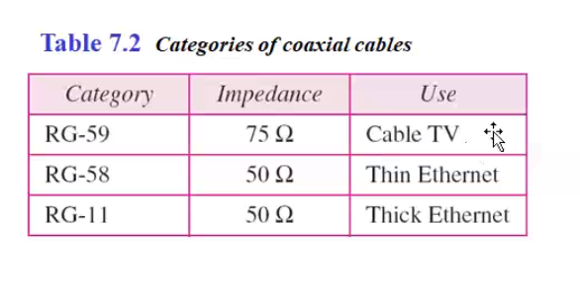  
Based on impedance 🡪 the end signal will be terminated.  
Discussed in topology  
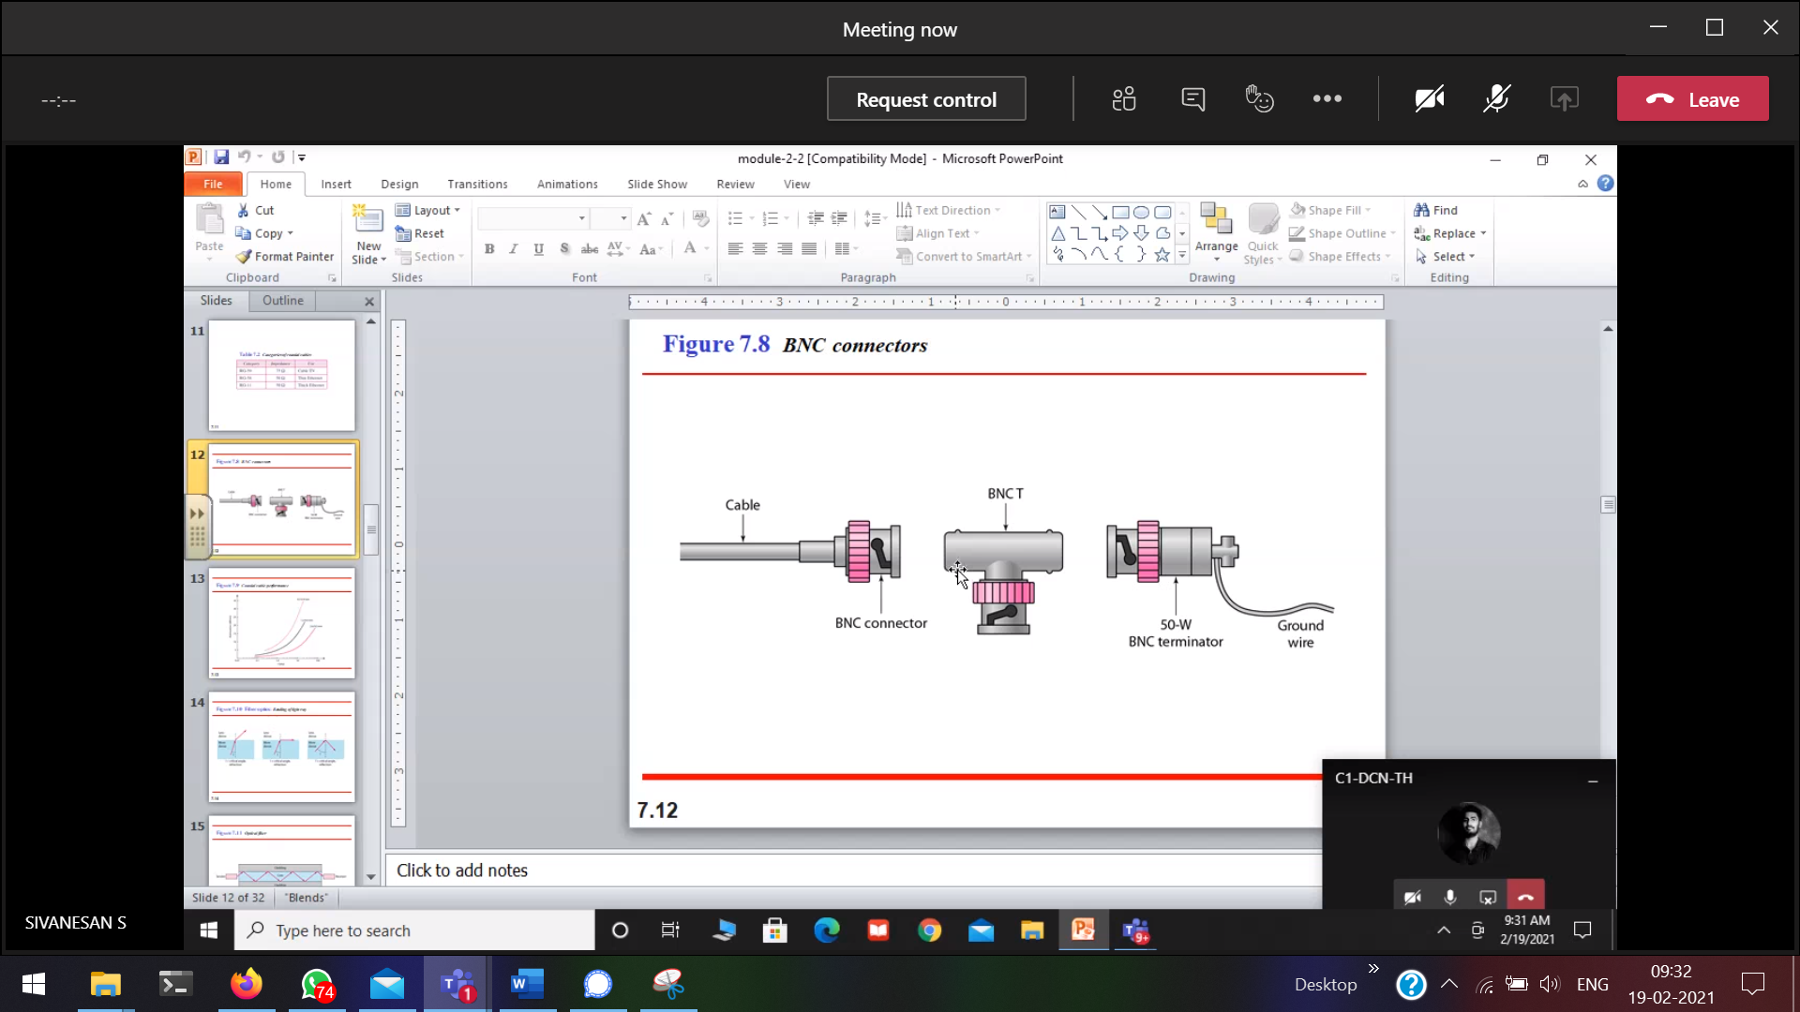  
connected to the NIC card



Before Coaxial cable(electrical signal) Now, Fibre Optics (light rays)

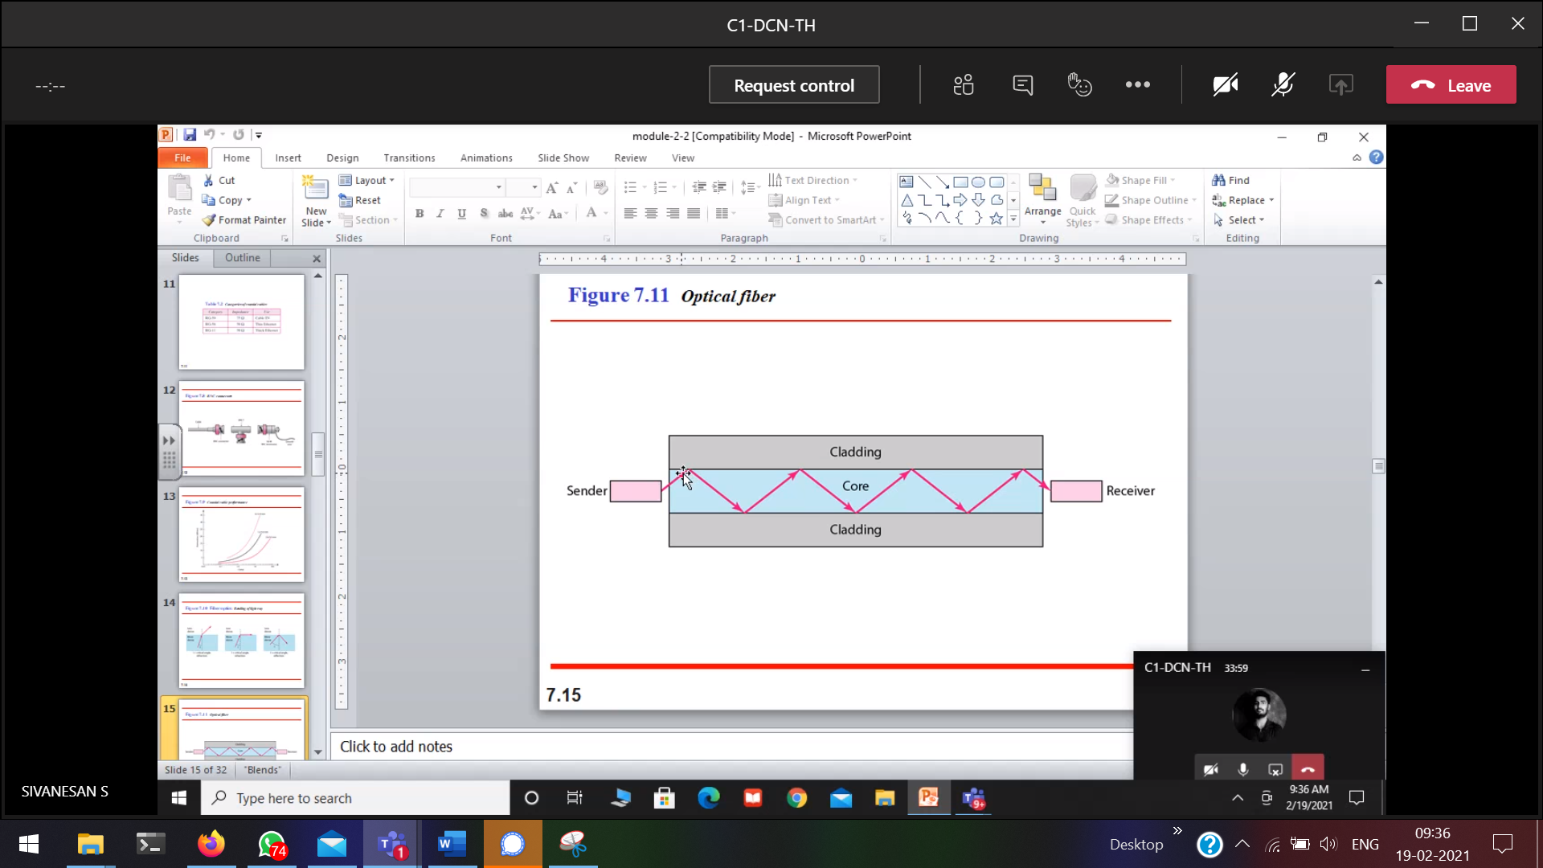

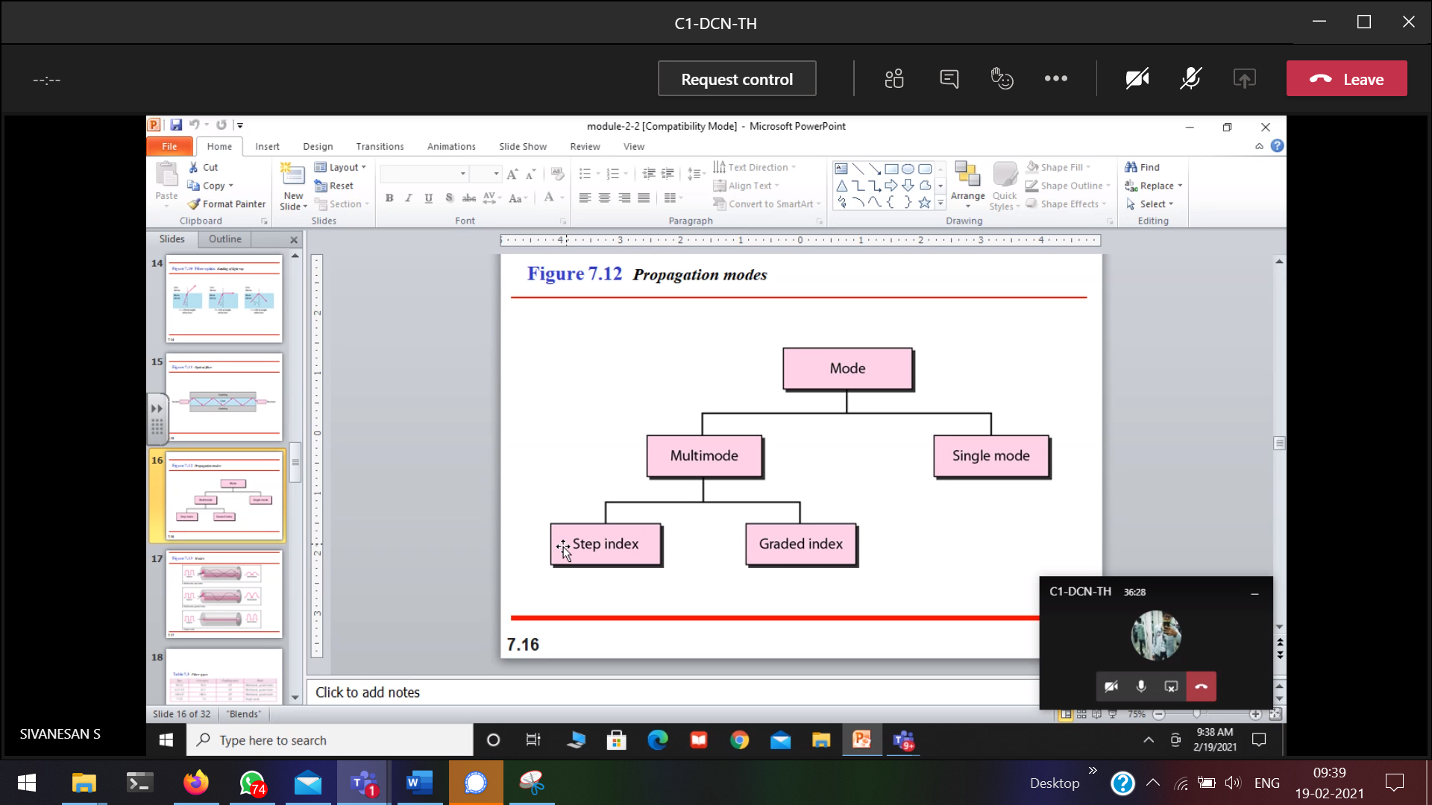  
classified based on the glass material used.

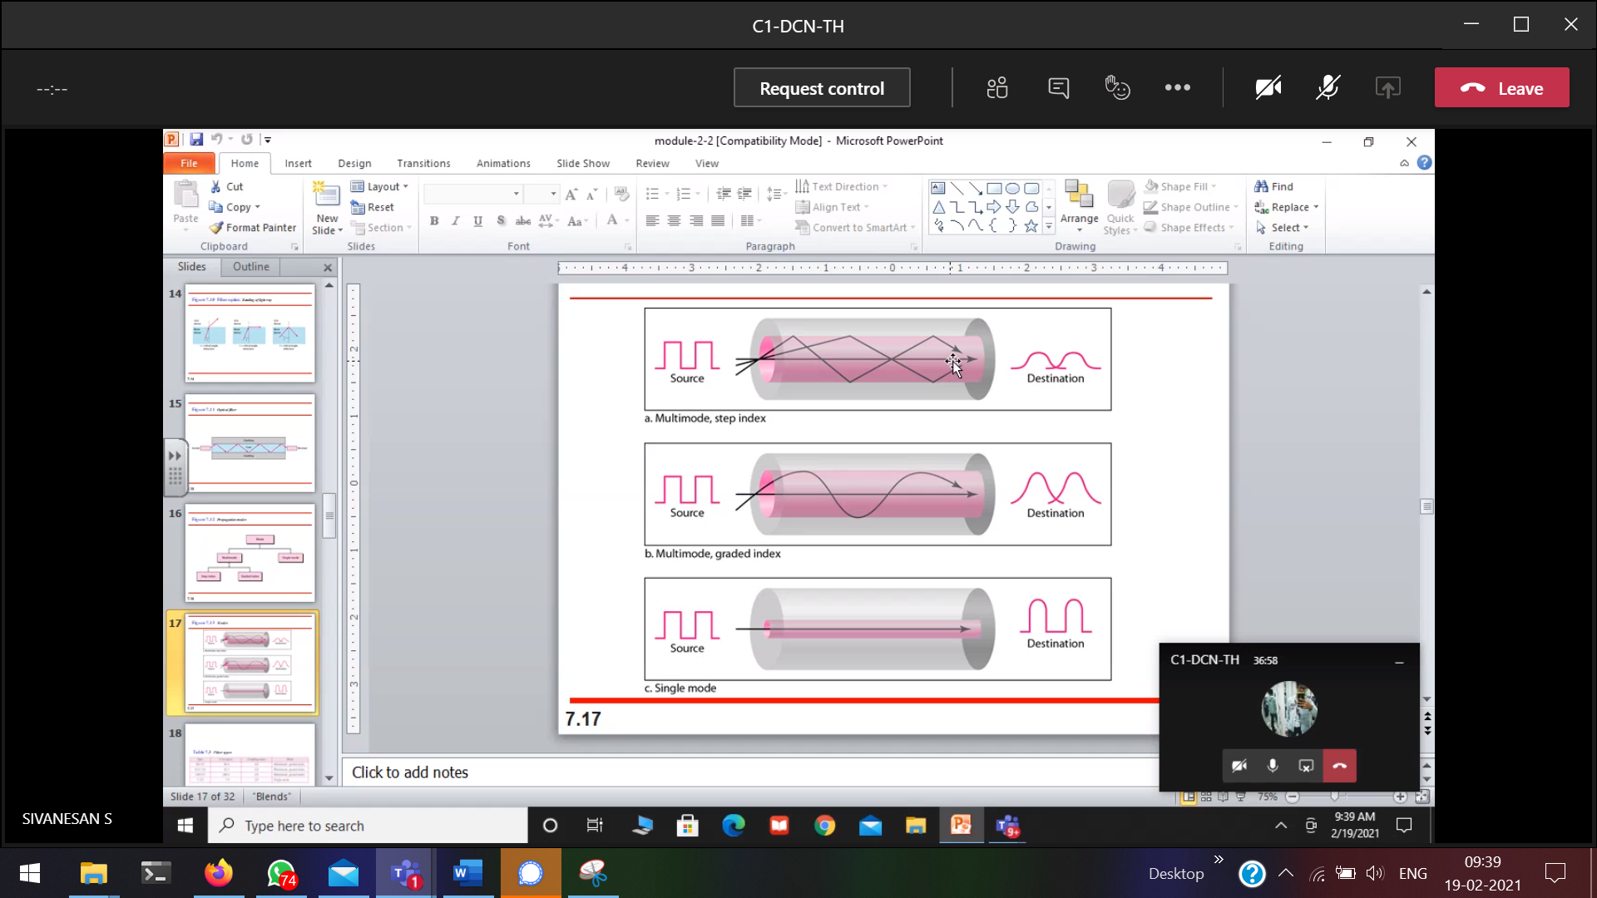

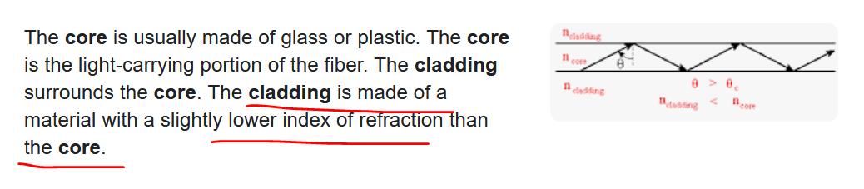

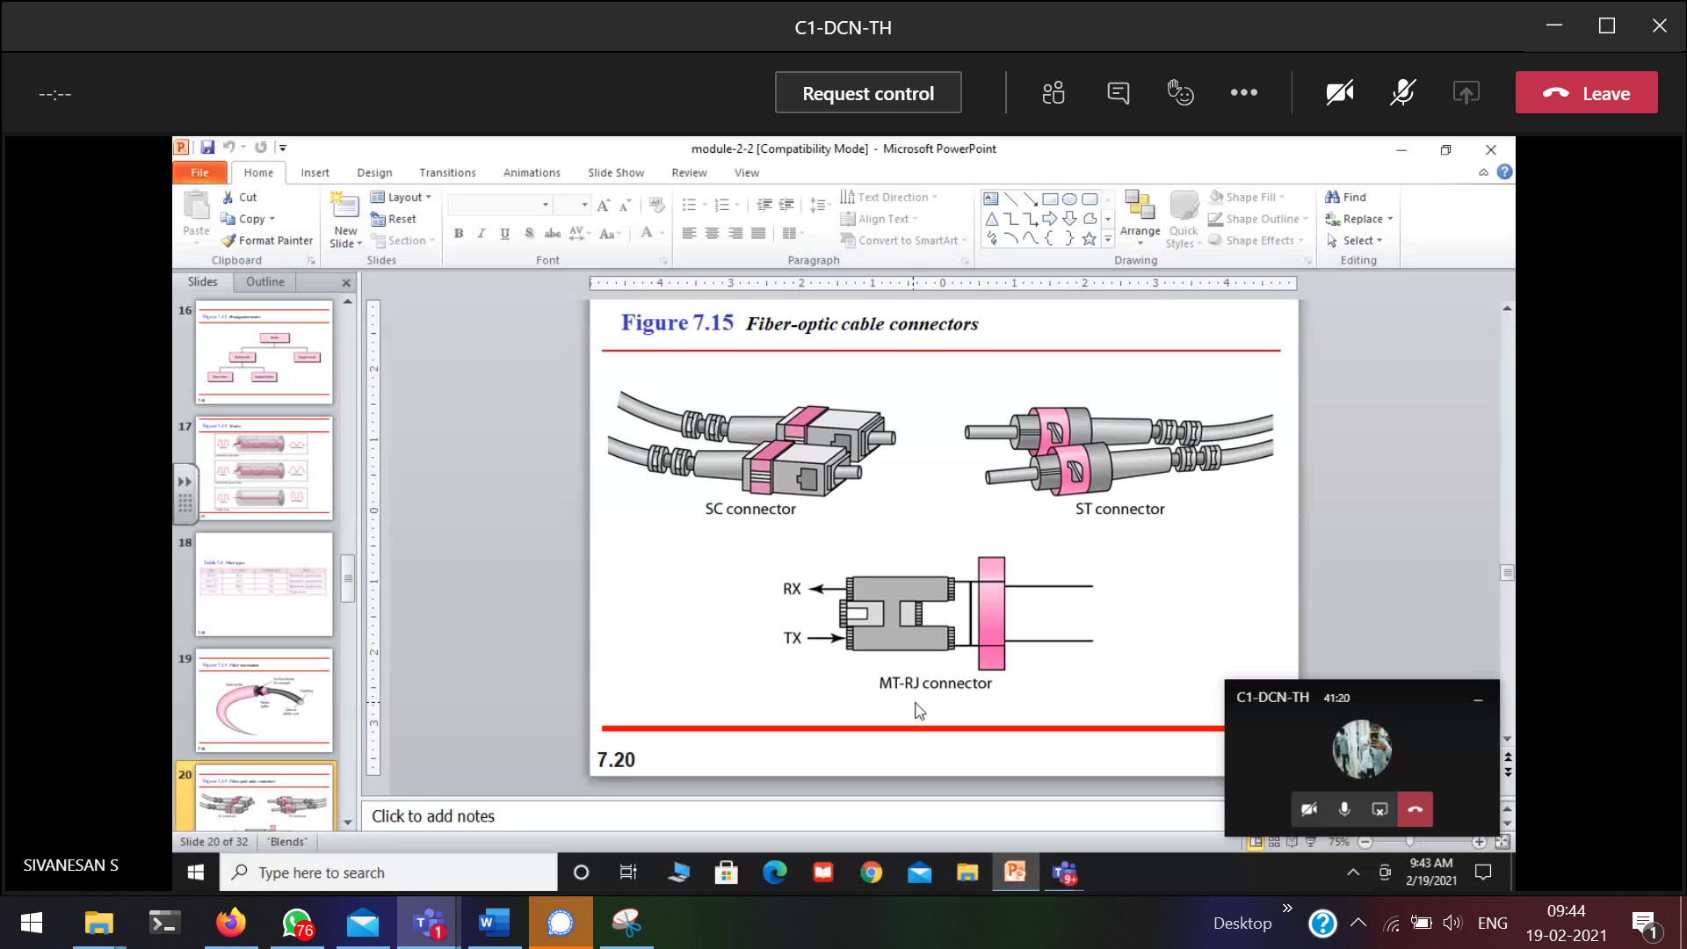  
Coaxial 🡪 Noise is in electrical form. Will also come.  
Fibre optics 🡪 Noise is in electrical which will not come in fibre optics.

23/2/2021

Digital conversion  
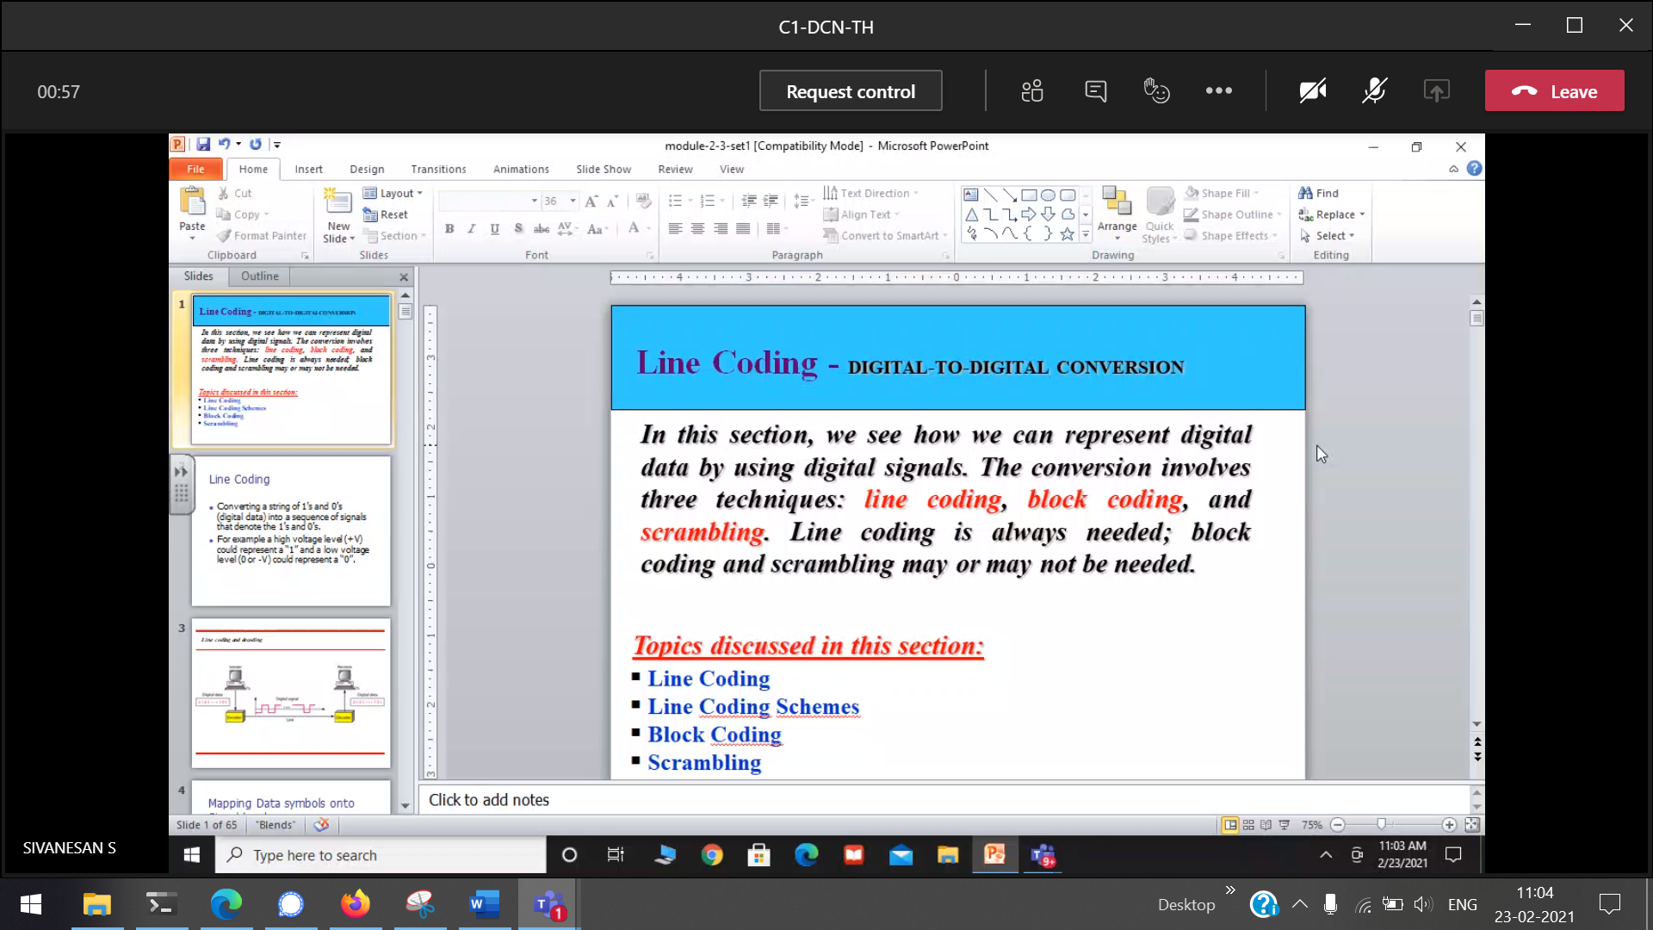  
line, block and scrambling 🡪 to represent the data in digital format.

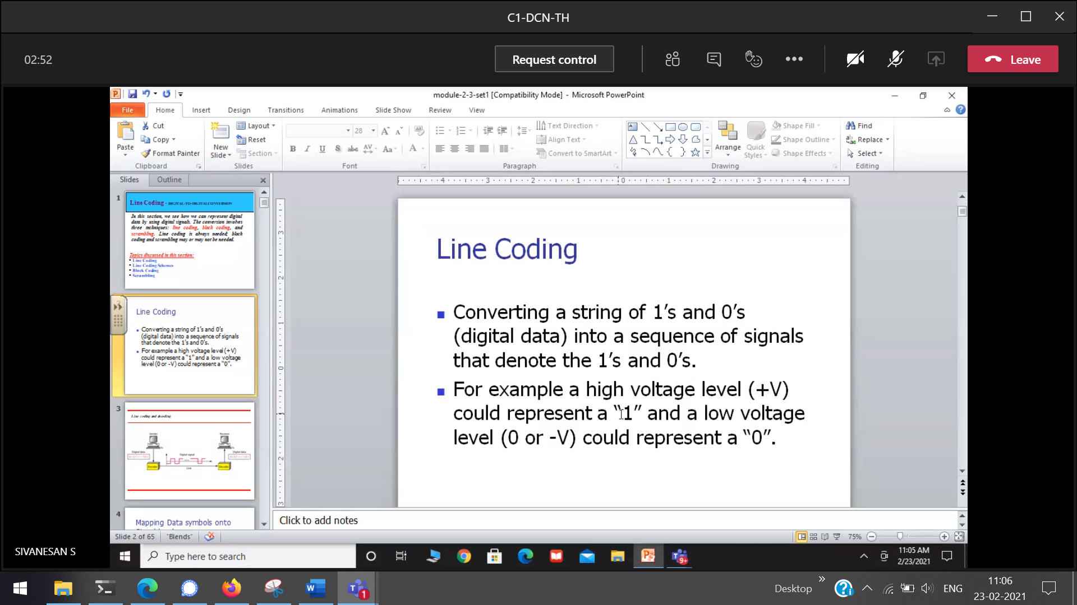

High voltage (+V) 🡪 1  
Low voltage (-V) 🡪 0

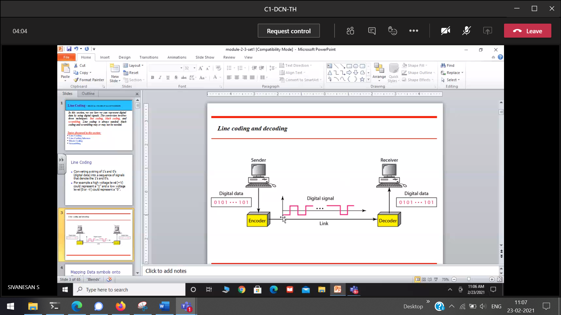  
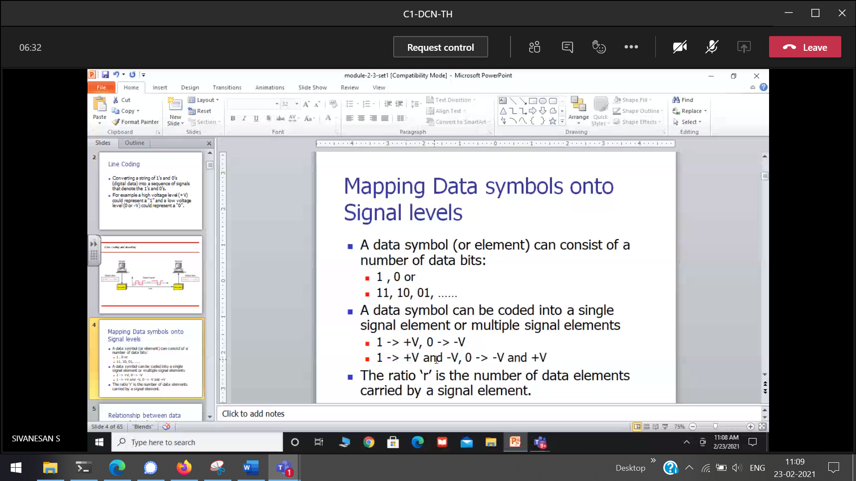  
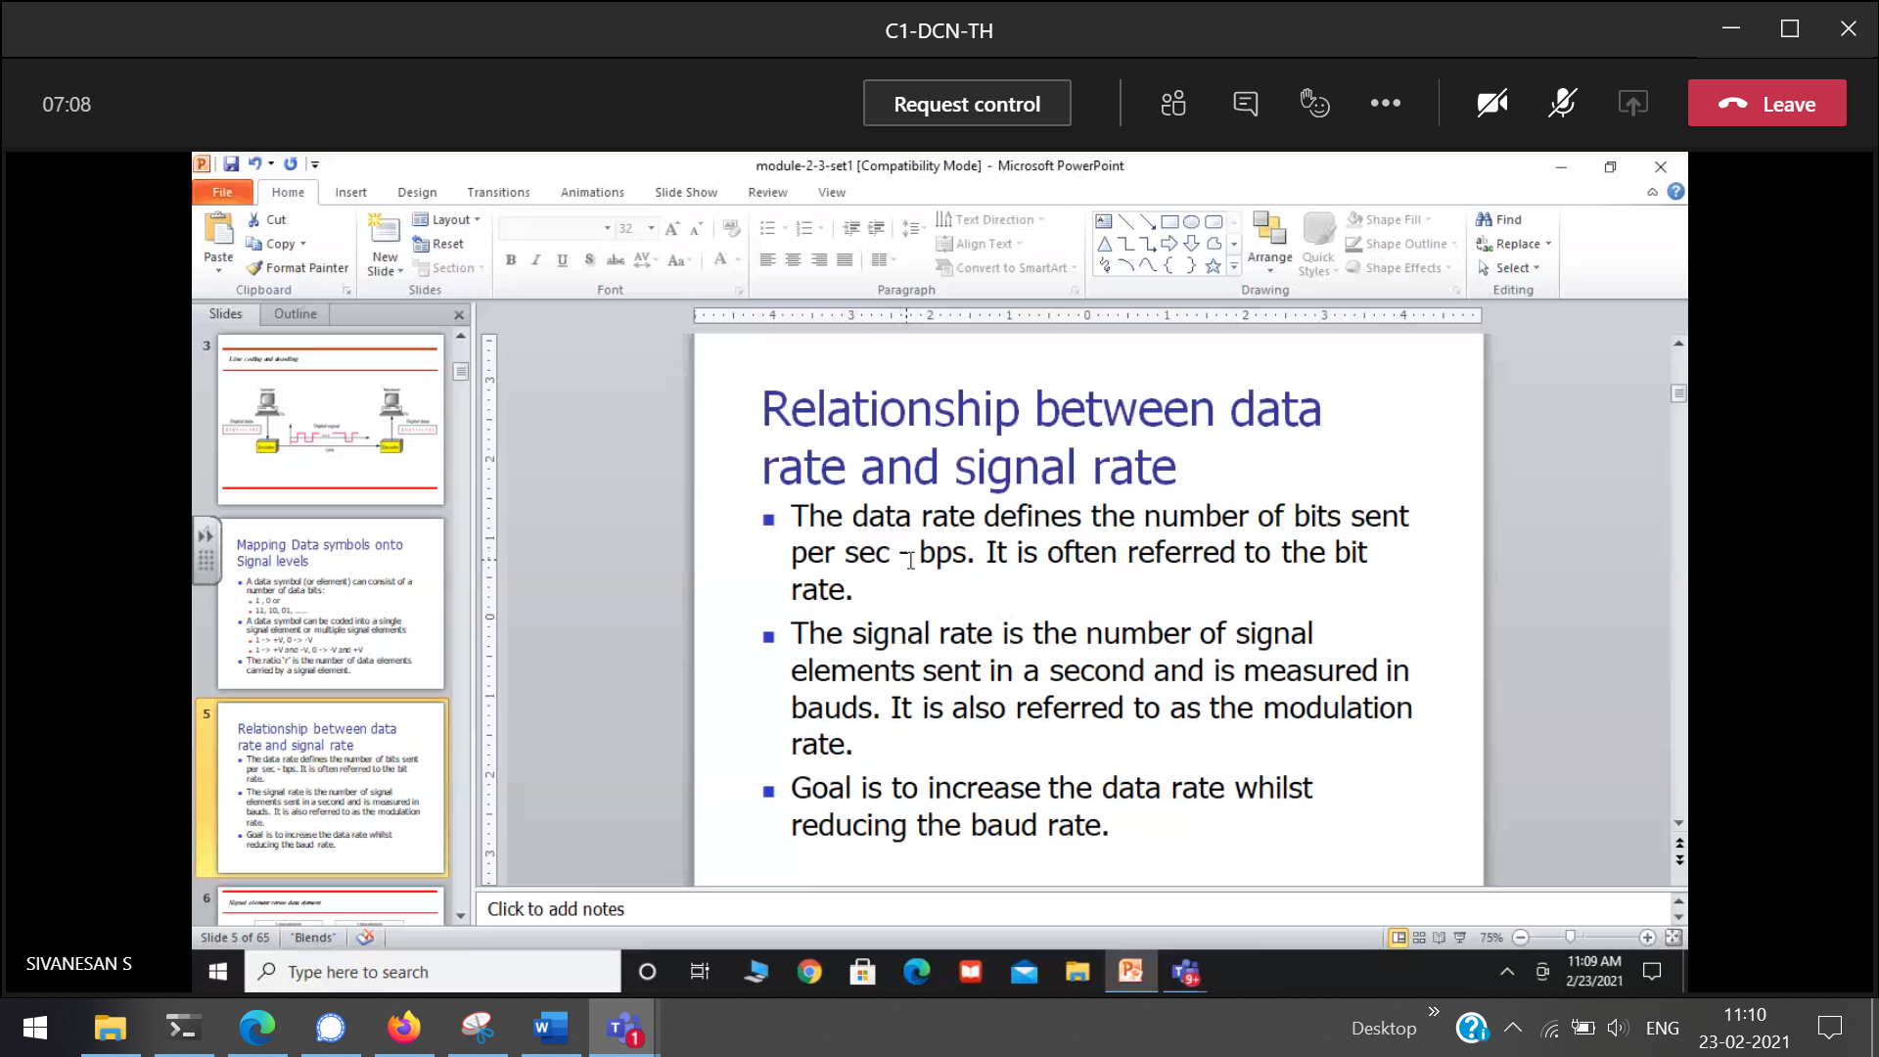

Data rate 🡪 How many bits/second  
Signal rate 🡪 How many signal/second (bauds)

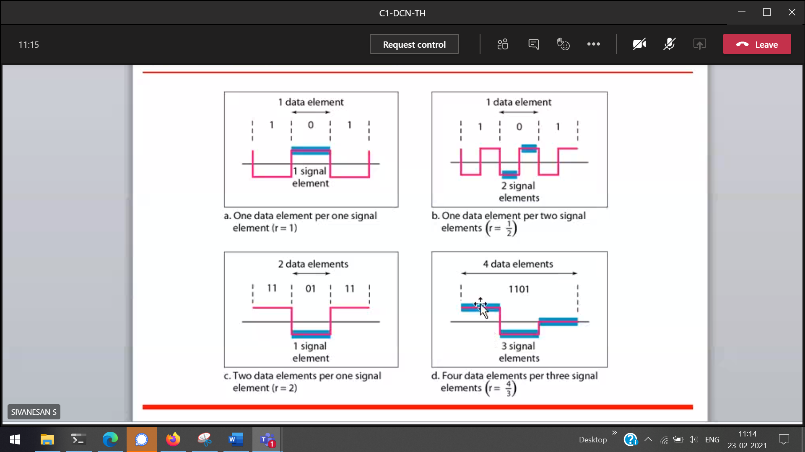

Data rate 🡪 how many data elements / signal element.

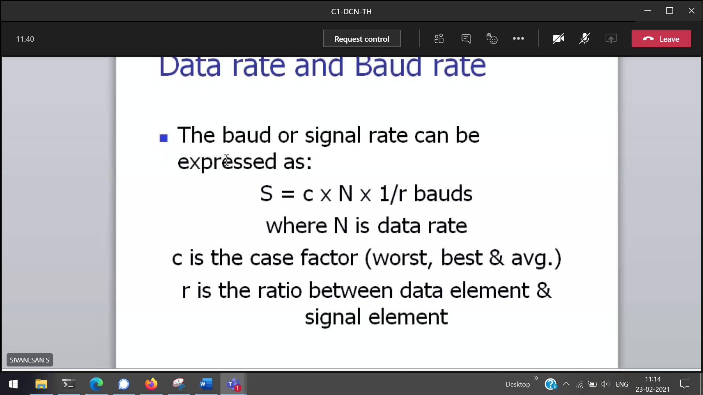  
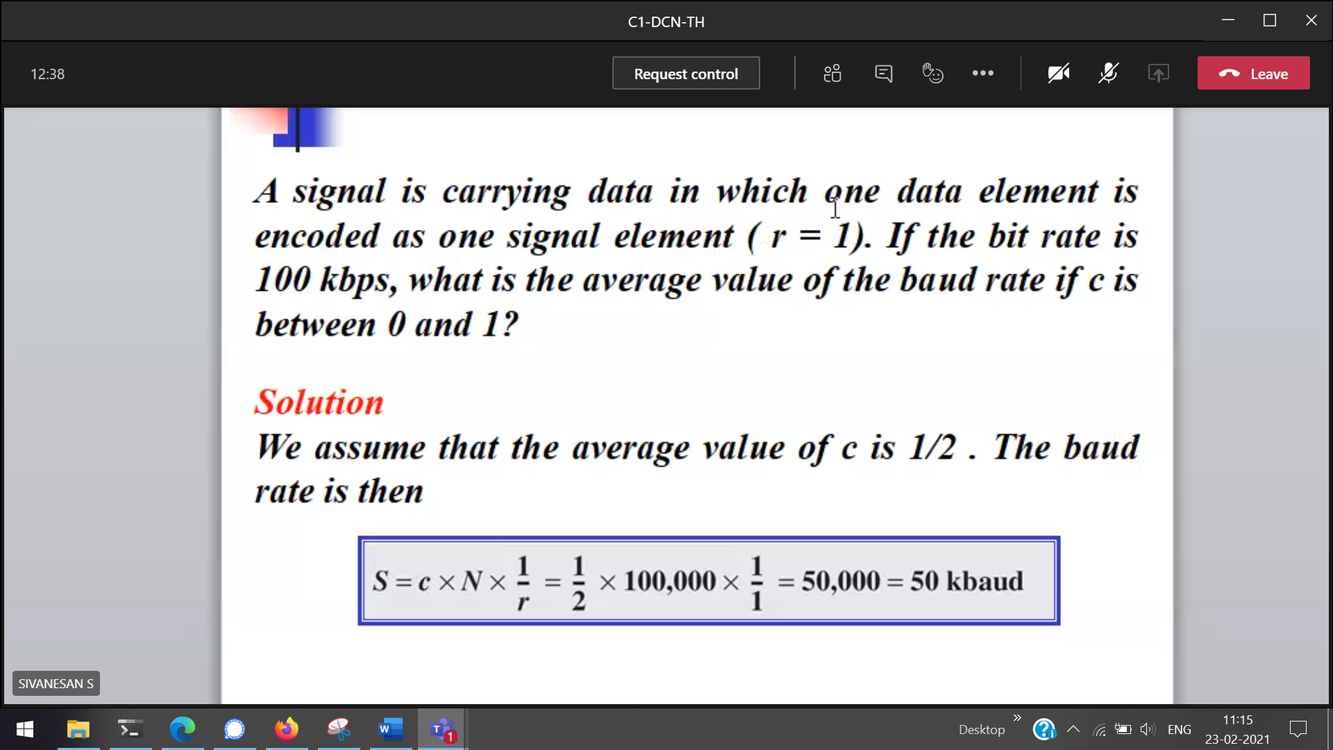

bit rate 🡪 data-rate  
c is in-between 0 and 1 [(0+1)/2 = 0.5]

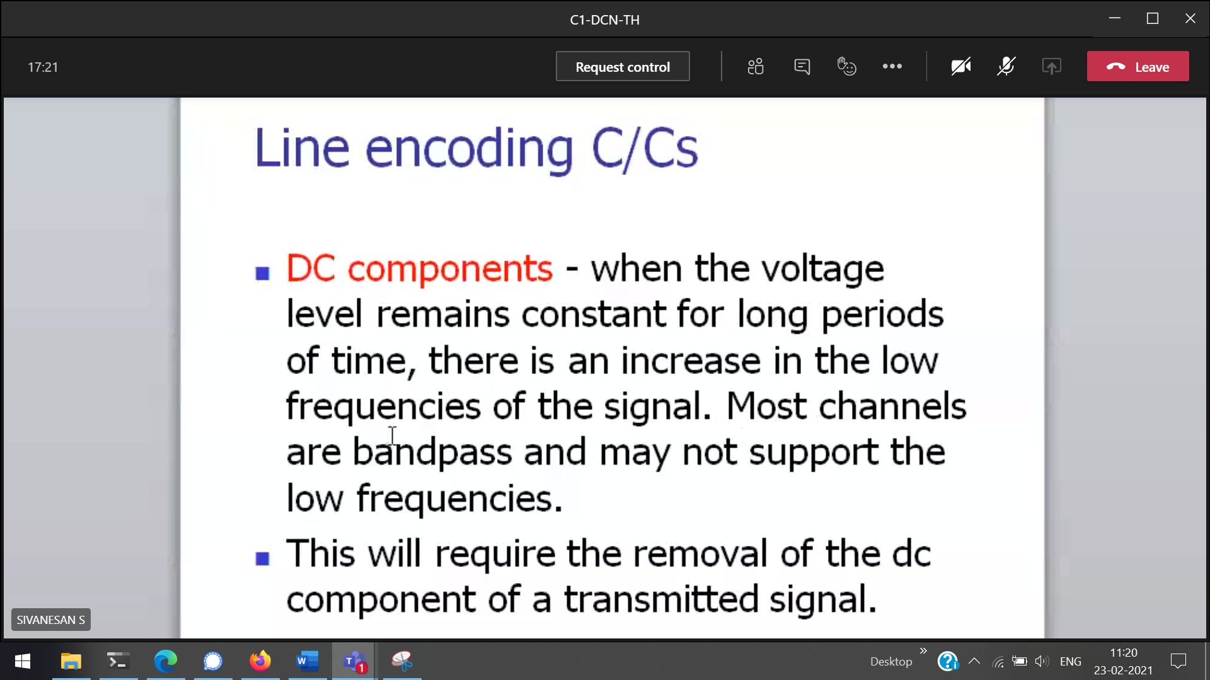

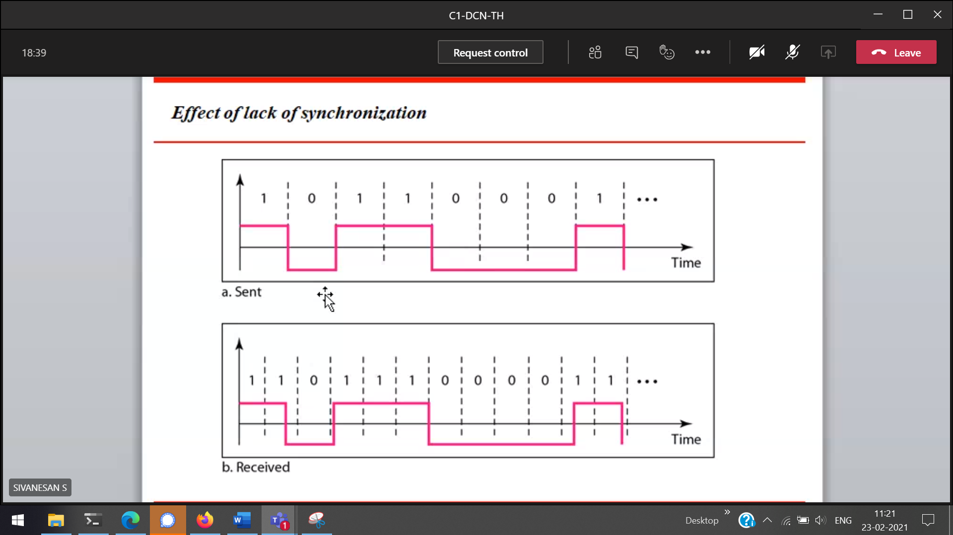



Sender ad receiver 🡪 Not synced

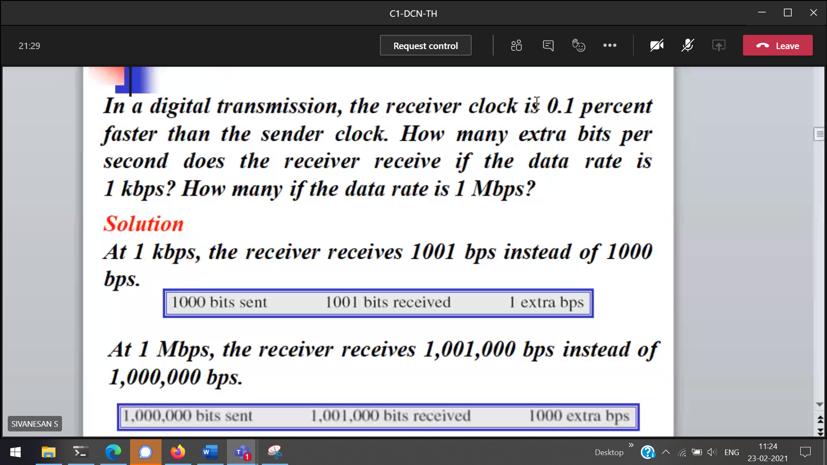

Smaller error(0.1%) 🡪 make a huge impact

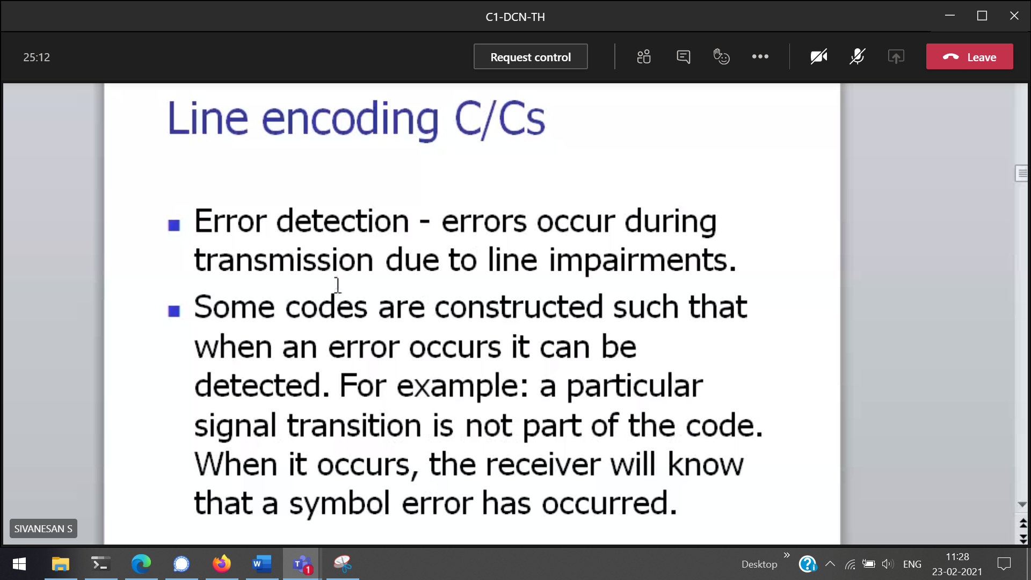

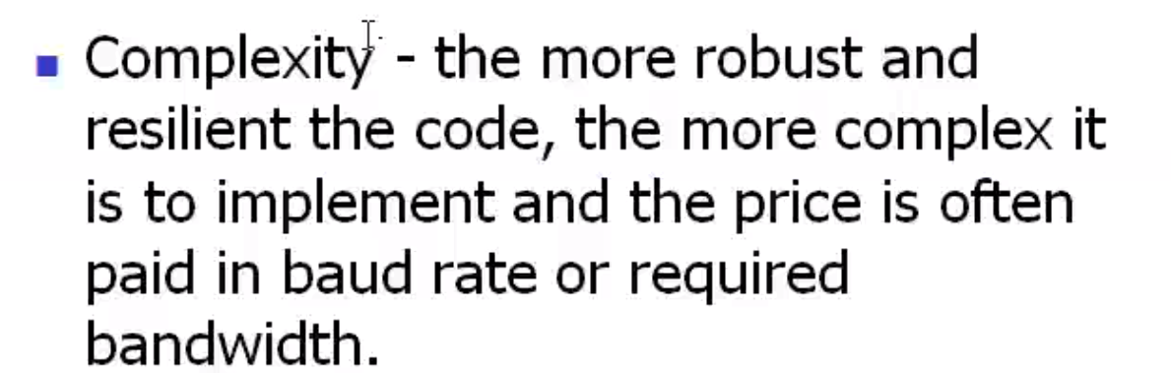

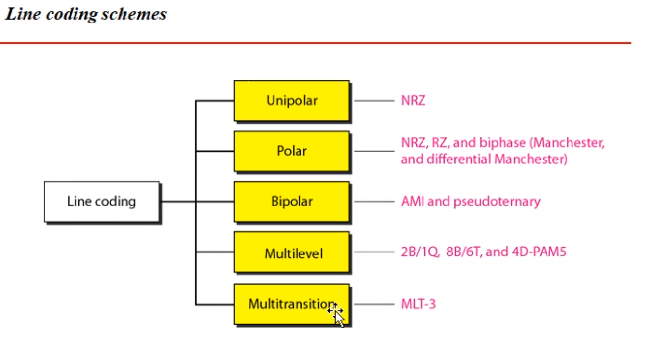

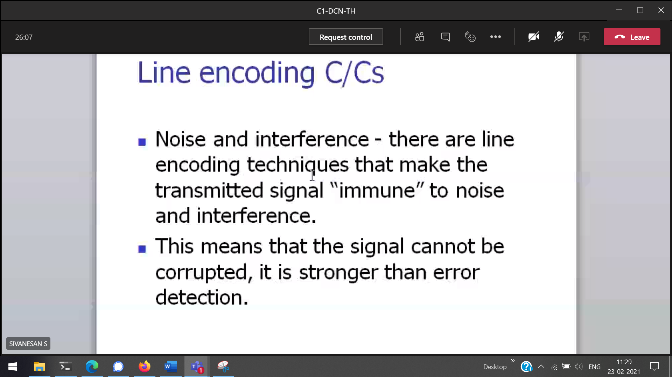

Either above X-axis or below X-axis [only one side of the time axis]

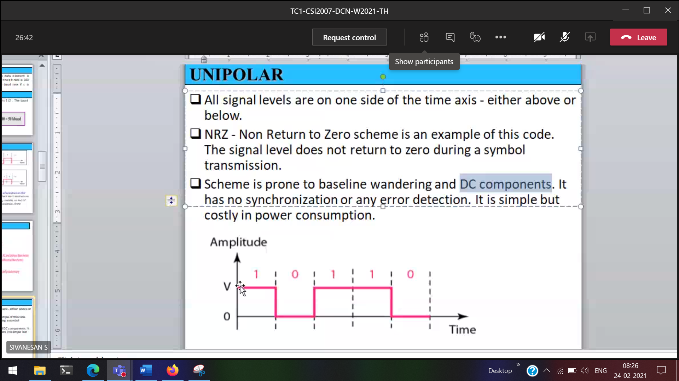

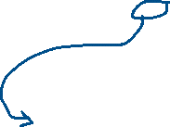

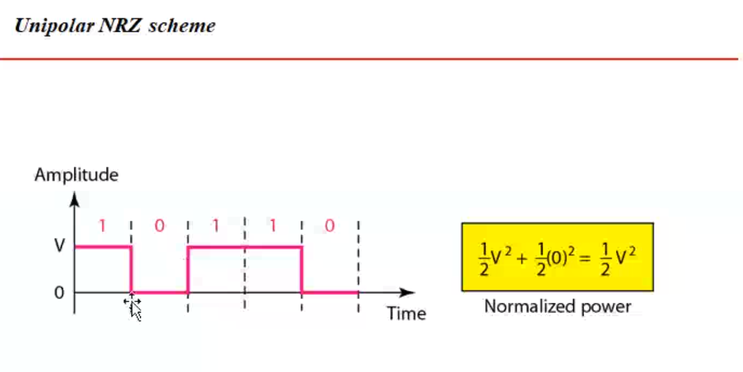

(Only +ve representation) Parallel to X-axis 🡪 0, with total power only 1 half is used.

Baseline wandering 🡪 here the signal is 0 , in other way around we may think that the signal is not at all present



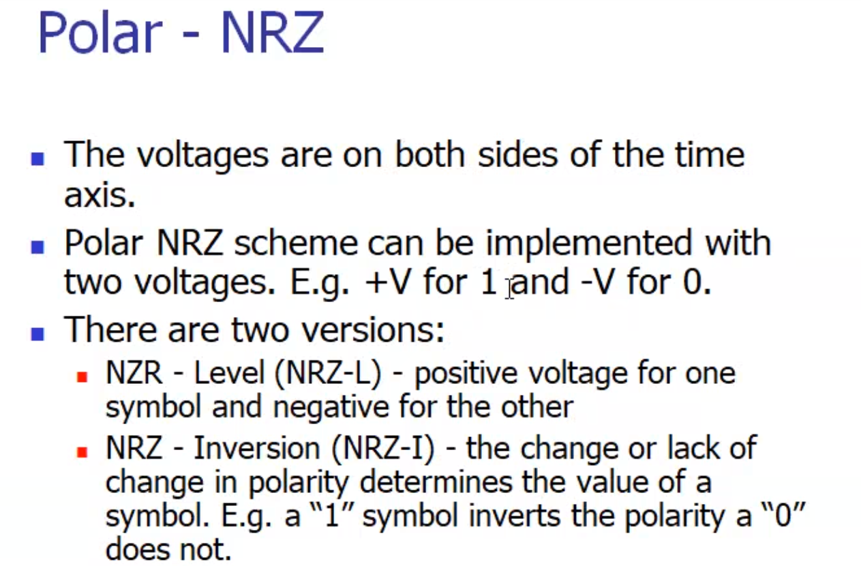



+v 🡪 1 and -v🡪 0  
change 🡪 1 to 0  
no change 🡪 0

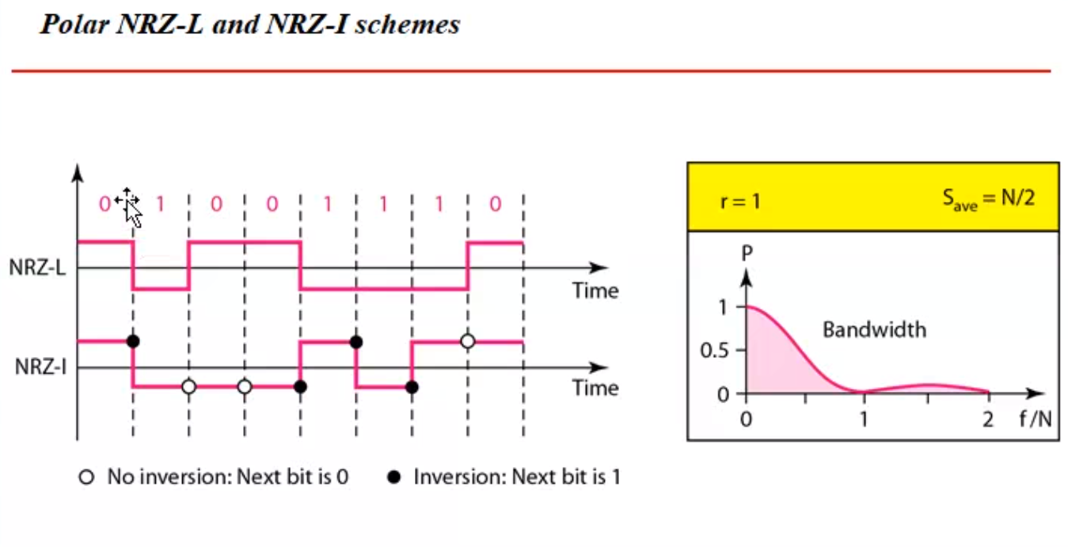



Level 🡪 constant representation of the signal  
inversion 🡪 transmission [ +ve to -ve or -ve to +ve ] 🡪 1

No Baseline wandering, and DC components

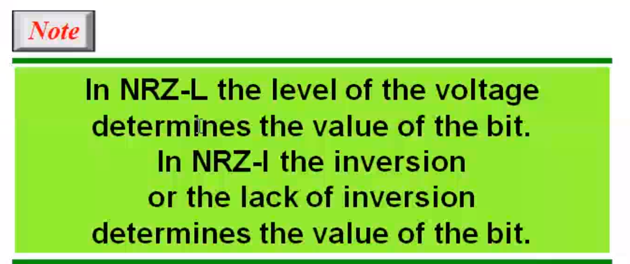

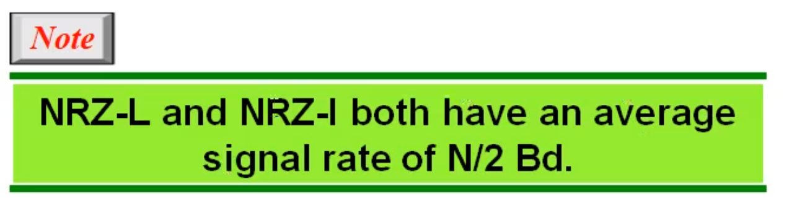  
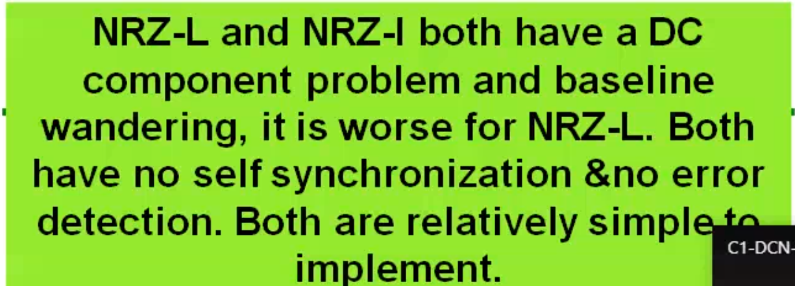

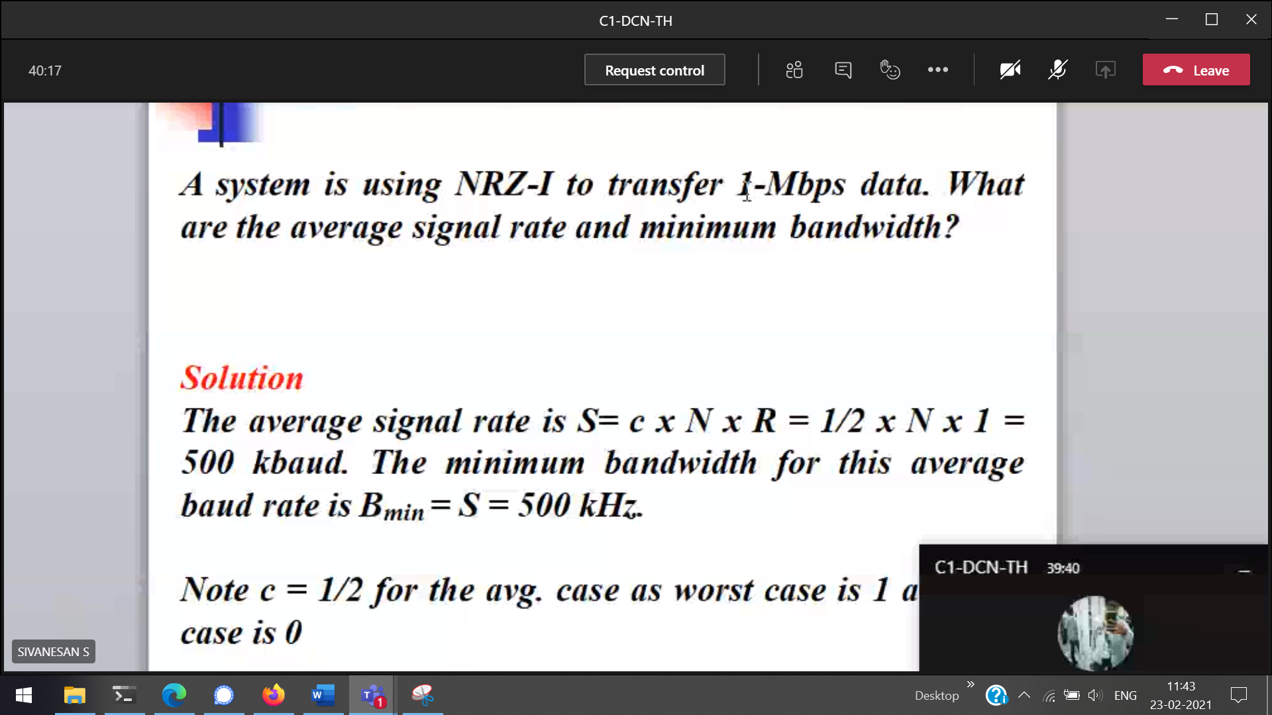

Three volatages ( -ve , 0, +ve )

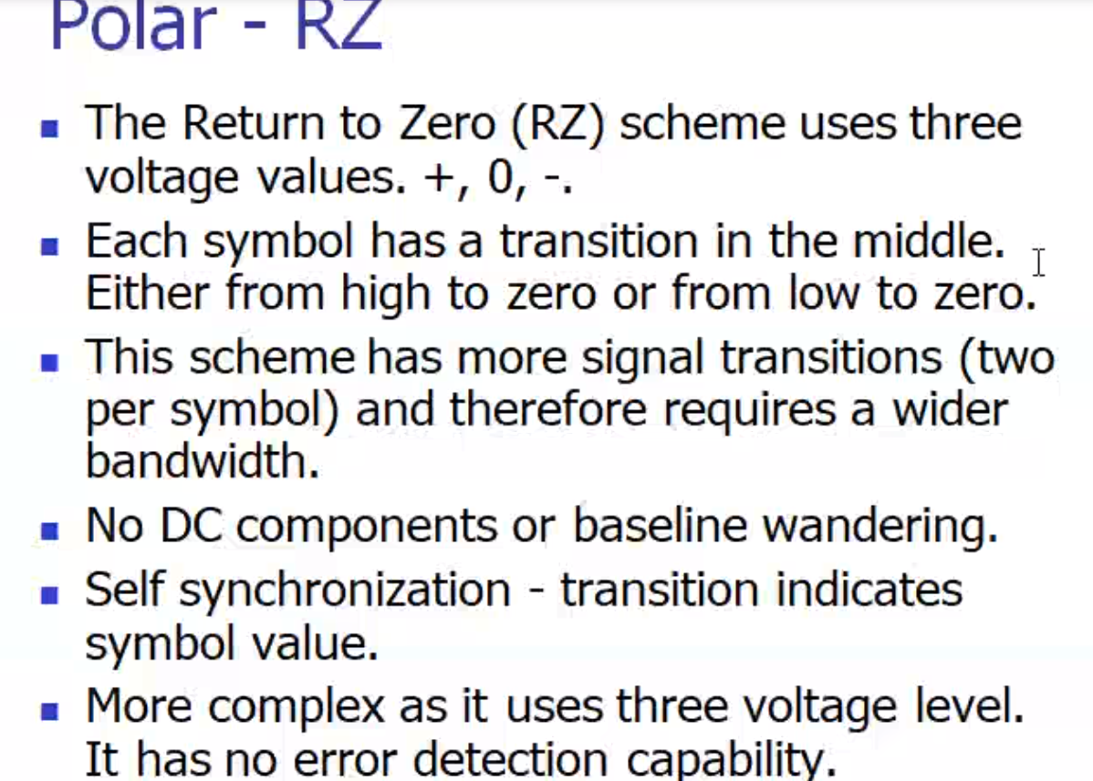



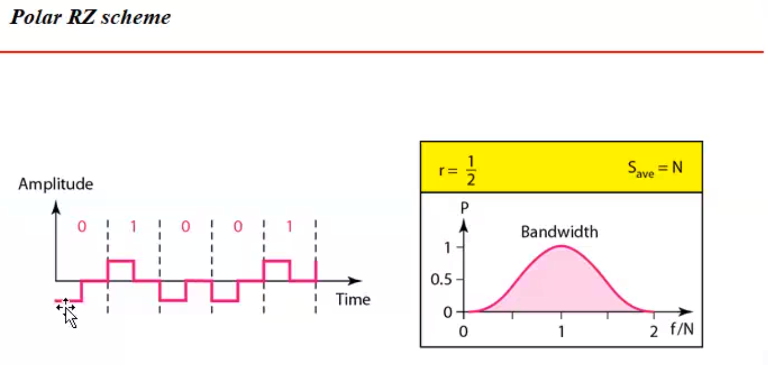



3 signal levels 🡪 represents the data bits

-ve 0 +ve 🡪 0  
+ve 0 -ve 🡪 1

1 always start from +ve (returning to 0 is important)  
0 always start from -ve

DC component :

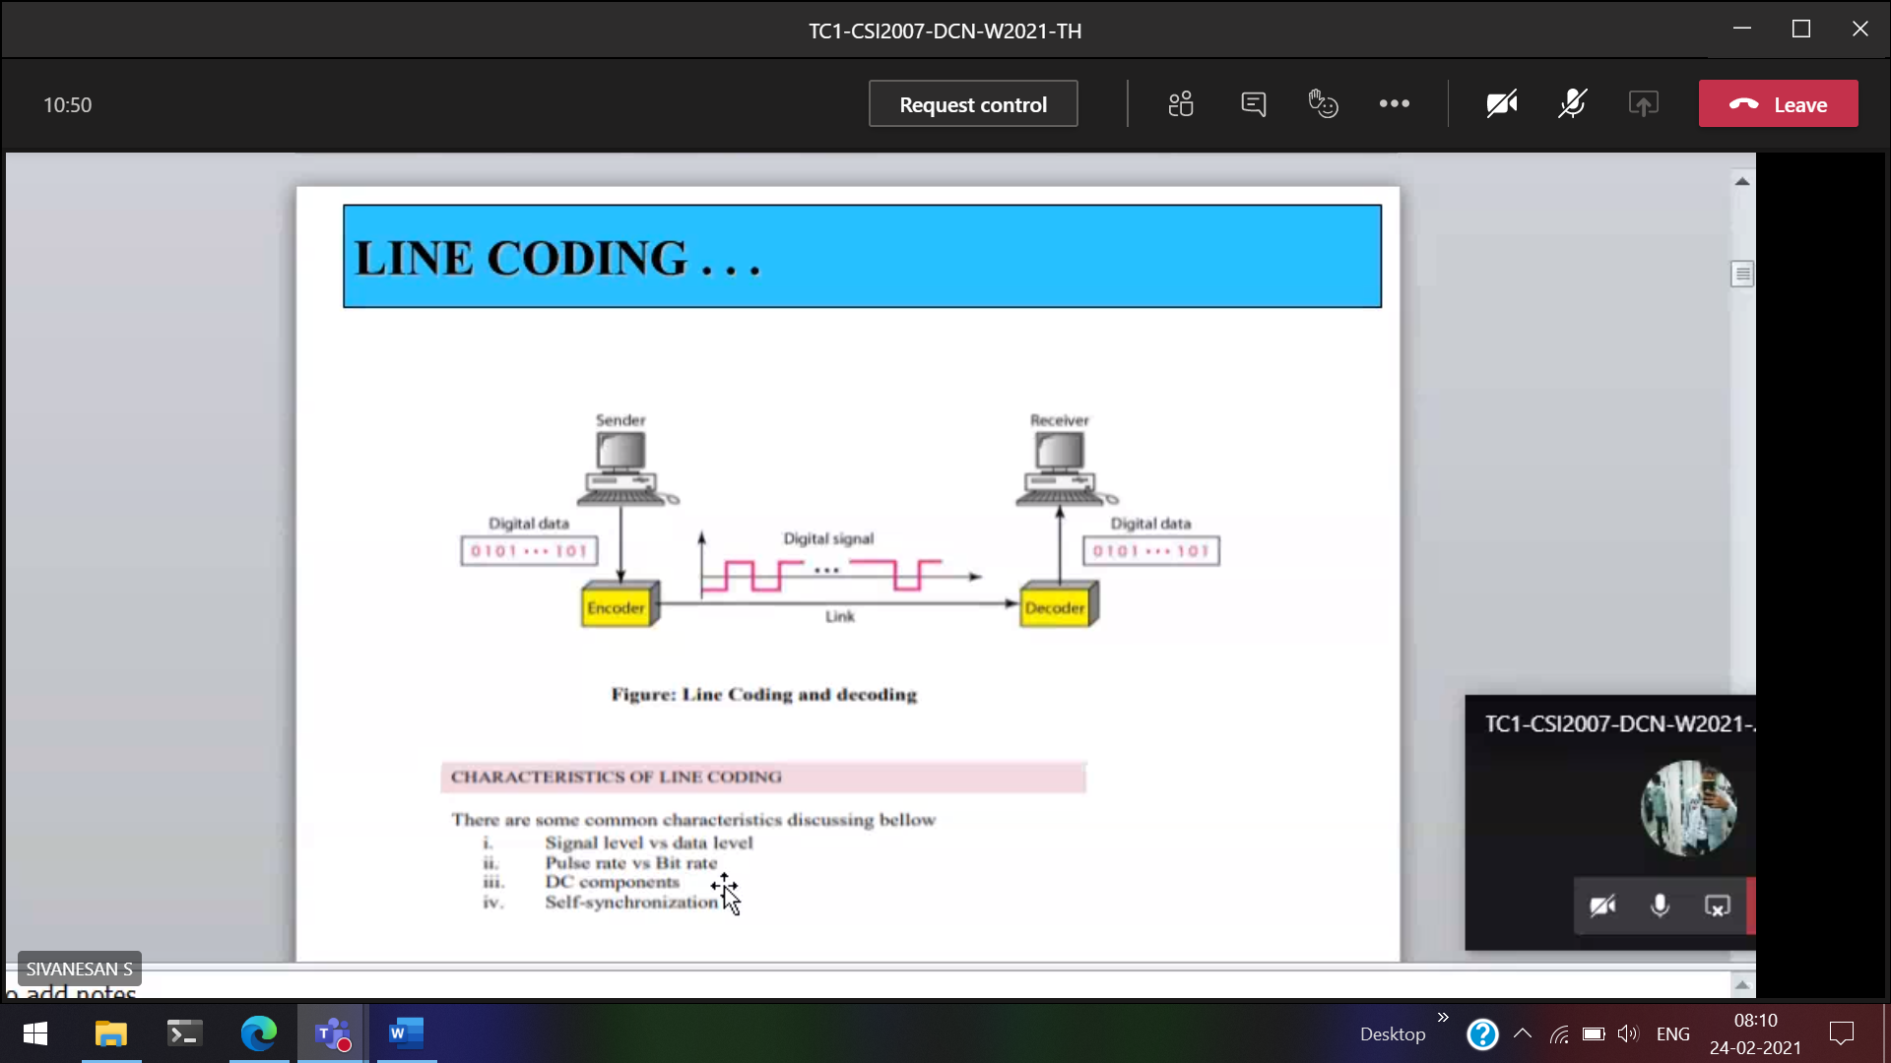  
DC component 🡪 0 frequency

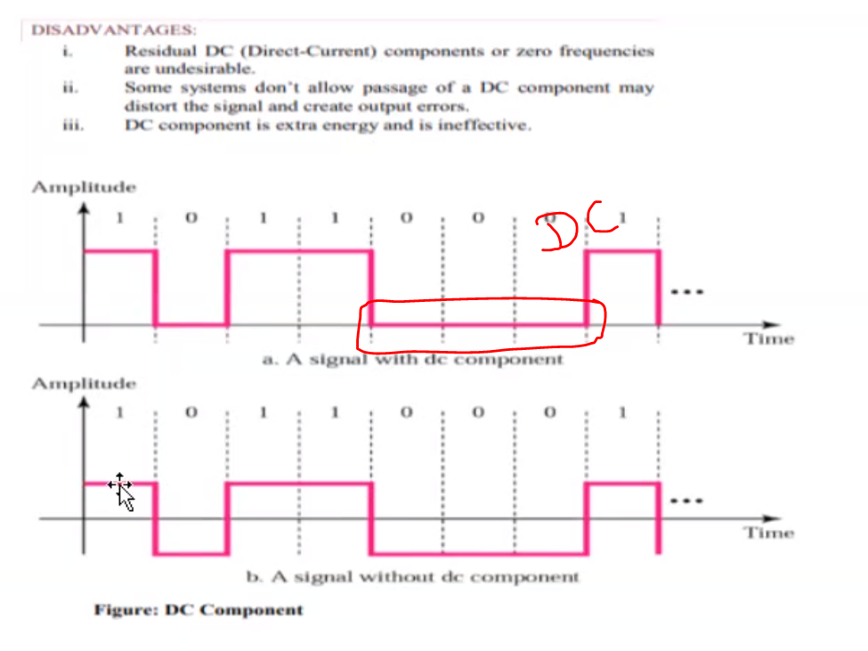  
This vibration will confuse the whether data is there/noise.  
(More important) Self synchronization 🡪

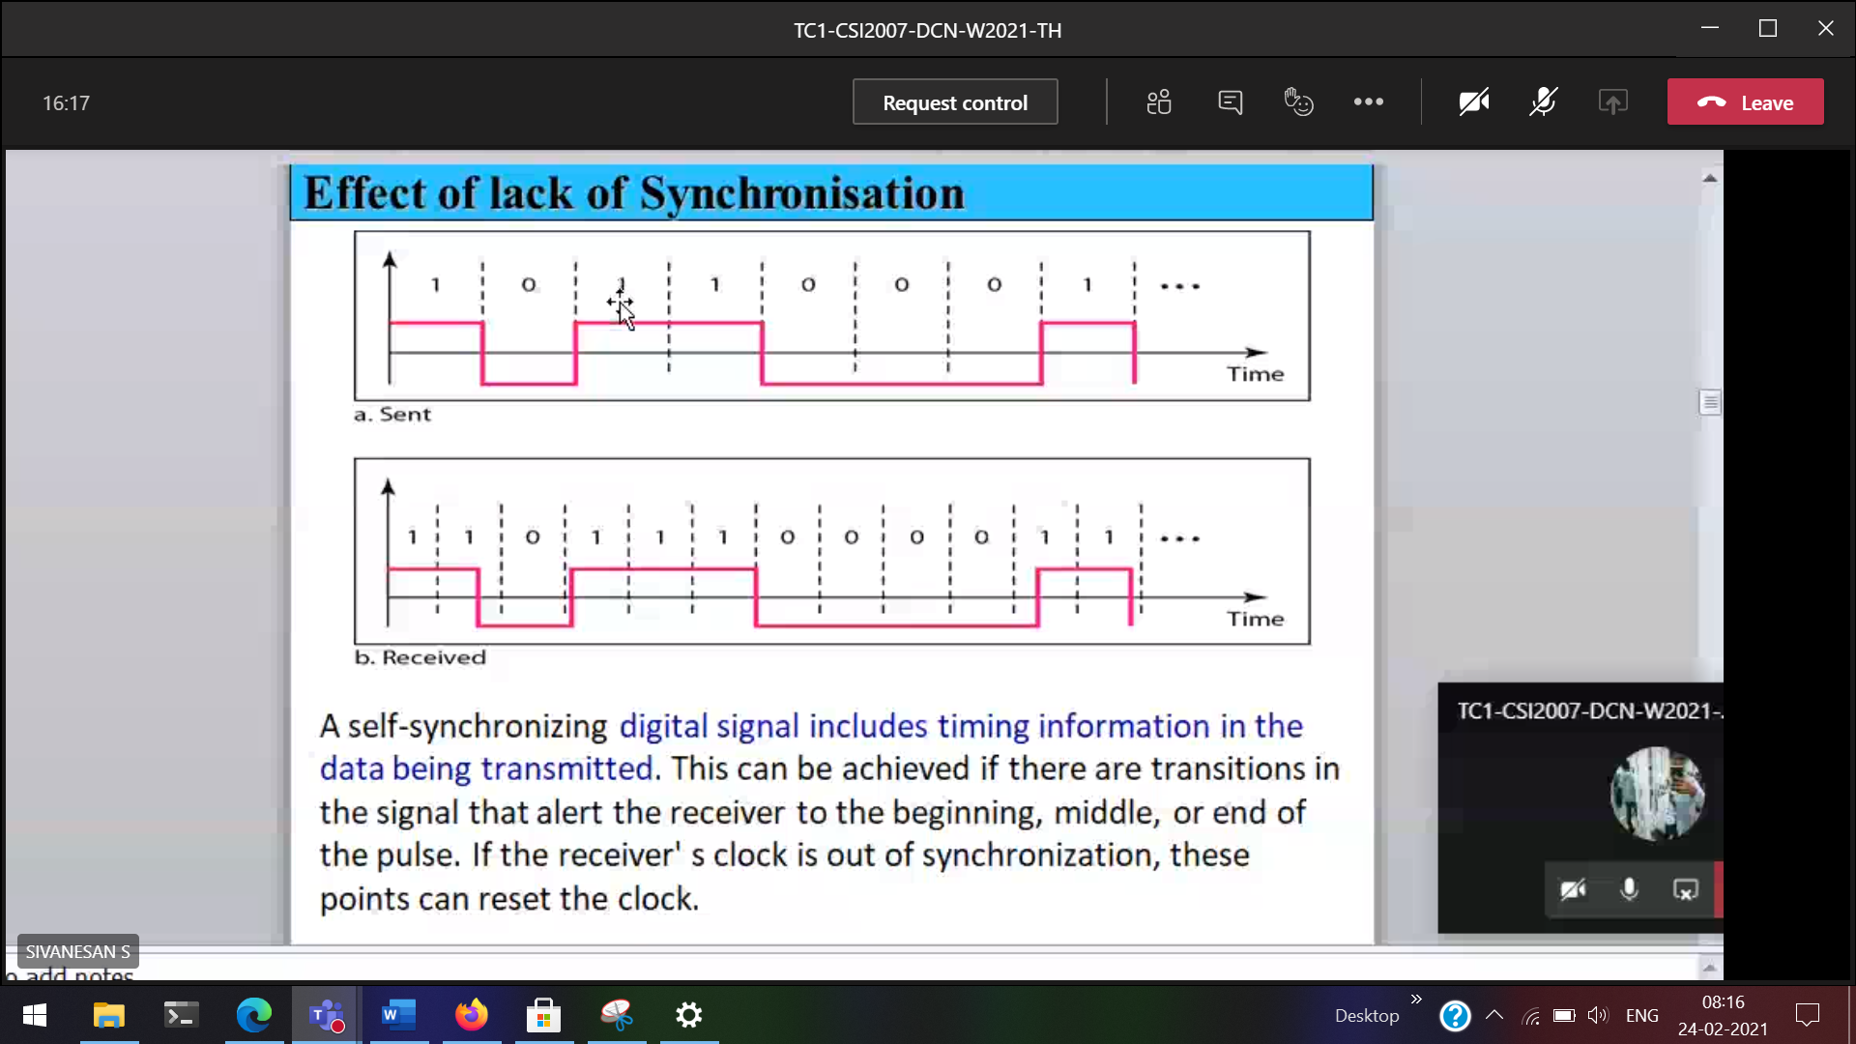

Receiver start a bit earlier | 3 sec |

To discard/eliminate noise 🡪 we will calculate running average [Base line wandering]

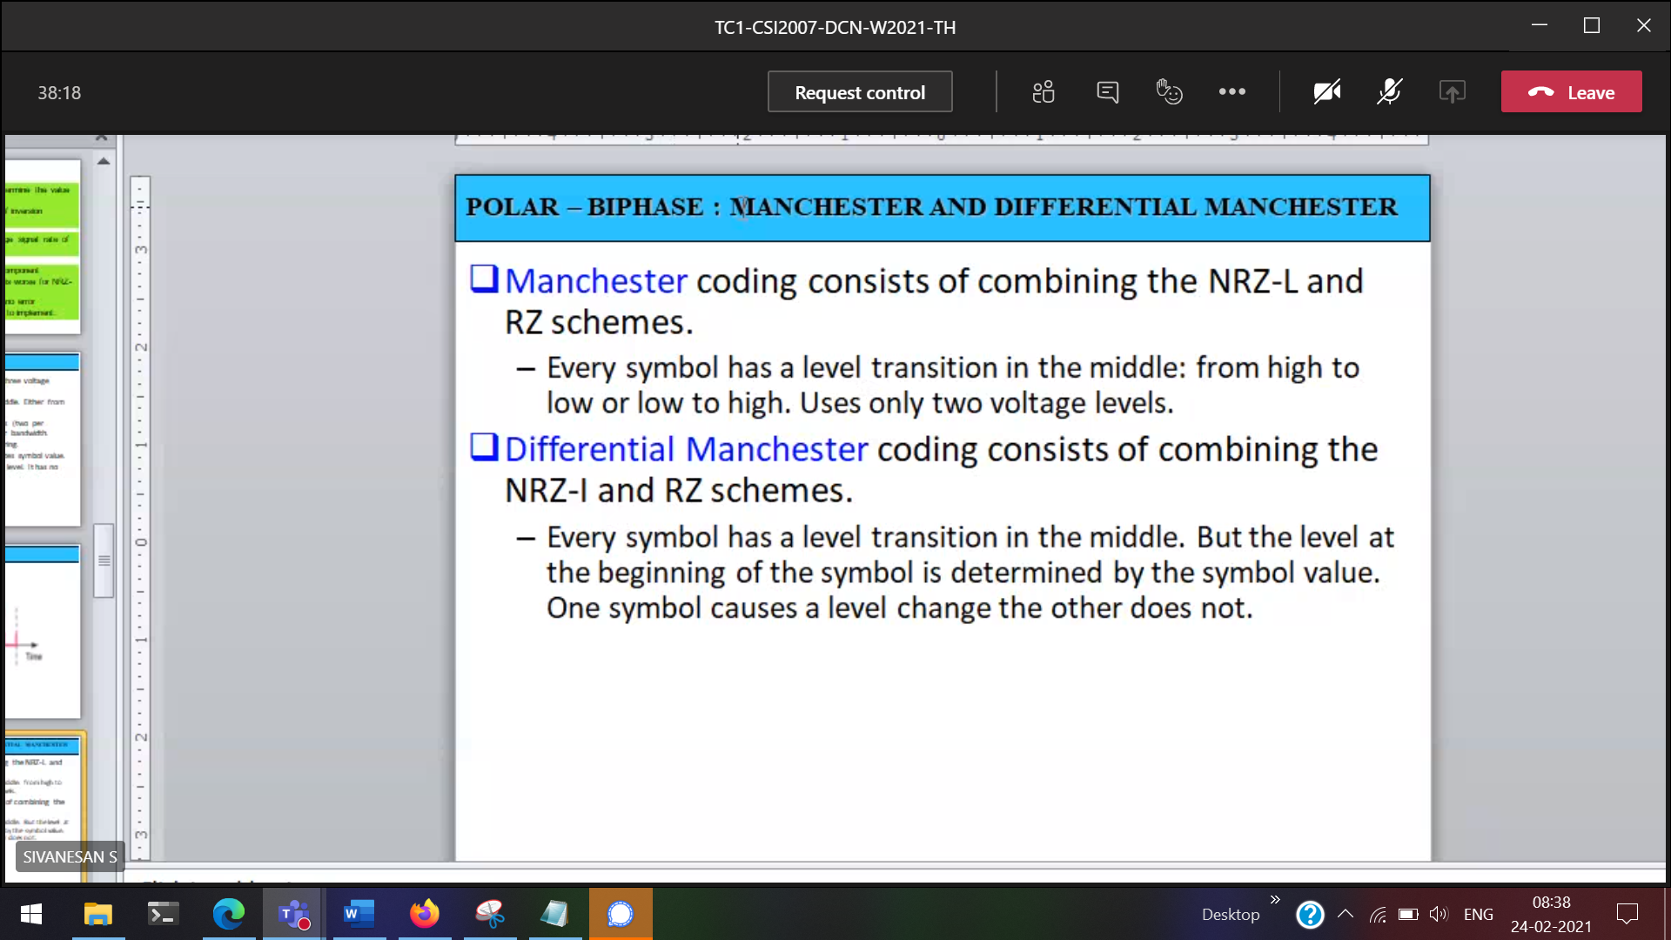  
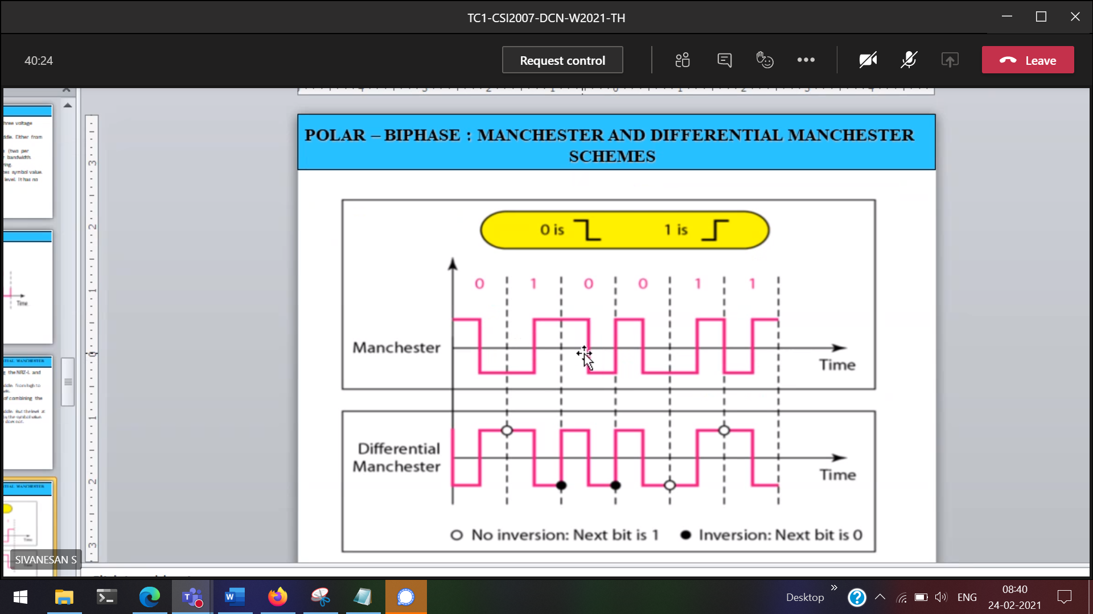



1 🡪 low to high  
0 🡪 high to low

(Manchester & Diff Manchester) 1 bit 🡪 minimum 2 signal elements

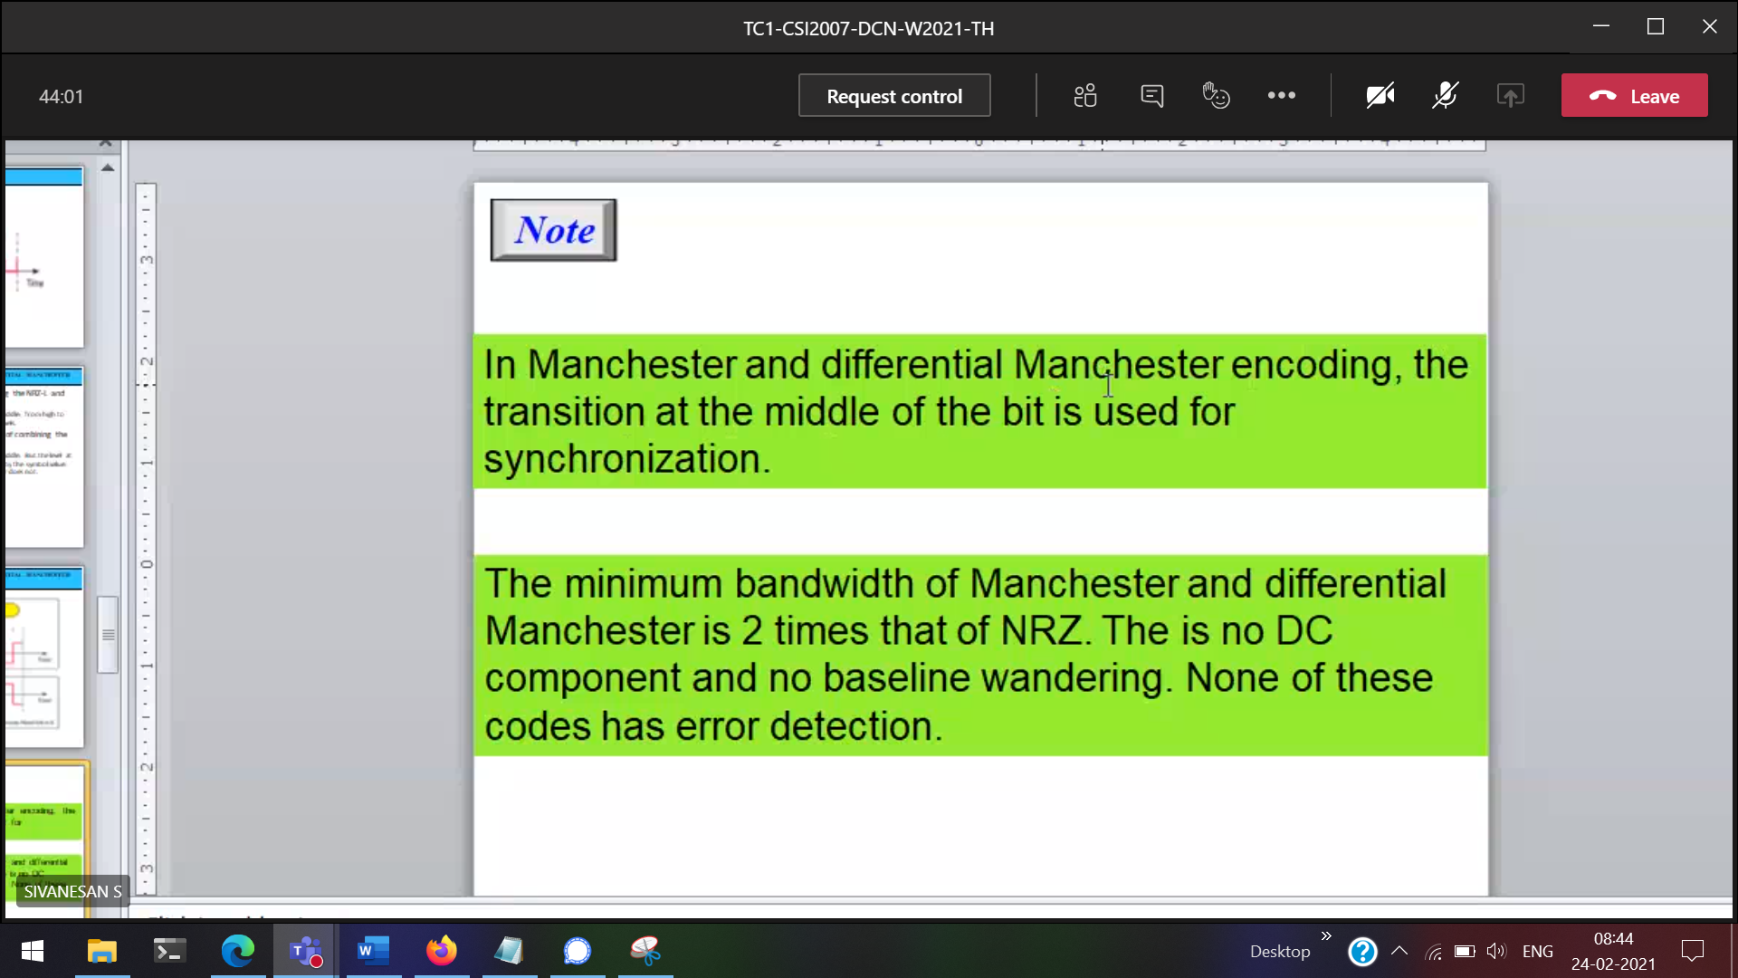

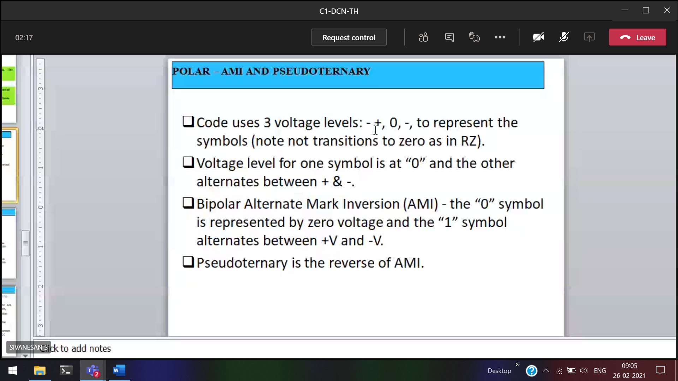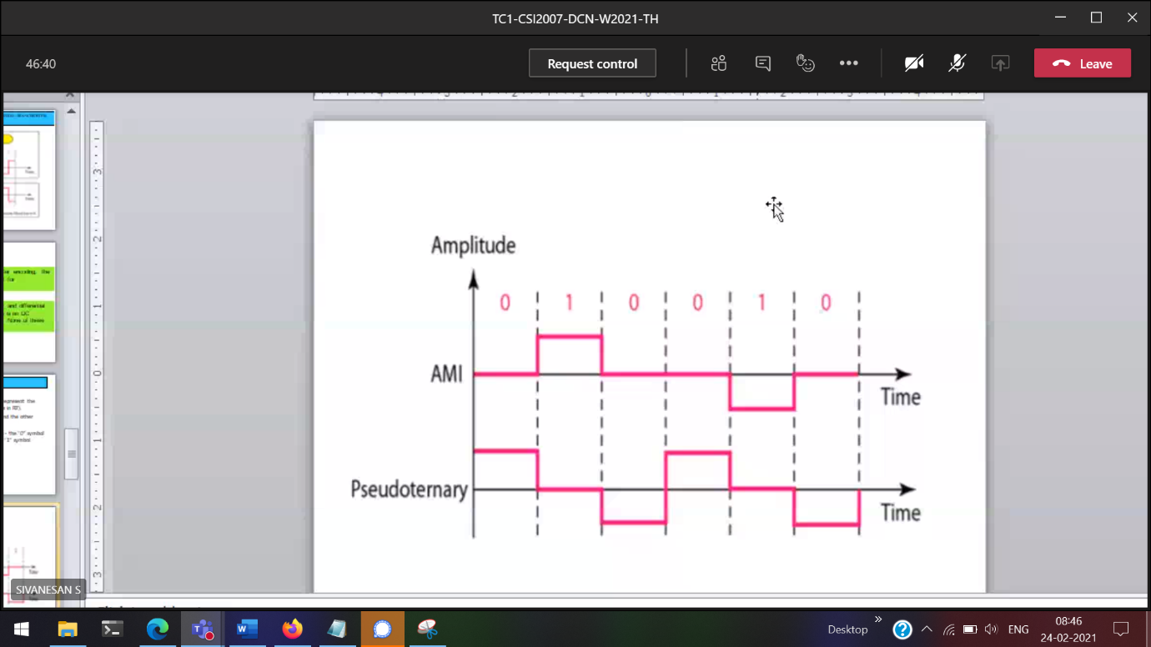

26/2/2021  
Before all the topics 🡪 digital to digital conversion

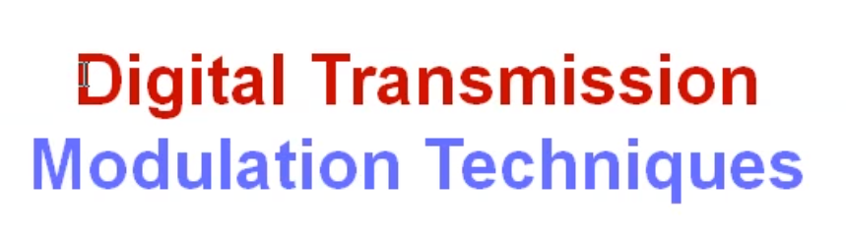

Modulation 🡪 mix the digital signal to analogue signal and send

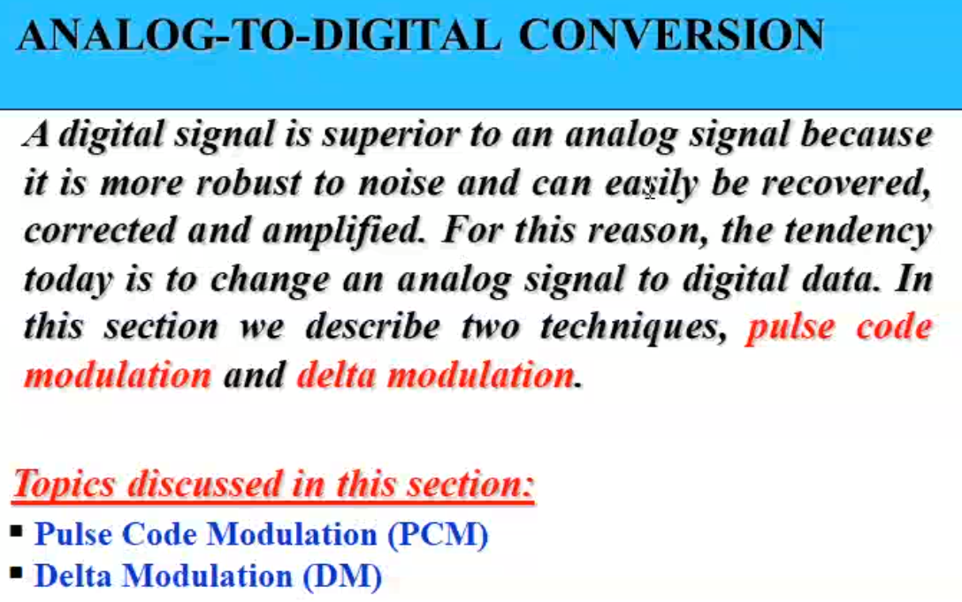

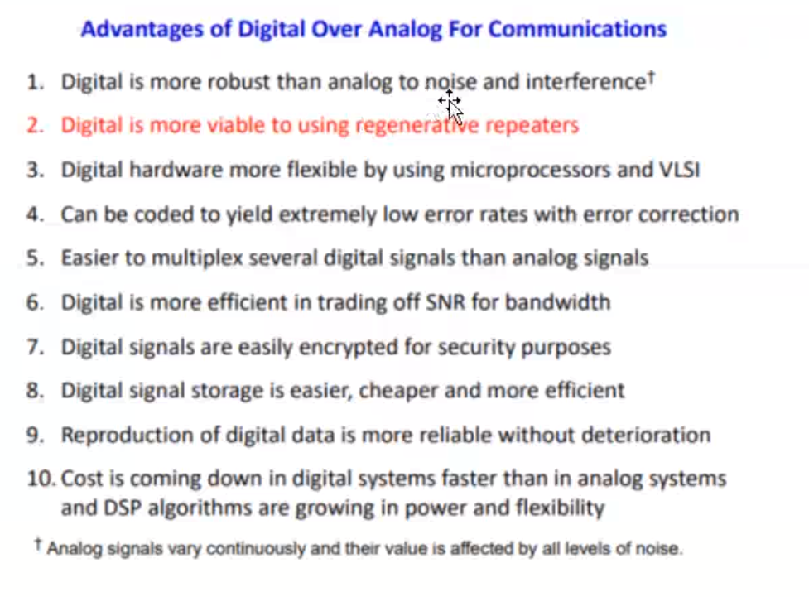

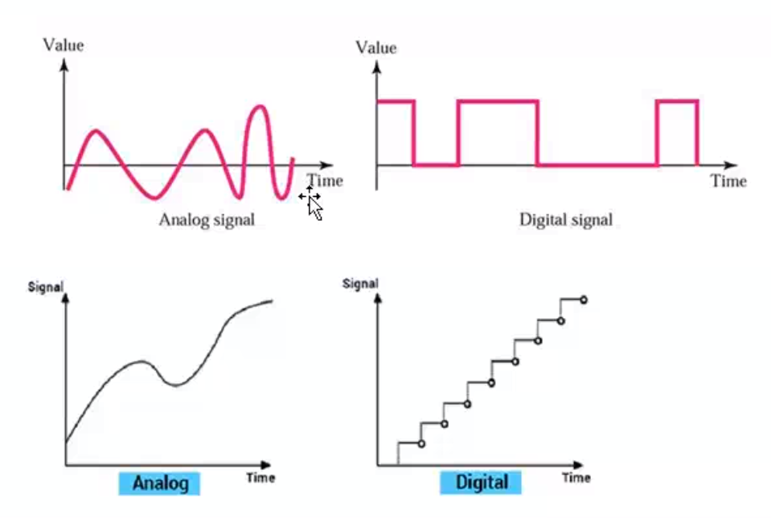

Coding 🡪 Mapping between signal and data

Pulse Code Modulation

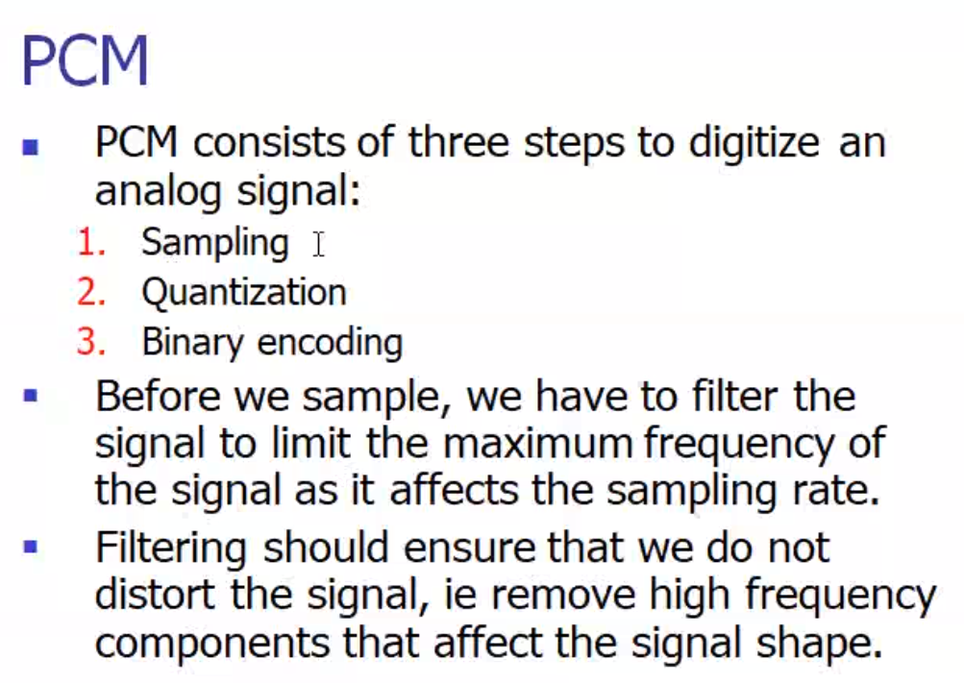

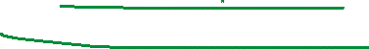

Sampling 🡪 dividing the original signal into multiple samples.



For reducing the pulse duration, more clock pulses will be generated.

More sampling 🡪 more clock speed

Draw a line in the analogue, (like removing the odd man out)

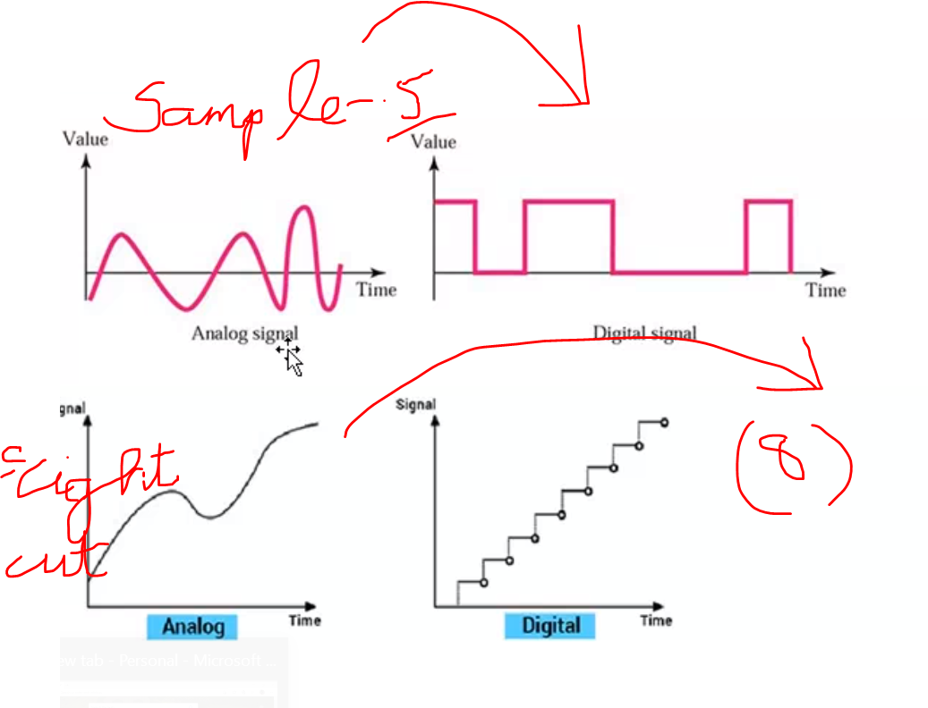



Like fan in our house

Quantization 🡪 How to Map between Sample (Analogue) and actual binary signal/ We are going to fix the levels.

Encode 🡪 quantized signal to binary

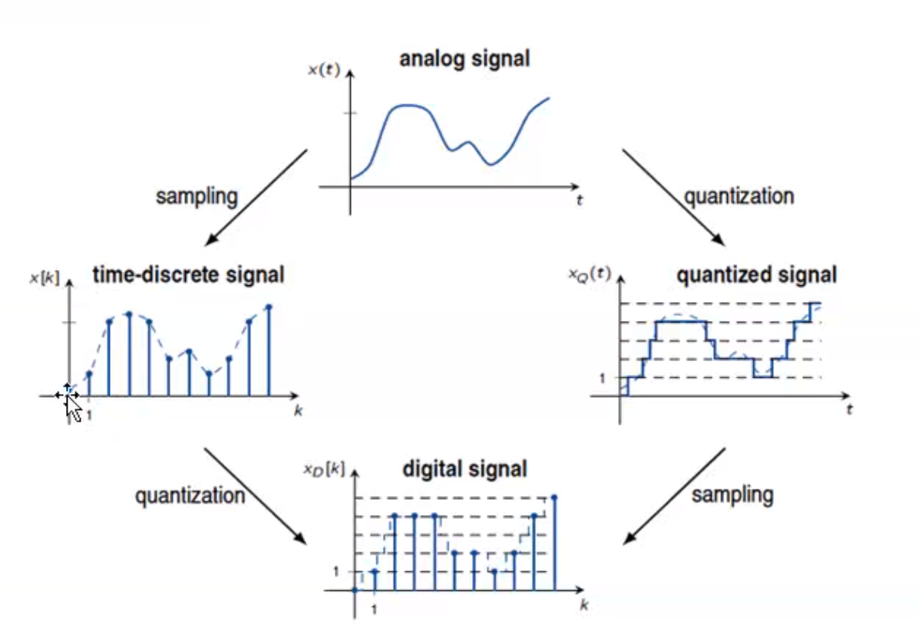

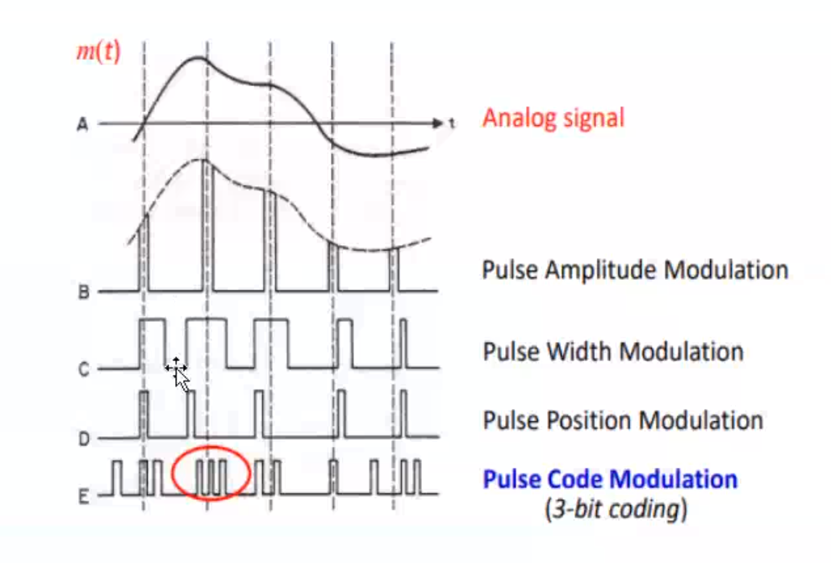

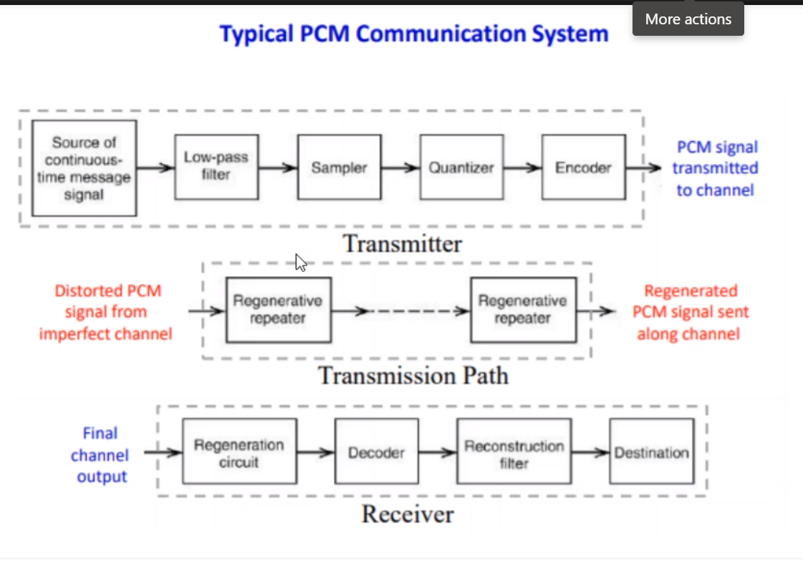



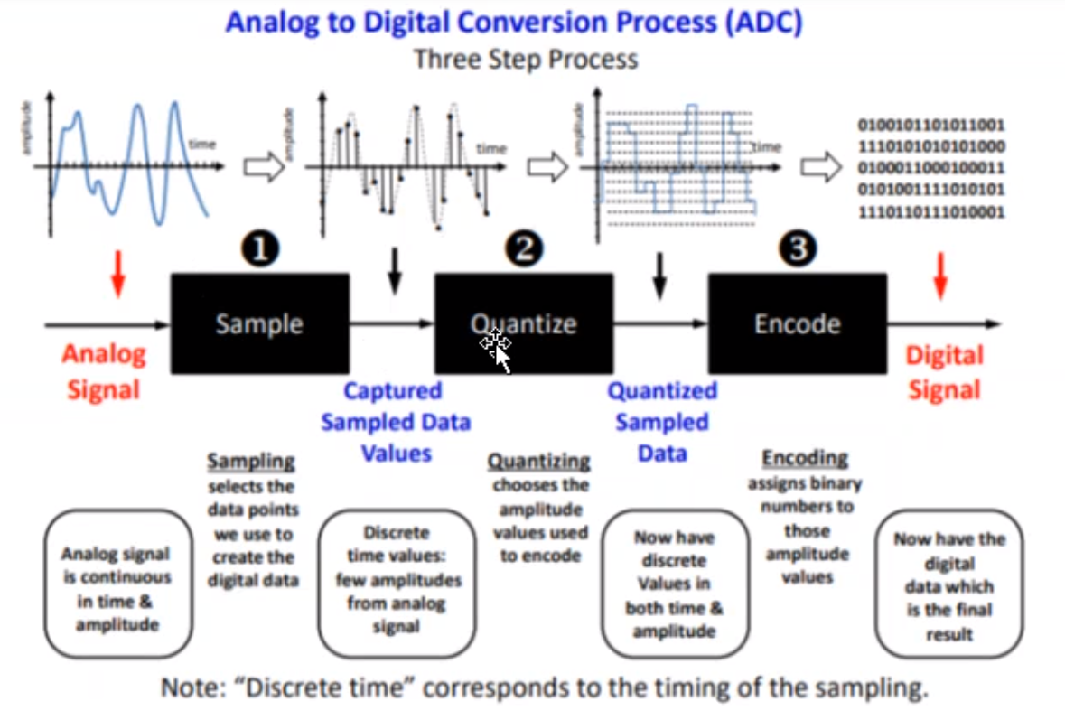

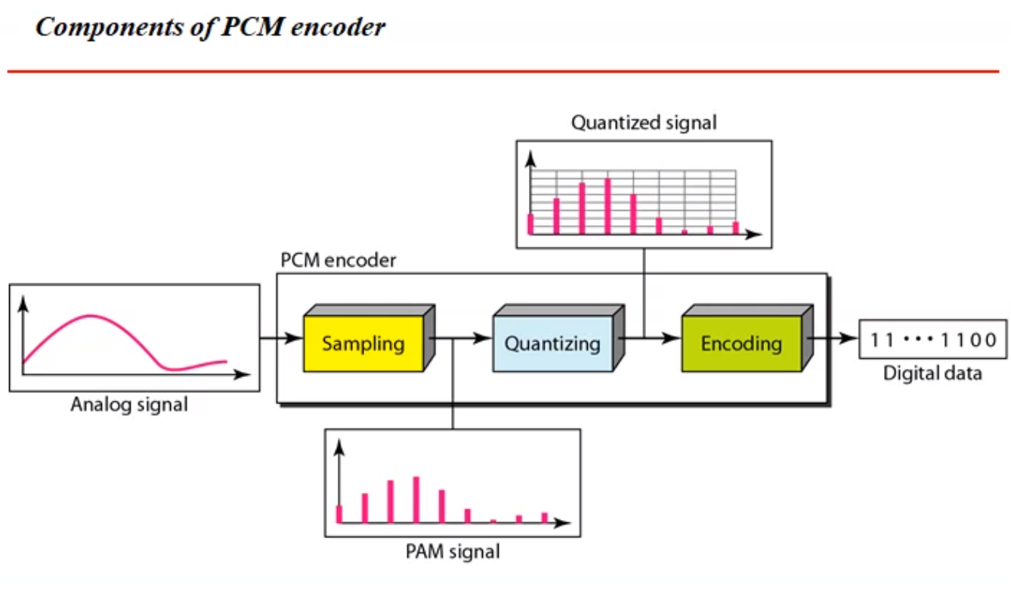

Encoder 🡪 always will receive in analog form

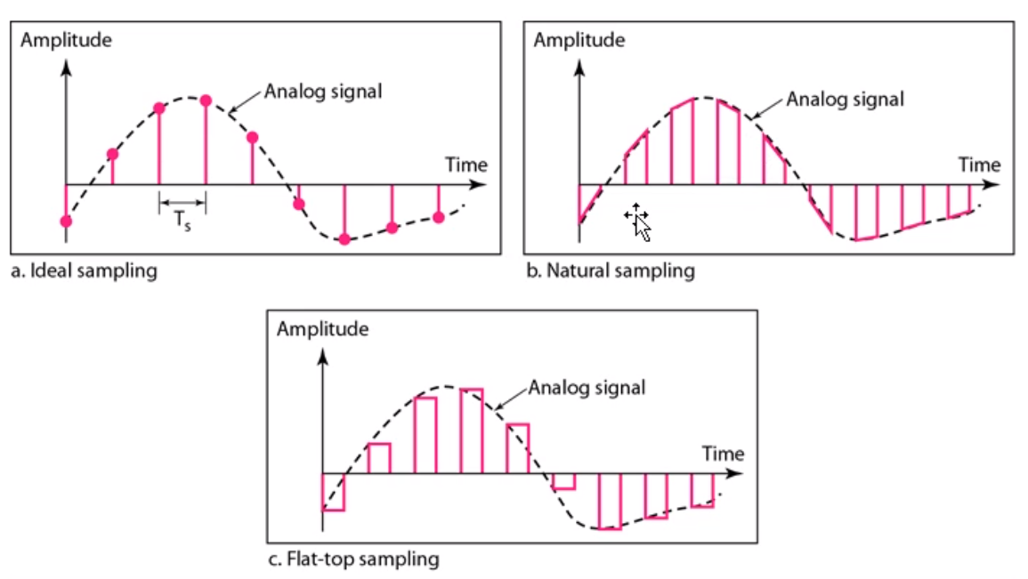

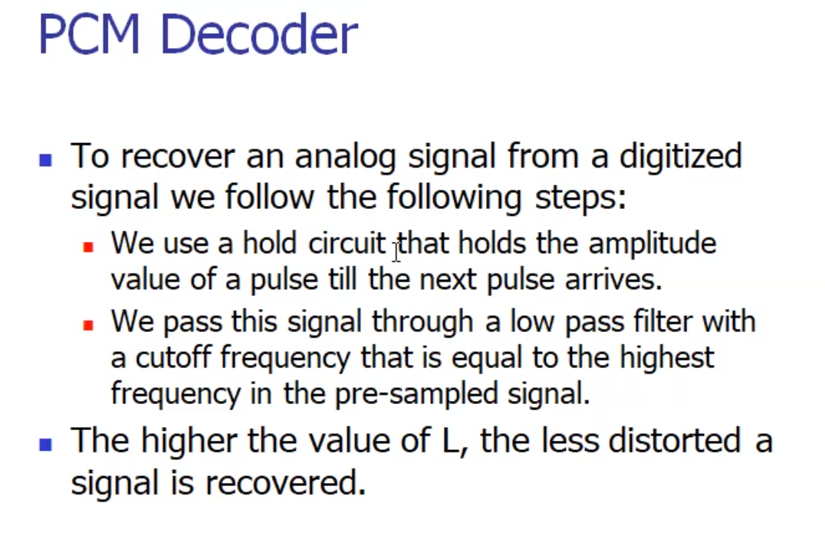

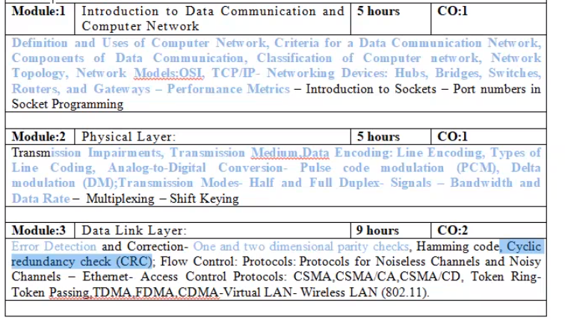

1st unit 🡪 upto Performance metrics  
2nd unit 🡪 upto data-rate

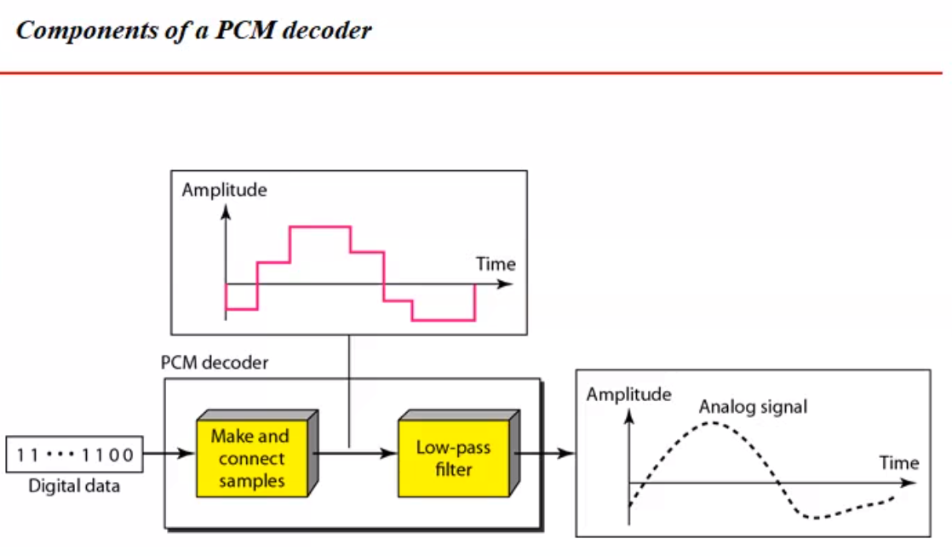

Decorder 🡪 will receive in digital form

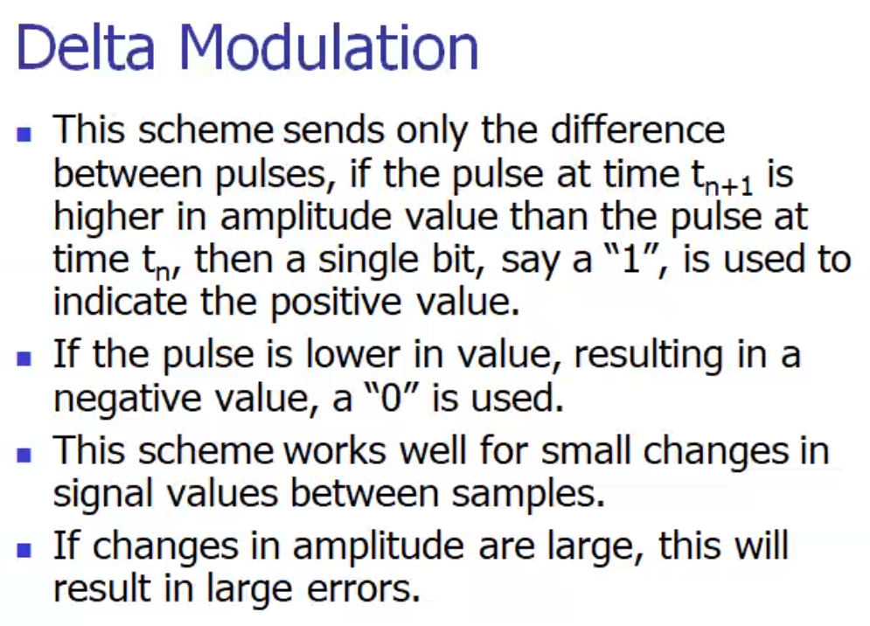

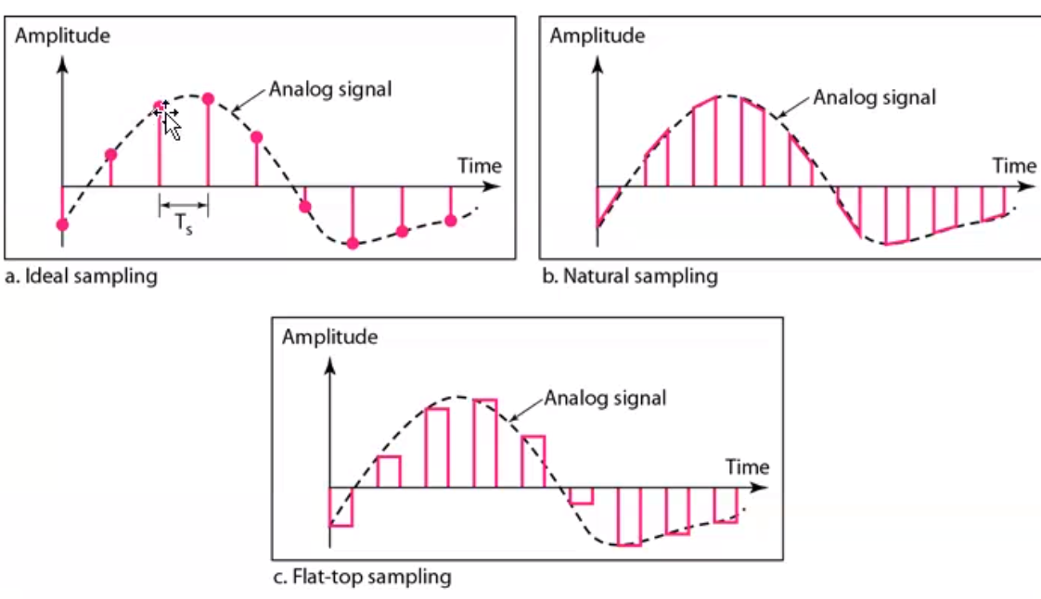­

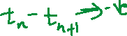

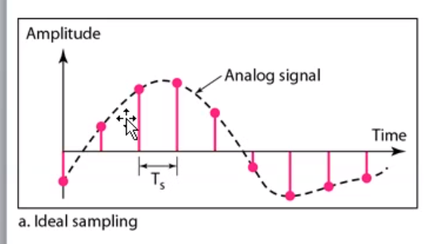



Samples more 🡪 distortion less  
Samples less 🡪 distortion more

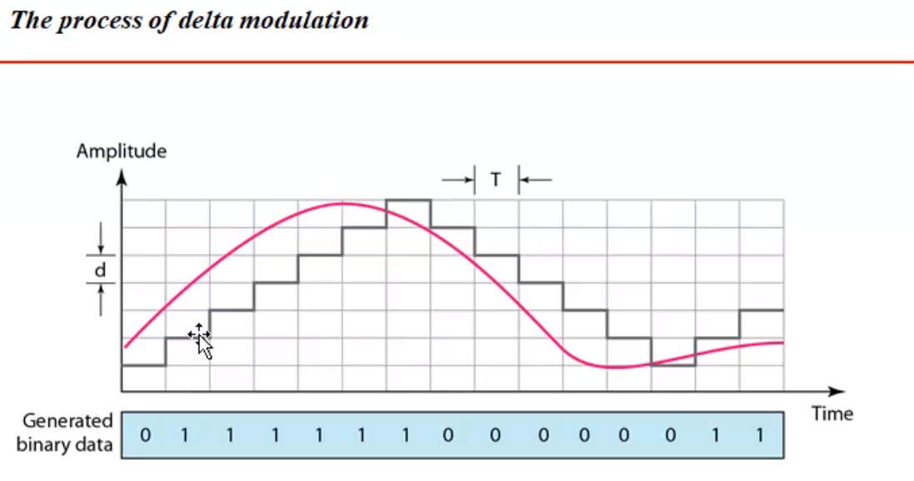

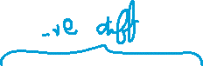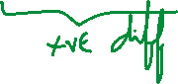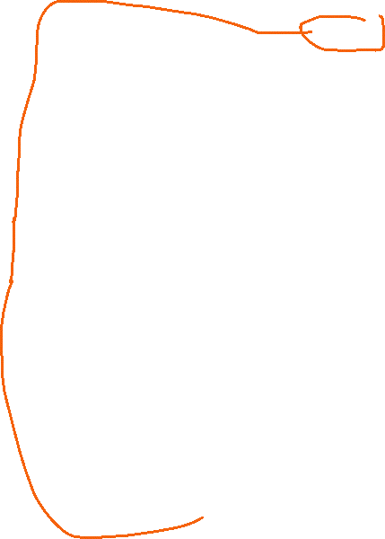

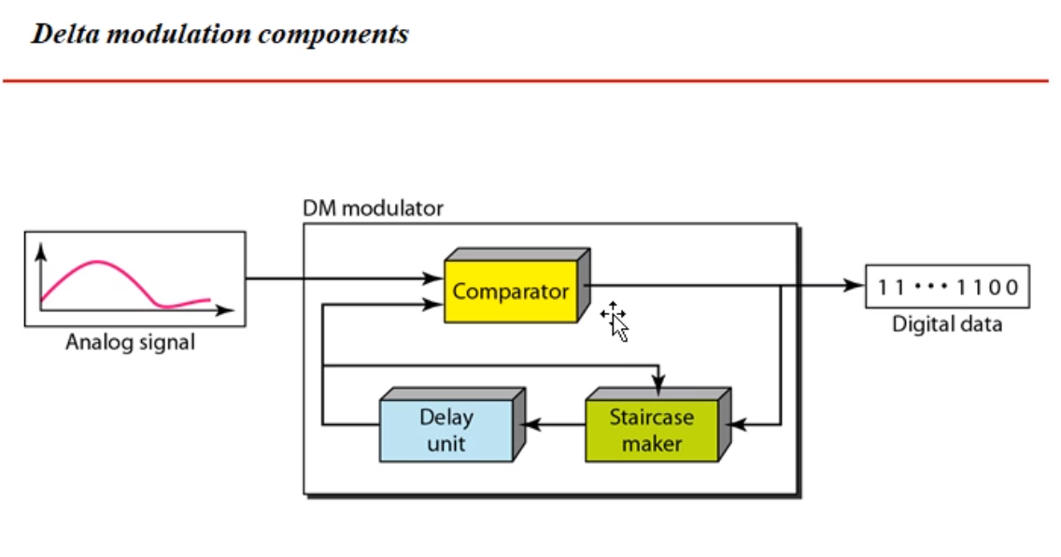



Every 3 mins 🡪 bus coming, now increased 3 mins  
Every 6 mins 🡪 bus coming

Increasing the duration 🡪 delay

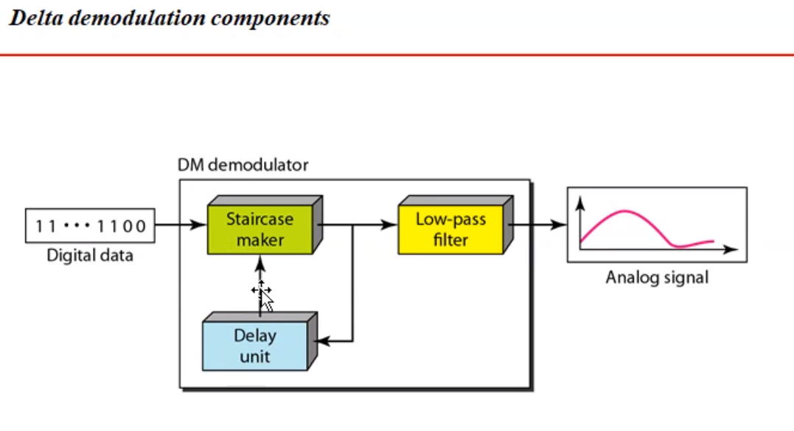

Delay unit should be consistent. (Same delay should be there in modulator and demodulator).

If not there mis-interpretation will be there.  
For 0, I will assume 1 and vice-versa.

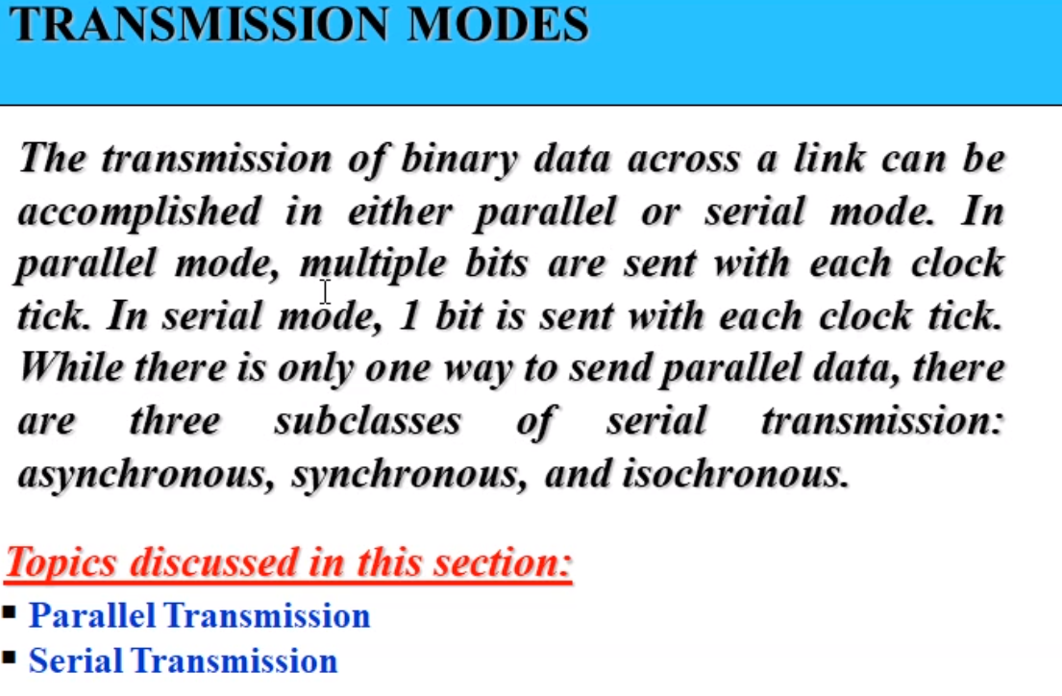



Parallel 🡪 more channels required  
Series 🡪 1 channel required



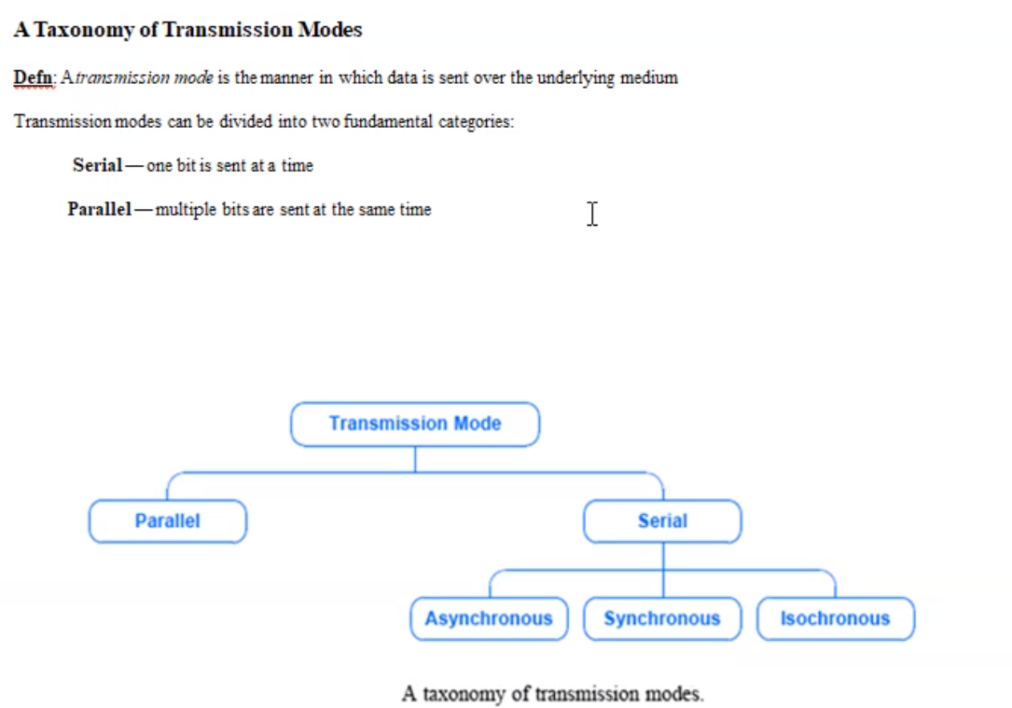

Isochronous 🡪 uniformly data transmission should take place.

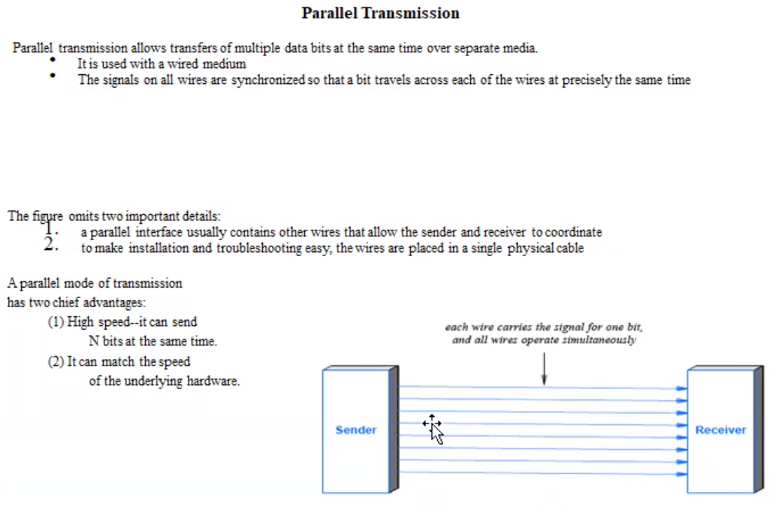



3/3/2021

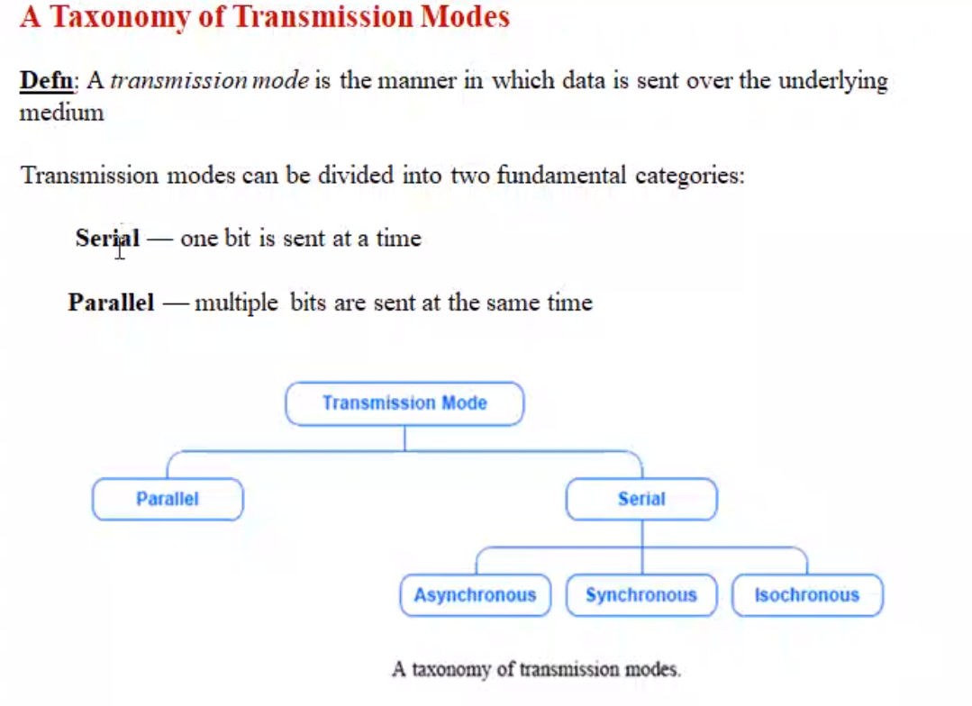

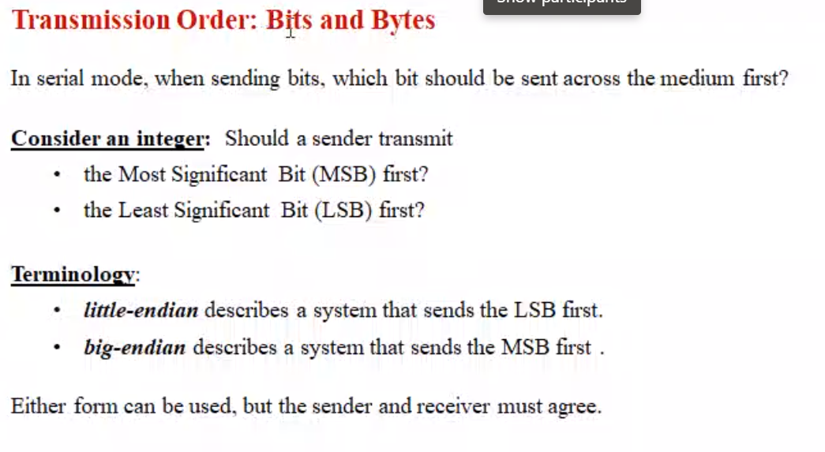



Little-endian 🡪 LSB should be sent first

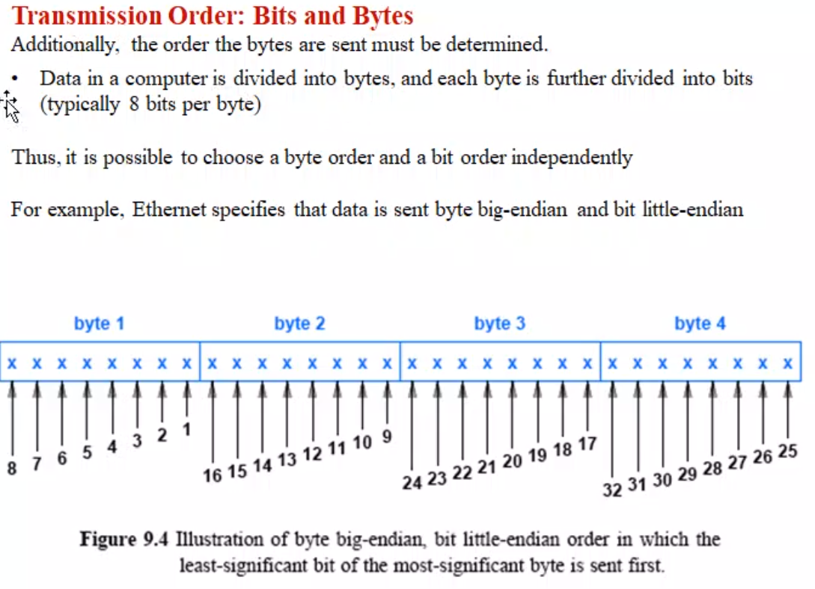

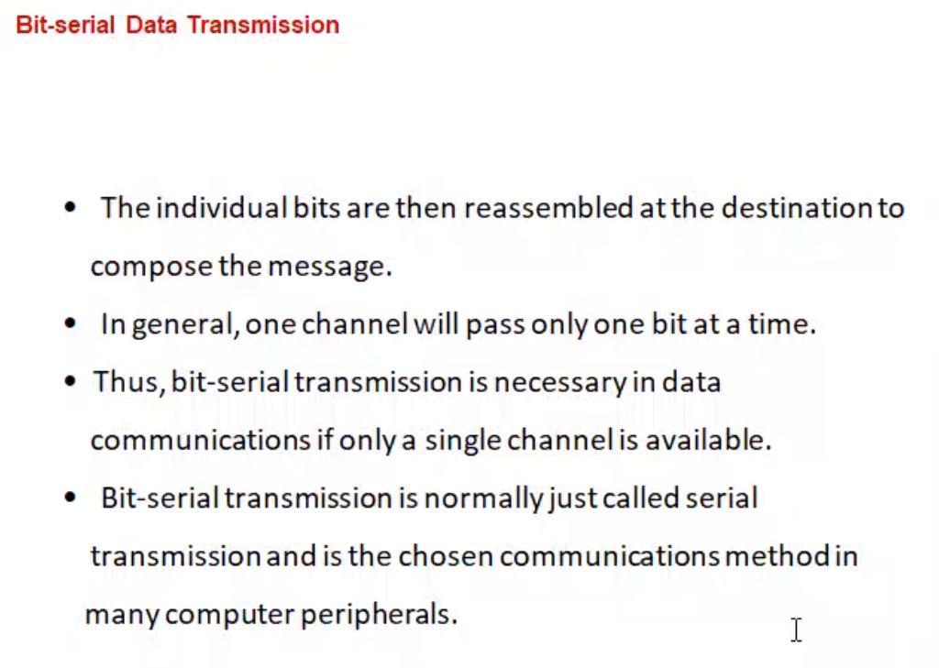



Time-complexity is more.

Peripheral device 🡪 Mouse (serial ) just one click at a time.

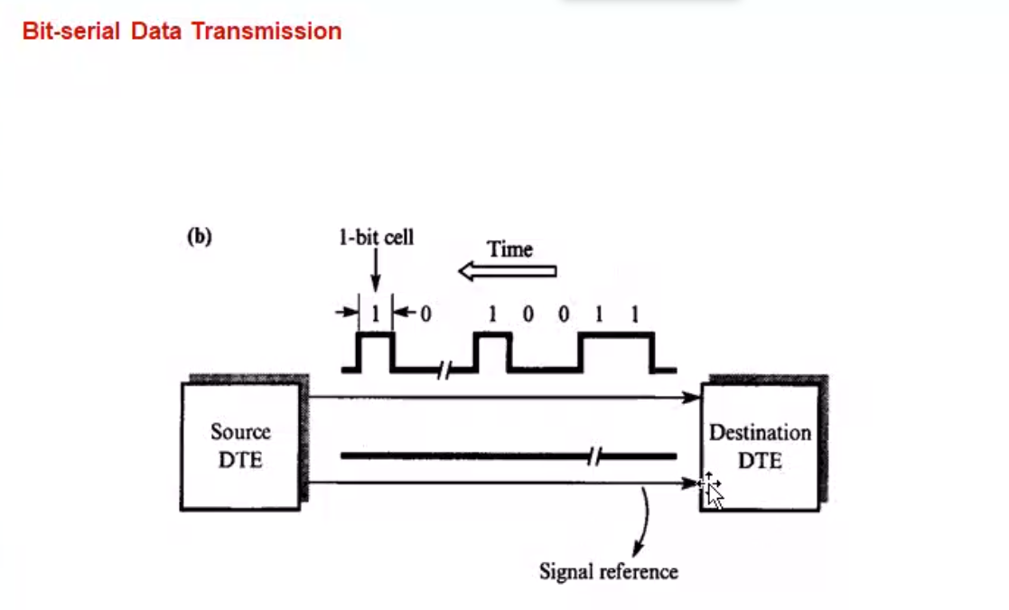

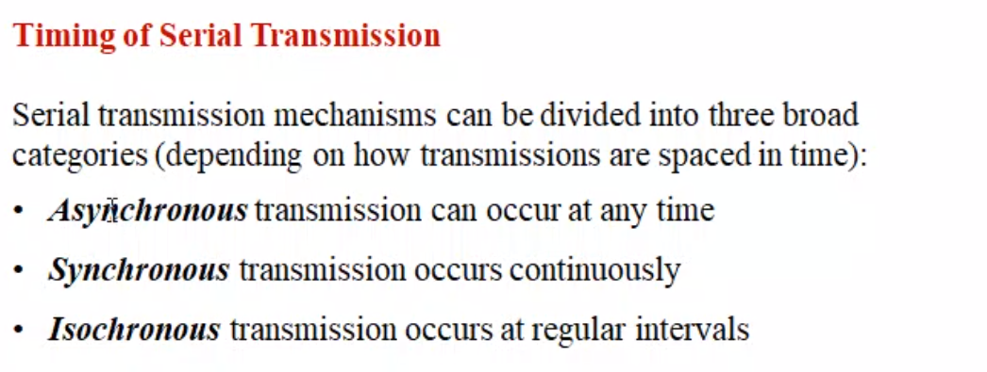

Isochronous (Interval 🡪 fixed)  
Synchronous and Asynchronous ( Interval 🡪 not fixed)

Isochronous 🡪 Watching o

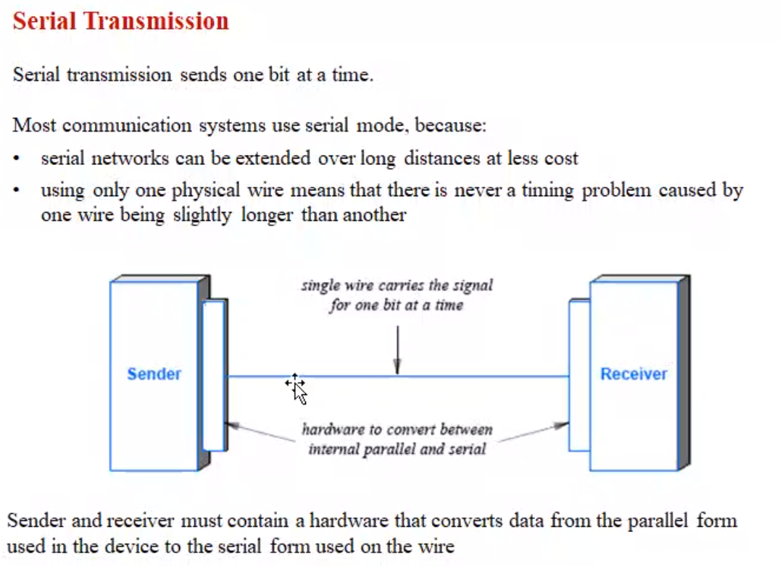

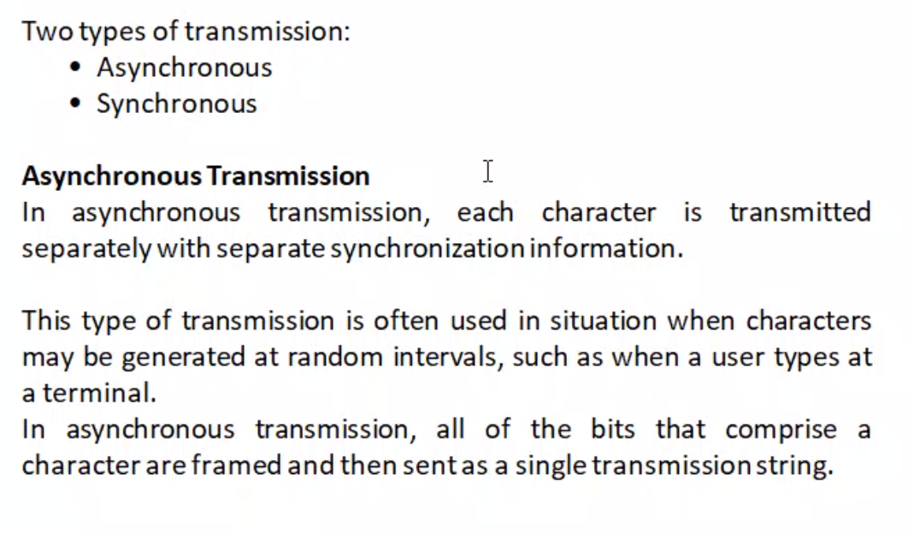

Asynchronous 🡪 keyboard typing. We will think and type often.

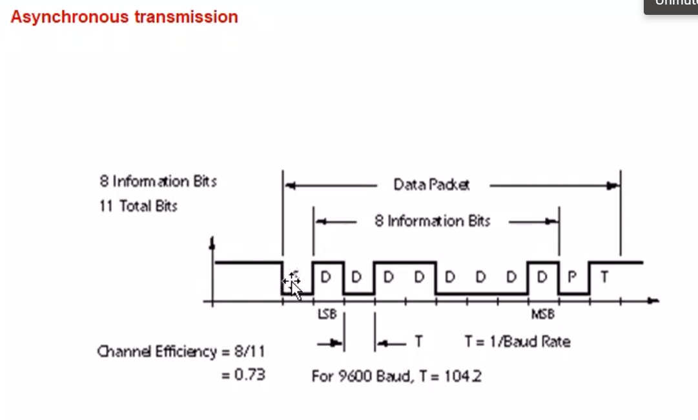

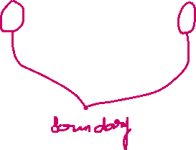

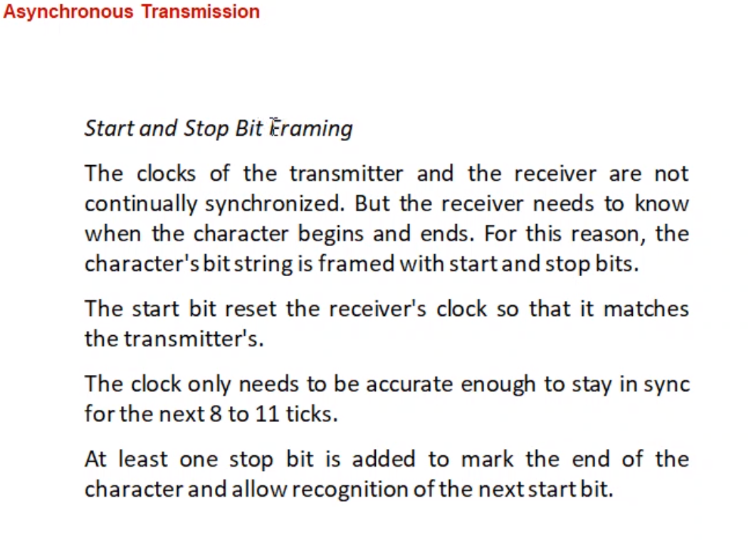

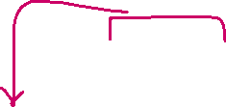

Over-over speaking  
Over 🡪 stop bit

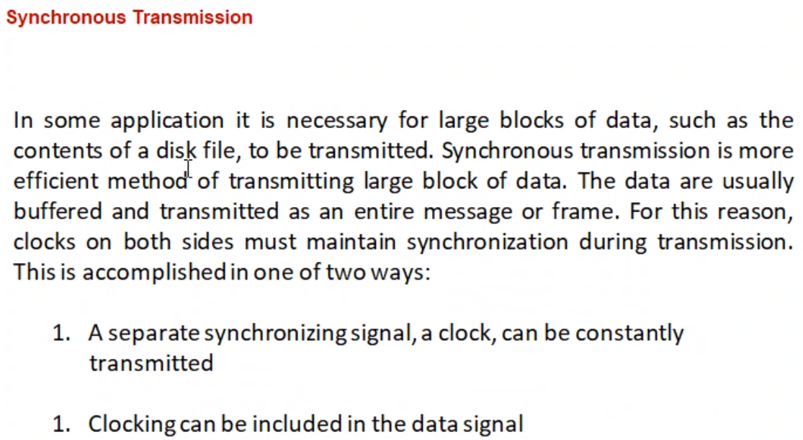

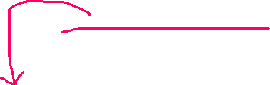

Before time, STD (exchange office will allocate a separate channel)  
Then only on approving, we can make a call

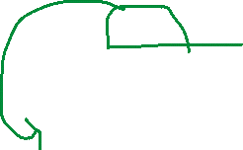

Am I audible, r u there(checking the receiver is there during long communication)

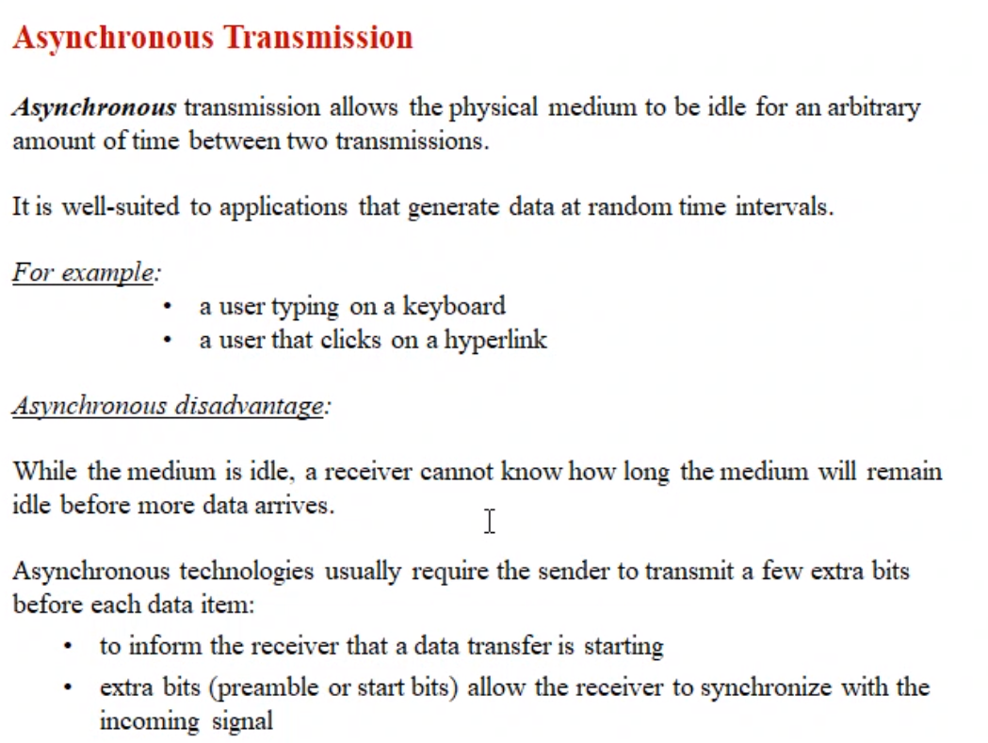

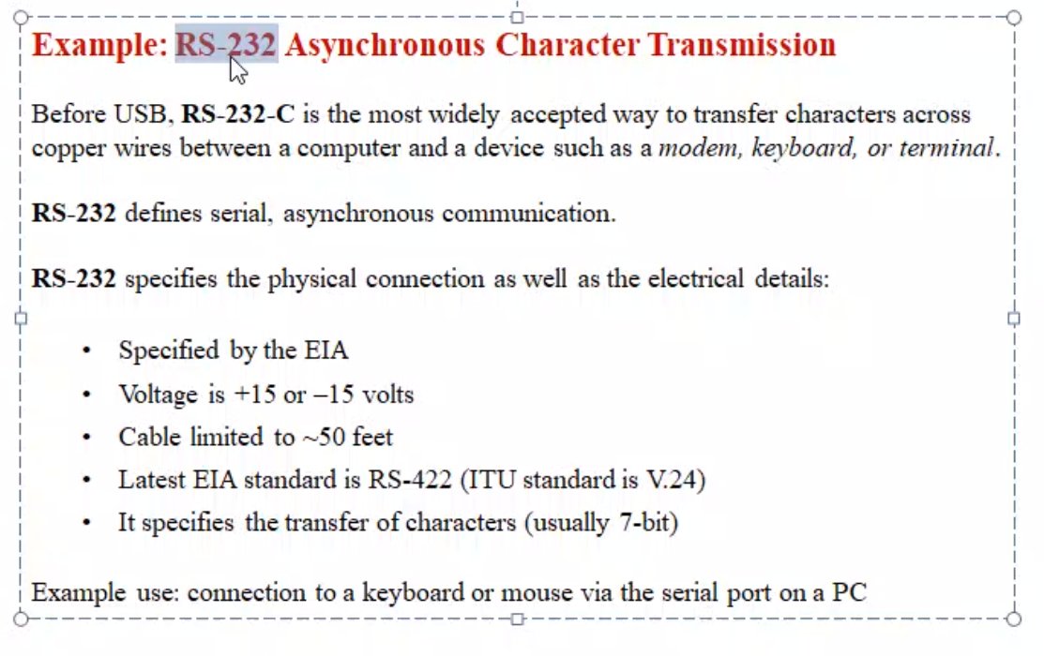



Terminal 🡪 display without a complete unit.  
Railway station (only a CPU and keyboard) to book the ticket.  
CPU will be at the backend.

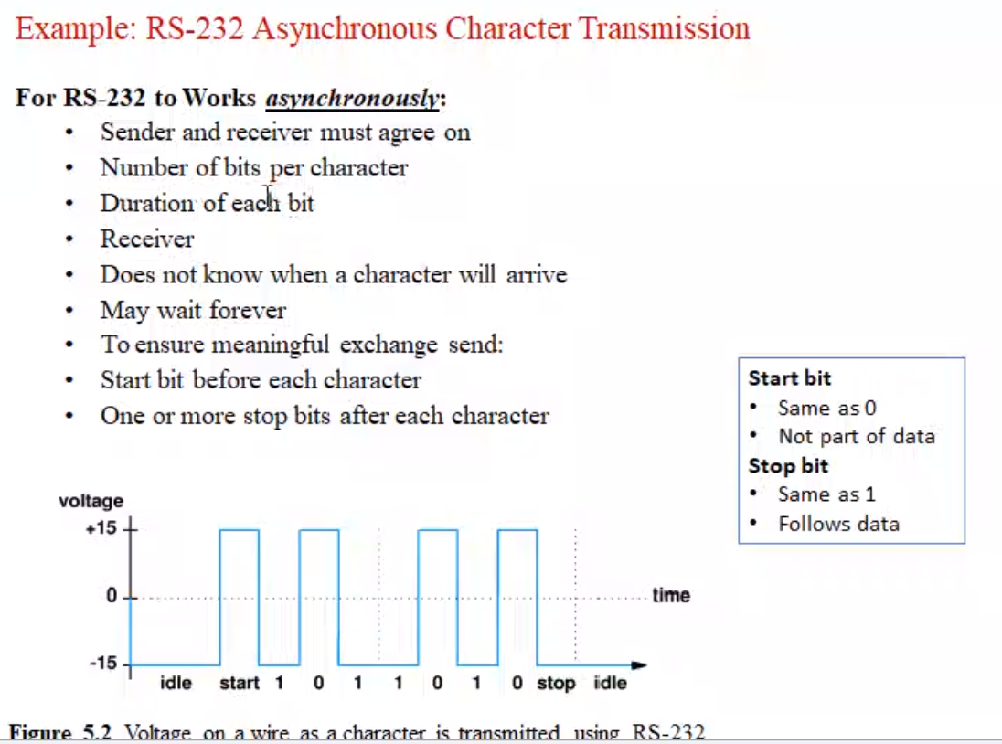

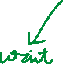

(May wait for-ever) Mouse click 🡪 PC don’t know when the user will click.